Contents
PYTHON 6
PYPI (PYTHON PACKAGE INDEX): 6
PYTHON PACKAGE INSTALLER- PIP 6
ANACONDA 6
RUNNING PYTHON FILE FROM COMMAND LINE (REPL – READ EVALUATE PRINT LOOP) 6
VIRTUAL ENVIRONMENT 7
SETTING UP VENV IN WINDOWS (USING PIP) 7
requirements.txt 9
STEPS TO CREATE requirements.txt 9
PIPENV 10
INSTALLING DEPENDENCIES 10
VARIABLE 13
PYTHON DATA TYPES 13
OPERATORS 13
TYPE CONVERSION 14
TYPE CHECKING 15
INT 15
NUMBERS 15
BOOLEANS 15
DATATYPES 17
BYTES 17
STRINGS 19
MATCH CASE 22
TERNARY OPERATOR 23
ITERABLES 24
LISTS 24
DICTIONARIES 26
TUPLES 30
SETS 31
SET AND LIST 32
SET AND DICTIONARY COMPREHENSION 32
ZIP FUNCTION 33
ENUMERATE 34
QUEUE 35
STACK 36
VARIABLE SCOPE 36
DESTRUCTURING 36
STANDARD DESTRUCTURING ASSIGNMENTS 36
DESTRUCTURING DICTIONARIES IN PYTHON 36
DESTRUCTURING IN FOR LOOPS 36
USING * TO COLLECT VALUES 37
UNDERSCORE VARIABLES 37
COMMENTS AND DOCSTRING 38
COMMENTS 38
DOCSTRINGS 38
STATEMENTS 38
IF-ELSE 38
NESTED IF-ELSE 39
ELIF 39
is KEYWORD 39
Is VERSUS == 40
in KEYWORD 40
LOOPS 40
FOR LOOP 40
WHILE LOOP 41
ELSE IN LOOP 41
EXAMPLES 41
SOME USEFUL OPERATORS AND FUNCTIONS 42
RANGE 42
SORT 42
FUNCTIONS 42
DEFAULT VALUE OF FUNCTION PARAMETERS 43
UNPACKING ARGUMENT 44
HIGH ORDER FUNCTION 45
LAMBDA FUNCTIONS, MAP AND FILTERS 45
FIRST CLASS FUNCTION 45
NESTED STATEMENT AND SCOPE 47
INTERACTIVITY – USER INPUTS 48
OOPS IN PYTHON 48
OBJECT ID 48
CLASSES AND OBJECTS 49
CLASS OBJECT ATTRIBUTES 49
__repr__ and __str__ METHODS 49
INSTANCE METHODS 50
CLASS AND STATIC METHODS 50
INHERITANCE 53
PROPERTY DECORATOR 56
POLYMORPHISM 58
MULTIPLE INHERITANCE 58
ABSTRACT CLASSES 60
MAGIC/ DUNDER METHODS (DOUBLE UNDERSCORE) 61
CATEGORIES OF MAGIC METHODS 61
TYPE HINTING 62
MODULES AND PACKAGES 62
PIP INSTALL AND PyPi 62
WRITING OWN PACKAGES AND MODULES 62
__name__ and __main__ 65
ERROR HANDLING 65
MECHANISMS FOR ERROR HANDLING 65
RAISING ERRORS/EXCEPTION 66
CUSTOM EXCEPTION 66
EXCEPTION HANDLING USING DECORATORS 68
GENERATORS 68
CREATING GENERATORS 68
KEY METHODS 69
CHAINING GENERATORS 69
EXAMPLES 69
REAL TIME USAGE OF GENERATORS 70
GENERATOR COMPREHENSION 71
GENERATORS CLASSES AND ITERATORS 71
ITERABLES 71
FILTER FUNCTION 71
MAP 73
any() 74
all() 75
COLLECTIONS MODULE 75
COMMONLY USED CLASSES IN THE `COLLECTIONS` MODULE 75
OSMODULE 77
DATETIME 78
MATH AND RANDOM 78
TIMEIT 78
REGULAR EXPRESSION 78
UNZIP AND ZIP MODULE 78
WEB SCRAPING 78
WEB SCRAPING PROCESS 78
FILES 79
I/O FILES 79
WORKING WITH SPREADSHEETS(CSV) 81
WORKING WITH JSON 84
WORKING WITH PDFs 86
OS MODULE 88
DATABASE OPERATION – SQLITE 88
SQLITE TERMINOLOGIES 88
CONTEXT MANAGER 89
DUNDER METHODS IN CONTEXT MANAGER 90
EXAMPLE 90
ERRORS IN CONTEXT MANAGER 91
TYPING 92
STATIC TYPE CHECKING 93
LOGGING 94
SIMPLE LOGGER 95
DECORATORS 97
ASSIGNING FUNCTION TO VARIABLE 97
THREAD AND PROCESS 100
POOLING 100
EVENT DRIVEN PROGRAMMING 100
COMMAND LINE ARGUMENT 101
ARGPARSE 101
UNIT TEST 104
LINTING - PYLINT 104
TESTING LIBRARY 107
CHEATSHEETS 107
ITERATION UTILITIES 107
SIMPLE WEB APP USING FLASK 108
PYTHON THIRD PARTY LIBRARIES 108
PENDULUM 108
USAGE 108
CREATING DATETIME 108
DATETIME FORMAT 109
REQUESTS 110
FEATURES 111
ISSUING REQUEST USING REQUESTS LIBRARY 111
PYFILESYSTEM 112
WORKING WITH FILES 112
WORKING WITH DIRECTORIES 113
WALKING A FILESYSTEM 114
PILLOW 115
IMAGE MANIPULATION 116
HANDLING RESPONSE USING REQUESTS LIBRARY 116
AUTHENTICATION 116
IMAGE EDITING 118

PYTHON
- Python distribution refers to a bundle or package that programming language along with additional tools, libraries, and packages that are commonly used includes the core Python programming language interpreter, along with in Python development.
- It provides an easy way to install and manage Python and its related components, making it convenient for users to additional libraries, tools, and resources that are commonly used in Python development. It provides a convenient and pre-packaged environment for working with Python.

PYPI (PYTHON PACKAGE INDEX):
- Official package repository
  - PyPI is the official repository for Python packages and libraries.
  - It hosts a vast collection of packages contributed by the Python community.
- General-purpose packages:
  - PyPI is suitable for a wide range of Python development needs, including web development, data analysis, machine learning, scientific computing, and more.
- `pip` package manager:
  - PyPI packages are typically installed using `pip`, the default package manager for Python.
  - `pip` allows us to install, upgrade, and manage packages from PyPI and other package indexes.
- Community-driven:
  - PyPI has a large and active community of developers who contribute, maintain, and update packages.
  - It is widely used and supported by the Python community.

PYTHON PACKAGE INSTALLER- PIP
- Used to manage Python Packages
- As of Python 3.4, it comes pre-installed
INSTALL PYTHON PACKAGE | pip install <package_name>
INSTALL SPECIFIC PACKAGE | pip install <package_name>=version  Example : pip install autopep=1.5
LIST INSTALLED PYTHON PACKAGE | pip list
LIST OUTDATED INSTALLED PACKAGE | pip list –outdated
UPDATE THE OUTDATED PACKAGE | pip install –upgrade <package_name>
UNISTALL PACKAGE | pip uninstall <package_name>
DETAIL OF PACKAGE | pip show <package_name>  Example - pip show Flask
ANACONDA
- Distribution for data science:
  - Anaconda is a Python distribution specifically focused on data science, scientific computing, and machine learning. It includes a curated set of packages optimized for these domains.
- Conda package manager:
  - Anaconda comes with its own package manager called `conda`, which can install packages from Anaconda Cloud (Anaconda's package repository) as well as PyPI. `conda` provides additional features like environment management and handling binary dependencies.
- Pre-installed packages:
  - Anaconda comes with a comprehensive set of pre-installed packages commonly used in data science, such as NumPy, Pandas, Matplotlib, scikit-learn, and TensorFlow. This makes it convenient for data scientists to get started quickly.
- Environment management:
  - `conda` allows us to create and manage isolated environments with specific versions of Python and packages. This helps in managing different project requirements and avoiding conflicts between dependencies.

RUNNING PYTHON FILE FROM COMMAND LINE (REPL – READ EVALUATE PRINT LOOP)
- Enter the “python” command to in terminal to start the Python REPL
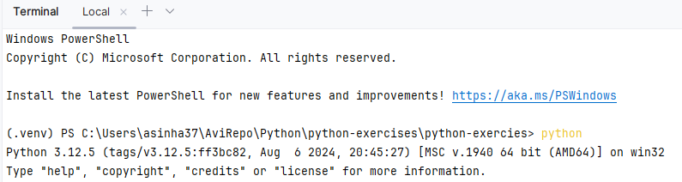 | 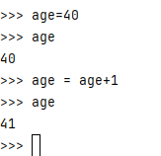

CHECK PYTHON VERSION | python -V
RUNNING A PYTHON FILE | python <file_name>

VIRTUAL ENVIRONMENT
- A virtual environment is a self-contained directory that contains a specific version of Python interpreter along with its installed packages.
- It allows us to isolate Python projects and their dependencies, ensuring that each project can have its own set of packages without interfering with each other.
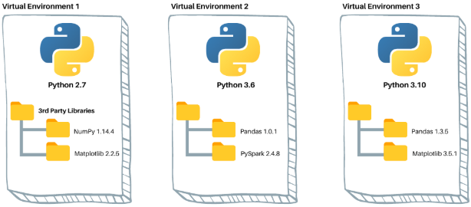

VIRTUAL ENVIRONMENTS ARE USEFUL IN SEVERAL SCENARIOS:
- Dependency Management:
  - If we are working on multiple projects that require different versions of packages or modules, virtual environments allow we to keep them separate and avoid conflicts.
- Project Isolation:
  - Virtual environments provide a clean and isolated environment for each project, making it easier to manage dependencies and avoid compatibility issues.
- Reproducibility:
  - By using virtual environments, we can easily share our project with others and ensure that they can reproduce the same environment and run your code without any issues.
To create a virtual environment, we can use tools like `venv`, `virtualenv`, or `conda`.

SETTING UP VENV IN WINDOWS (USING PIP)
Step 1: Create a directory where the virtual environment needs to be set up
Step 2: Run the following command in the cmd line
CREATE THE VIRTUAL ENVIRONMENT USING venv
- Virtual environments are created using tools like virtualenv or the built-in venv module in Python.
- These tools create a separate directory with its own Python executable, libraries, and scripts.
- This command uses the built-in venv module in Python to create a new virtual environment
- This is the recommended way to create virtual environments in Python 3.
python -m venv <virtual_env_name>
python -m venv flaskenv
CREATE THE VIRTUAL ENVIRONMENT USING virtualenv
- This command uses the third-party package virtualenv to create a new virtual environment named "venv".
- It is executed directly from the command line, without invoking the Python interpreter.
- This method can be used in both Python 2 and Python 3.
Step 1: INSTALLING VIRTUALENV PACKAGE: pip install virtualenv
Step 2: CREATE VIRTUAL ENVIRONMENT: virtualenv <virtual_env_name>
ACTIVATE THE VIRTUAL ENVIRONMENT: | <virtual_env_name>\Scripts\activate.bat  flaskenv\Scripts\activate.bat
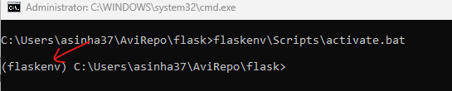
- Once inside a virtual environment, we can use the Python interpreter and install packages using tools like pip.
- Any packages installed in the virtual environment will only be available within that environment and won't interfere with other projects or the system.
For example – Let install the “flask” package in the virtual environment (fastapiapp)  pip install flask  - When we execute – pip list command it in the virtual environment it will show the flask in installed packages list | 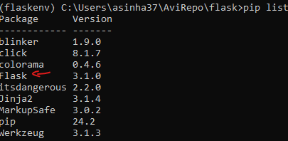
Once we are in virtual environment – we can deactivate it too | COMMAND : deactivate
NOTE: -When we activate a virtual environment, it modifies your system's environment variables to prioritize the isolated environment over the system-wide Python installation.

CONFIGURE VIRTUAL ENVIRONMENT IN PYCHARM
- Click on the interpreter (right buttom corner in the IDE) Add New Interpreter Add local Interpreter
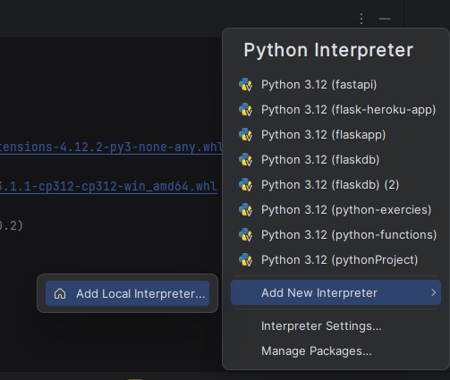

requirements.txt
A `requirements.txt` file is commonly used in Python projects to specify the dependencies and their versions required for the project to run. It is useful for managing and reproducing the project's environment and avoid compatibility issues (like package.json)

STEPS TO CREATE requirements.txt
- Step 1: When a given virtual environment is activated - run the command pip freeze in terminal.
The pip freeze command will output a list of installed packages and their versions in the format package==version. For example: | flask==1.1.2  requests==2.25.1  pandas==1.2.4
- Step 2:
- Redirect the output to a text file. For example, we can use the command pip freeze > requirements.txt to save the output to a file named "requirements.txt".
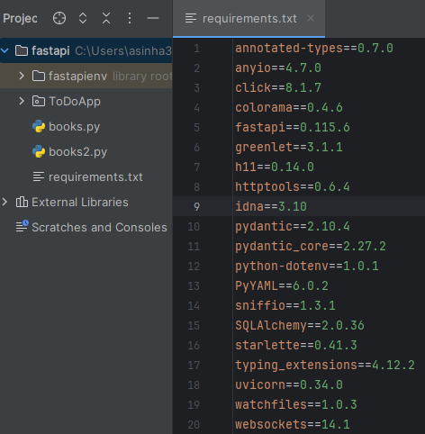
- Step 3:
- The resulting list of packages and versions generated by pip freeze can be used to recreate the same environment on another machine or to install the same set of packages in a different virtual environment.
- This is often done by sharing the "requirements.txt" file and using the pip install -r requirements.txt command to install the packages listed in it.

PIPENV
- Pipenv is a tool that combines the functionality of pip (the package installer for Python) and virtualenv (the tool for creating virtual environments).
- It aims to provide a more streamlined and user-friendly experience for managing Python dependencies and virtual environments within projects.
INSTALL PIP ENV PACKAGE | pip install pipenv
Type ”pipenv” command to validate | 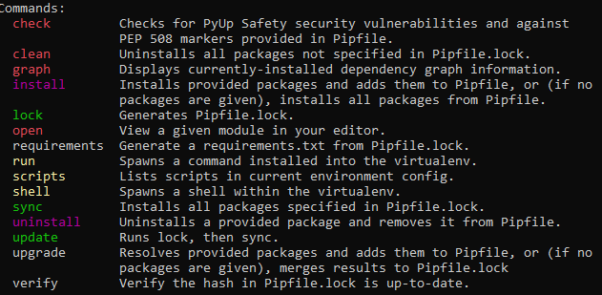

INSTALLING DEPENDENCIES
- If we have requirements.txt already in the project . Run ”pipenv install” command. This will perform following
- Install all the dependencies mentioned in requirements.txt.
- Creates Pipfile and Pipfile.lock files
- Creates the virtual environment
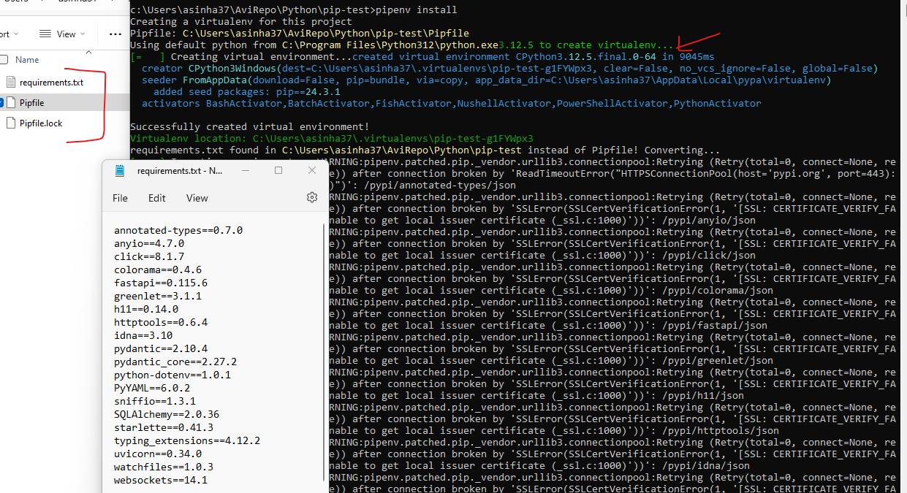

INSTALLING DEPENDENCIES IN PYCHARM
- Go to Settings Project Python Interpreter (+)
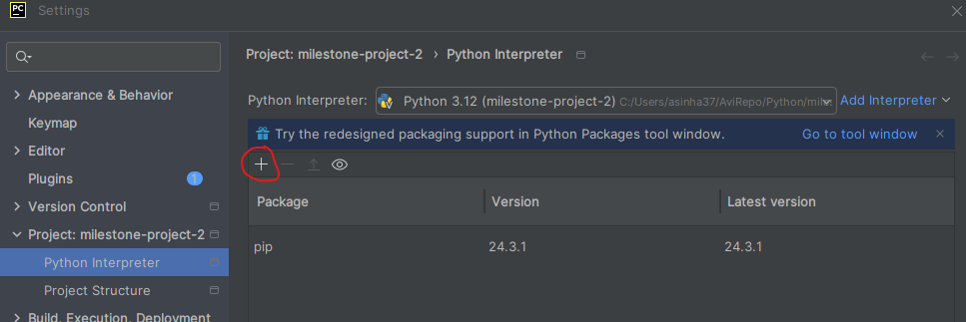
- Search for the package to install Install
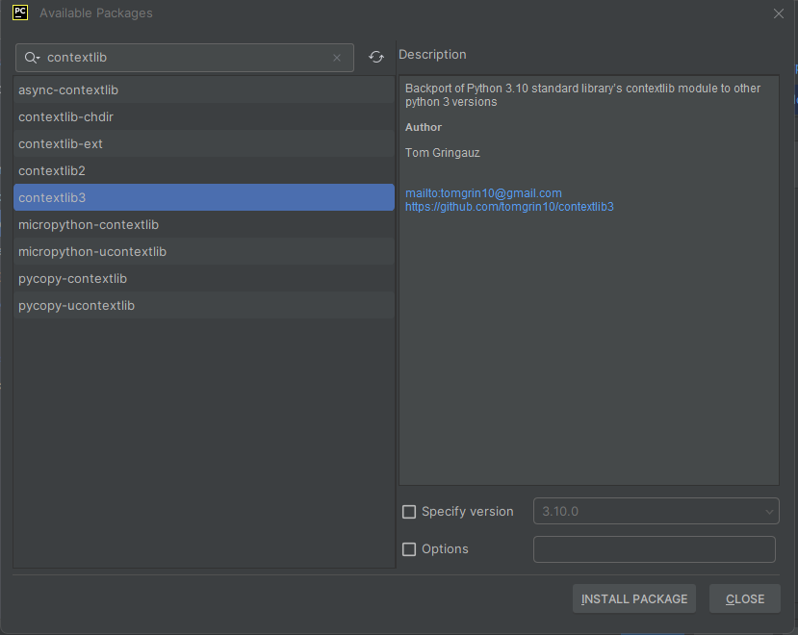

Pipfile and Pipfile.lock FILES
- The Pipfile and Pipfile.lock files are used by Pipenv, a Python dependency management tool, to manage project dependencies and create deterministic builds.

Pipfile
- The Pipfile is a human-readable file used to specify the dependencies and their versions for a Python project. (It is intended to replace the traditional requirements.txt file. )
- The Pipfile is written in TOML (Tom's Obvious, Minimal Language) format and contains two main sections:
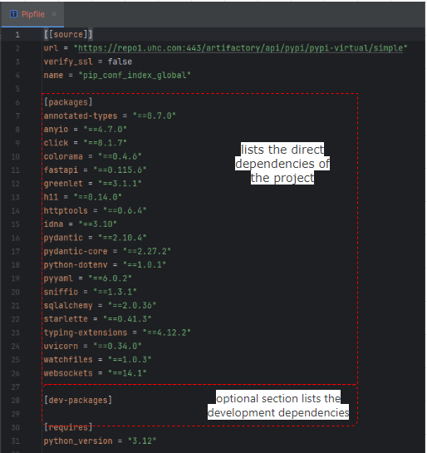 | - [packages]:  - This section lists the direct dependencies of the project.  - Each package is specified with its name and optional version specifier.  - [dev-packages]:  - This optional section lists the development dependencies, which are only required for development and testing. It follows the same format as the `[packages]` section.

Pipfile.lock:
- The Pipfile.lock file is automatically generated by Pipenv when dependencies are installed or updated.
- It is a lockfile that records the exact versions of all the dependencies, including their sub-dependencies.
- The purpose of the lockfile is to ensure deterministic builds, meaning that the exact same versions of dependencies are installed consistently across different environments.
- The Pipfile.lock file is automatically updated when we run commands like `pipenv install` or `pipenv update`.
- It should be committed to version control, and when other developers or deployment environments use `pipenv install`, Pipenv will install the exact same versions of packages specified in the lockfile.
- The Pipfile.lock file also includes other information such as hashes of packages to ensure integrity and security.

VIRTUAL ENVIRONMENT – PIP
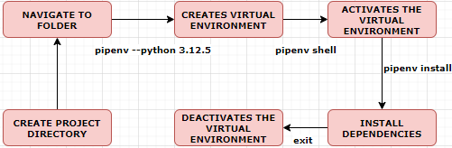
- Install Pipenv: If you haven't already, install Pipenv on your system by running pip install pipenv in your command prompt or terminal.
- Navigate to your project directory: Open a command prompt or terminal and navigate to the directory where your Python project is located.
- Create a virtual environment: Run the command pipenv --python 3 to create a virtual environment using the latest installed version of Python 3. If you want to use a specific version of Python, you can replace 3 with the desired version number, such as 3.8.
- Activate the virtual environment: Run the command pipenv shell to activate the virtual environment. Once activated, your command prompt or terminal prompt will change, indicating that you are now working within the virtual environment.
- Install project dependencies: With the virtual environment activated, you can use the pipenv install command to install project dependencies specified in the Pipfile. This command will create or update the Pipfile.lock file as well.
- Run Python commands: Now you can run Python commands or scripts within the virtual environment, and Pipenv will ensure that the correct packages and versions are used.
- Deactivate the virtual environment: To exit the virtual environment, simply run the command exit or close the command prompt or terminal window. This will deactivate the virtual environment and return you to your system's default Python environment.

VARIABLE
Best practices in variable declaration
- Declare constants in upper case. PI = 3.14
- Declare non-constant variables in snake case. e.g. even_numbers =[2,4,6]
- A variable cannot begin with a number.
- Variable cannot have special character except “underscore”

PYTHON DATA TYPES

Data Type | Description | Example(s)
int | Integer numbers without decimal points | x = 5
float | Floating-point numbers with decimal points | y = 3.14
str | Sequence of characters enclosed in single or double quotes | name = "John"
bool | Represents the truth values True or False | is_valid = True
list | Ordered collection of items enclosed in square brackets | numbers = [1, 2, 3, 4]
tuple | Immutable ordered collection of items enclosed in parentheses | coordinates = (10, 20)
dictionary | Unordered collection of key-value pairs enclosed in curly braces | person = {'name': 'John', 'age': 25, 'city': 'NYC'}
set | Unordered collection of unique elements enclosed in curly braces | fruits = {'apple', 'banana', 'orange'}
NOTE
- In Python, we can represent large numbers using underscores as separators for improved readability.
- This feature was introduced in Python 3.6.
large_number = 1_000_000_000_000_000_000  print(large_number) | OUTPUT  1000000000000000000

OPERATORS

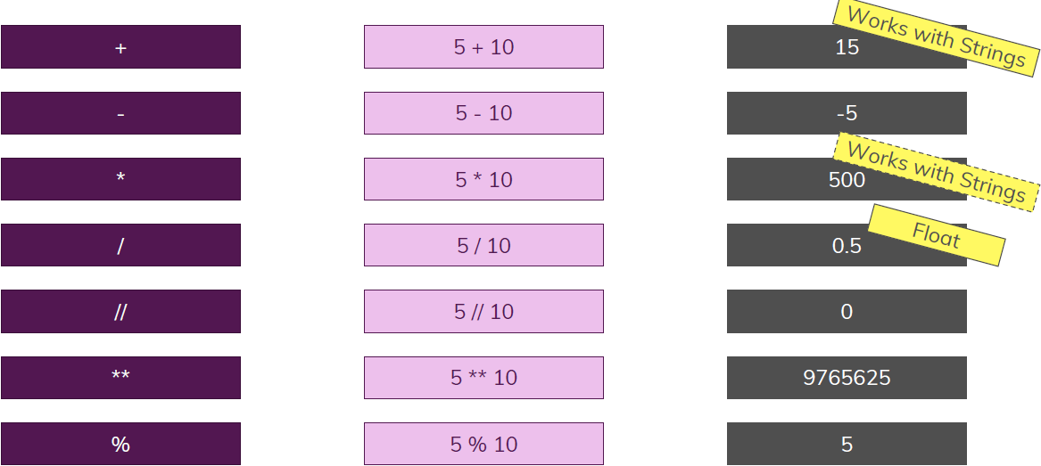
NOTE
- The double forward slash operator // is used for floor division.  - Floor division performs division between two numbers and rounds down the result to the nearest integer. | a = 10  b = 3  result = a // b  print(result) 3
- We can multiply a string by an integer to repeat the string multiple times.  - The * operator is used for string multiplication. | string = "Hello "  multiplier = 3  result = string * multiplier  print(result)  OUTPUT : Hello Hello Hello
STEIMG

TYPE CONVERSION

Python is a dynamically Typed language | In Python, dynamic typing allows variables to hold values of any data type and allows the type of a variable to be changed during execution
Example | x = 5  print(x) # Output: 5  print(type(x)) # Output: <class 'int'>  x = "Hello"  print(x) # Output: Hello  print(type(x)) # Output: <class 'str'>
- In Python, type conversion refers to the process of converting one data type to another.
- Python provides several built-in classes for type conversion. Note int(), float() , str(), list(), tuple() and bool() are classes in Python. NOT FUNCTION
int(): Converts a value to an integer data type.  Example:  num = int("10") # converts the string "10" to an integer  print(num) # output: 10  num = int(8.9999) 8 [Trims the decimal part ] | float(): Converts a value to a floating-point data type.  Example:  num = float("3.14") # converts the string "3.14" to a float  print(num) # output: 3.14
int(‘number’, base): (int(“101”,2) 5
- When we pass the second argument – it will take it as a base, it will consider 101 as binary number and print the integer equivalent(base 10)
- The “first” argument is “string”
str(): Converts a value to a string data type.  Example:  age = 25  age_str = str(age) # converts the integer 25 to a string  print(age_str) # output: "25" | list(): Converts a value to a list data type.  Example:  numbers = "1 2 3 4 5"  numbers_list = list(numbers)  # converts the string "1 2 3 4 5" to a list  print(numbers_list)  # output: ['1', ' ', '2', ' ', '3', ' ', '4', ' ', '5']
tuple(): Converts a value to a tuple data type.  Example:  numbers = "1 2 3 4 5"  # converts the string "1 2 3 4 5" to a tuple  numbers_tuple = tuple(numbers)  print(numbers_tuple)  # output: ('1', ' ', '2', ' ', '3', ' ', '4', ' ', '5') | bool(): Converts a value to a boolean data type.  Example:  value = 0  bool_value = bool(value)  # converts the integer 0 to False  print(bool_value)  # output: False

TYPE CHECKING
- Using the type() function: The type() function returns the data type of an object.
number = 10  print(type(number)) # output: <class 'int'> | name = "John"  print(type(name)) # output: <class 'str'>
is_valid = True
print(type(is_valid)) # output: <class 'bool'>
- Using the isinstance() function: The isinstance() function checks if an object belongs to a specific class or data type. It returns True if the object is an instance of the specified class or data type, otherwise it returns False.
number = 10  print(isinstance(number, int)) # output: True | name = "John"  print(isinstance(name, str)) # output: True
is_valid = True
print(isinstance(is_valid, bool)) # output: True

INT

int(‘100’) | 100  - Typecast the num string to integer
- int(‘100’,2) 4  - int(‘1ab’,16) 427  int(num_as_string,base) | - converts the binary string '100' into an integer, using base 2.

NUMBERS

- 20/4 = 5.0  - 4+4.0 = 8.0  - 4* 4.0 = 16.0  - 4**4.0 = 256.0 | - Python returns a float for the division.  - Addition, multiplication & exponential of float and integer returns a float
div = 8/3: 2.6666666666666665  result = int(div) : 2 | OUTPUT: 2  Trims the decimal points
round(8/3,2) | OUTPUT: 2.67  Round it to 2 decimal places
8//3 | Integer Division - It is same as int(8/3)  8/3= 2.6666666666666665  8//3 = 2
Assignment Operator | score=0  score +=1 1  score -=1 0
2**3 OR  pow(2,3) | To find the power of the number
hex(num) | Hexadecimal Representation of the number
bin(num | Binary Representation of the number
abs(-2) | OUTPUT = 2(Absolute value)
BODMAS | 1+3*4/2-1 = 6.0  Note – The division operation always returns a float even if the result is an integer e.g. (4/2 = 2.0)

BOOLEANS
- Boolean data type represents the truth values `True` and `False`.
- The Boolean type has two possible values: `True` and `False`. (These values are case-sensitive)
bool(1) | True
bool(0) | False
bool(-1) | True
bool(1j) | True
bool(0.0) | False
bool(0j) | False
bool(“False”)  Note : bool(“”)[Empty String] is false, but any non empty string is considered as True | True
bool([]) | False
bool({}) | False
bool(None) | False

LOGICAL OPERATORS – CHAINING COMPARISON OPERATOR
- Booleans can be combined using logical operators to create more complex conditions. The logical operators include:
And  - `and`: Returns `True` if both operands are `True`.  - and returns the first value if it evaluates to false, otherwise it returns the second value.  or  - `or`: Returns `True` if at least one of the operands is `True`.  - or returns the first value if it evaluates to true, otherwise it returns the second value.  not  - `not`: Returns the opposite boolean value of the operand. | is_raining = True  is_sunny = False  print(is_raining and is_sunny) # False  print(is_raining or is_sunny) # True  print(not is_raining) # False

EXAMPLES

and - returns the first value if it evaluates to False | Or - the first value is returned if it evaluates to True
>>> None and '35'  None  >>> x = []  >>> x and 12  []  >>> 10 and 20  20 | >>> None or '35'  '35'  >>> x = []  >>> x or 12  12  >>> 10 or 20  10
- ` The `and` operator has higher precedence than the `or` operator.  - The `and` operator is evaluated before the `or` operator. If `age` is greater than 18 and less than 65, the expression `age > 18 and age < 65` evaluates to `True`. If `side_job` is `True`, the final expression `True or True` evaluates to `True`. The result will be printed as `True` if both conditions are satisfied. | age = int(input("Enter your age: "))  side_job = True  print(age > 18 and age < 65 or side_job)

TRUTHY AND FALSY VALUES
- When a value evaluates to True we call it "Truthy". Similarly, when it evaluates to False we call it "Falsy".
- Most values in Python are "Truthy". What that means is when you pass them to the bool() function, it returns True:
>>> bool(None) False  >>> bool('35') True  >>> bool(10) True  >>> bool([]) False  >>> bool([1, 2, 3]) True | The values that are "Falsy" are:  - Empty strings, lists, tuples, dictionaries, and other empty iterables.  - None  - 0 and other zero numbers (such as 0.0).
BOOLEAN FUNCTIONS
- Python provides built-in functions that can be used to work with Booleans, such as:
- `bool()`: Converts a value to a boolean. Returns `False` for empty containers, `0`, and `None`; otherwise, returns `True`.  - `all()`: Returns `True` if all elements in an iterable are `True`.  - `any()`: Returns `True` if at least one element in an iterable is `True`.  Question : Check when the list has any evens  nums = [1,2,3,5,7]  any([num for num in nums if num %2 ==0]) True | x = 10  y = 0  z = []  print(bool(x)) # True  print(bool(y)) # False  print(bool(z)) # False  numbers = [1, 2, 3, 4, 5]  print(all(numbers)) # True  print(any(numbers)) # True
Examples
default_age = 30  age = 0  final_age = age or default_age  print(final_age) # Output: 30 | default_value = "Hi There!"  name = input("Enter your name: ") or default_value  print(name or default_value) # Output: Hi There! (if no name is entered)

DATATYPES

BYTES
bytes is a built-in data type that represents immutable sequences of bytes (8-bit values). It's commonly used for binary data, such as files, network communication, or encoding/decoding text.
- A bytes object is a sequence of integers in the range 0 <= x < 256.
- It is immutable, meaning it cannot be changed after creation.
Bytes Object are
- Useful for handling binary data (e.g., images, files, network packets).
- Often used in encoding/decoding strings (e.g., UTF-8).
- Streaming files
- Transmitting text without knowing the encoding
CREATING BYTES OBJECT | bytes(4)  - OUTPUT: b'\x00\x00\x00\x00'  - The “b” represents that it is a byte not string  - Create an empty byte object which is 4 bytes long. Each byte is represented with a /x followed by two hexadecimal or base 16 numbers
ENCODE TO BYTE FROM STRING | - Creating the bytes from string – We need to pass the encoding (UTF -Unified Transform Format)  b1 = bytes("hello", "utf-8")  print(b1) # Output: b'hello'
DECODE FROM BYTE TO STRING | b1.decode(“utf-8”) hello

Decimal to Hexadecimal Conversion  Let’s say you want to convert 156 to hexadecimal.  Steps:  - Divide the number by 16.  - Write down the remainder (this will be a hex digit).  - Repeat the process with the quotient until the quotient is 0.  - Read the remainders in reverse order.  Example: Convert 156 to Hex | 🔡 Hexadecimal Digits  Result:  Read remainders from bottom to top → 9C  So, 156 (decimal) = 9C (hexadecimal)
  Step | Division | Quotient | Remainder | Hex Digit
  1 | 156 ÷ 16 | 9 | 12 | C
  2 | 9 ÷ 16 | 0 | 9 | 9
  Decimal | Hex
  10 | A
  11 | B
  12 | C
  13 | D
  14 | E
  15 | F
Hex to Decimal Conversion
Let’s say you want to convert 2F (hex) to decimal.
Steps:
- Write down the hex digits and their positions (right to left, starting from 0).
- Multiply each digit by ( 16^{\text{position}} ).
- Add the results.
Example: Convert 2F to Decimal
Hex Digit | Decimal Value | Position | Calculation
F | 15 | 0 | ( 15 \times 16^0 = 15 )
2 | 2 | 1 | ( 2 \times 16^1 = 32 )
Total: (32 + 15 = 47 )
So, 2F (hex) = 47 (decimal)
EXAMPLE 2: hexadecimal number 2FF to decimal:
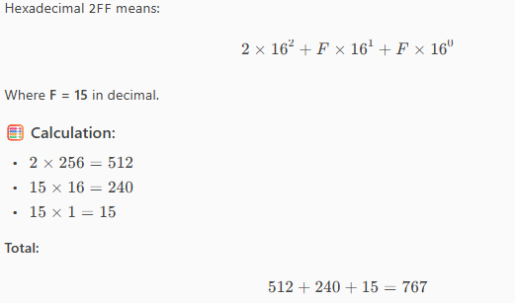

BYTEARRAY
- A bytearray is a mutable sequence of bytes.
- It’s useful when we need to manipulate binary data, such as reading or modifying files, network data, or encoding/decoding.
Example: Creating and Modifying a bytearray  # Create a bytearray from a string  data = bytearray("Hello, world!", "utf-8")  print("Original bytearray:", data)  # Modify a byte (change 'H' to 'J')  data[0] = ord('J')  # Append a byte (exclamation mark)  data.append(ord('!'))  # Convert back to string  result = data.decode("utf-8")  print("Modified bytearray:", data)  print("As string:", result) | OUTPUT  Original bytearray: bytearray(b'Hello, world!')  Modified bytearray: bytearray(b'Jello, world!!')  As string: Jello, world!!

STRINGS
- In Python, a string is a sequence of characters enclosed in either single quotes (' ') or double quotes (" "). Strings are one of the basic data types in Python and are used to represent text or a sequence of characters.

STRINGS ARE IMMUTABLE
Strings are immutable. This means that once a string is created, we cannot change its individual characters. However, we can create a new string by performing operations on the original string.
my_string = "Hello"  my_string[0] = "J" # This will raise a TypeError: 'str' object does not support item assignment | SOLUTION  my_string = "Hello"  new_string = "J" + my_string[1:]  print(new_string) # Output: Jello
- An string cannot be concatenated with non-string data types ”1” +1 (Error)  - The non-string data type need to be converted to string before concatenation  - OR we can use String Formatting using f-string(template string) or “format()” method | Example  age = 34  print ("Age is "+age) Error
 | USING THE TYPE CONVERSION | USING STRING FORMATING
 | age = str(34)  print ("Age is "+age) | print(f”The age ={age}”)
ESCAPING IN STRING  message = "He said \"Python is easy\"" | OUTPUT - 'He said "Python is easy"'

STRINGS OPERATIONS

CREATING A STRING  my_string = "Hello, World!"  print(my_string) # Output: Hello, World! | ACCESSING CHARACTERS IN A STRING  my_string = "Hello, World!"  print(my_string[0]) # Output: H  print(my_string[7]) # Output: W | STRING LENGTH  my_string = "Hello, World!"  print(len(my_string)) # Output: 13
CONCATENATING STRINGS  string1 = "Hello"  string2 = "World"  concatenated_string = string1 + " " + string2  print(concatenated_string) # Output: Hello World | STRING SLICING  my_string = "Hello, World!"  print(my_string[7:12]) # Output: World  print(my_string[:5]) # Output: Hello  print(my_string[7:]) # Output: World! | STRING METHODS  my_string = "Hello, World!"  print(my_string.upper()) # Output: HELLO, WORLD!  print(my_string.lower()) # Output: hello, world!  print(my_string.split(",")) # Output: ['Hello', ' World!']  print(my_string.replace("Hello", "Hi")) # Output: Hi, World!
MULTILINE STRING  - triple quotes (""" or ''') are used to define multi-line strings or string literals.  - Triple quotes allow us to include line breaks and preserve the formatting of the text within the string. |  | my_string = """This is a  multi-line  string."""  print(my_string)  OUTPUT  This is a  multi-line  string.
- The multiline strings are typically used to define string literals, they can also be used as comments by placing them within the code but not assigning them to any variable. These multiline strings act as comments and are ignored by the Python interpreter.  - In the example, the multiline string is enclosed within triple quotes and contains multiple lines of text. It serves as a comment to provide information or explanations about the code. The Python interpreter ignores this multiline string, and only the `"Hello, World!"` statement is executed.  - Using multiline strings as comments can be useful when we need to include longer explanations or documentation within your code. However, it's important to note that these multiline strings are still stored in memory, so they may consume some memory resources. |  | """  This is a multiline string  that can be used as a comment.  It can span multiple lines  without affecting the code.  """  print("Hello, World!")

STRING SLICING AND INDEXING

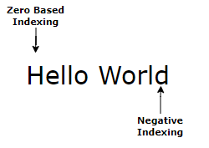

INDEXING
Syntax: sequence[index]
COMMAND | OUTPUT | NOTES
message[0] | ‘H’ | Indexing starts at 0 for the first element
message[-1] | ‘d’ | Negative indexing starts at -1 for the last element

SLICING

Syntax: sequence [start:stop:step] | Parameters:  - start (inclusive): Index where the slice begins.  - stop (exclusive): Index where the slice ends.  - step (optional): Step size for selecting elements. Default Step is 1

COMMAND | OUTPUT | NOTES
message[1:3] | ‘el’ | Start from index =1 to elements before index =3 (exclude 3)
message[2:] | 'llo World' | Start with index
message[:3] | 'Hel' | Till before index= 3
message[1:8:2] | 'el o' | Start from index =1 till before index= 8 in step of 2
message[::-1] | 'dlroW olleH' | Reverse String
message[::-2] | 'drWolH' | Reverse String in step of 2

H | e | l | l | o |  | W | o | r | l | d
0 | 1 | 2 | 3 | 4 | 5 | 6 | 7 | 8 | 9 | 10

STRING FUNCTIONS

- `capitalize()`: This method capitalizes only the first character of a string and converts the rest of the characters to lowercase. | text = "hello world"  capitalized_text = text.capitalize()  print(capitalized_text)  Output: Hello world
- `title()`: This method capitalizes the first character of each word in a string and converts the remaining characters to lowercase. Here's an example: | text = "hello world"  title_text = text.title()  print(title_text)  Output: Hello World

STRING FORMATTING

TEMPLATE STRING
- The format() method is used to format strings by replacing placeholders with corresponding values.
BASIC SYNTAX | formatted_string = "Hello, {}!"  message = formatted_string. .format(value)
- “formatted_string” is a string template which can be re-used with multiple values
- The curly braces {} serve as placeholders in the string.
- The format() method replaces these placeholders with the value specified inside the format() method.
name = "Alice"
age = 25
message = "Hello, my name is {} and I am {} years old.".format(name, age)
print(message) # Output: Hello, my name is Alice and I am 25 years old.
EXAMPLE - 1
name = "John"
age = 25
message = f"My name is {name} and I am {age} years old."
print(message) # output: My name is John and I am 25 years old.
EXAMPLE -2
name1='Alex'
name2='Pam'
name2='Alok'
print("Friends name {1},{2} and {0}".format(name1,name1,name2))
# output: Friends name Alex,Alok and Alex.
EXAMPLE - 3
name1='Alex'
name2='Pam'
name2='Alok'
print("Friends name {secondName},{thirdName} and {firstName}".format(firstName=name1,secondName=name1,thirdName=name2))
# output: Friends name Alex,Alok and Alex
pi = 3.14159  formatted_pi = "The value of pi is approximately {:.2f}".format(pi)  print(formatted_pi) |  | Output: The value of pi is approximately 3.14

FSTRING
- f-strings (formatted string literals) provide a concise and convenient way to embed expressions inside string literals.
- They allow us to include variables, expressions, and even function calls within curly braces `{}` directly in the string.
- F-strings also support simple expressions and function calls:
x = 5
y = 10
result = f"The sum of {x} and {y} is {x + y}."
print(result) # output: The sum of 5 and 10 is 15.
greeting = f"Hello, {get_name()}!"
print(greeting) # output: Hello, John!
In the above examples, the expressions `{x + y}` and `{get_name()}` are evaluated and the results are inserted into the strings.

STRING FORMATING OPERATOR
- We can use %s to inject strings into the print statements. The modulo `%` is referred to as a string formatting operator.
STATEMENT | OUTPUT
print("I'm going %s to inject here." % 'something') | I'm going something to inject here.
print("I'm going %s to inject here %s." % ('something','as well!')) | I'm going something to inject here as well!.
x, y = 'some', 'more'  print("I'm going to inject %s text here, and %s text here."%(x,y)) | I'm going to inject some text here, and more text here.
- The `%s` operator converts whatever it sees into a string, including integers and floats.  - The `%d` operator converts numbers to integers first, without rounding. Note the difference below:  print('I wrote %s programs today.' %3.75)  print('I wrote %d programs today.' %3.75) | I wrote 3.75 programs today.  I wrote 3 programs today.

PADDING AND PRECISION OF FLOATING POINT NUMBERS
Floating point numbers use the format %5.2f
- 5 would be the minimum number of characters the string should contain; these may be padded with whitespace if the entire number does not have this many digits.
- .2f stands for how many numbers to show past the decimal point.
print('Floating point numbers: %5.2f' %(13.144)) | Floating point numbers: 13.14
print('Floating point numbers: %1.0f' %(13.144)) | Floating point numbers: 13
print('Floating point numbers: %1.5f' %(13.144)) | Floating point numbers: 13.14400

ADVANCED STRING

Capitalize: converts the first character of a string to uppercase and all other characters to lowercase. | message="hello world"  message.capitalize()  OUTPUT : Hello world
count(substring): This method returns the number of occurrences of a specified substring within a string. | text = "Hello, hello, hello"  count = text.count("hello")  print(count)  OUTPUT : 3
find(substring): This method returns the index of the first occurrence of a specified substring within a string. If the substring is not found, it returns -1 | text = "Hello, world"  index = text.find("world")  print(index)  OUTPUT : 7

MATCH CASE
The match and case statements introduced in Python 3.10 provide a powerful way to write concise and readable conditional logic, similar to switch-case in other languages but more versatile.
SYNTAX  match variable:  case pattern1:  # Code block for pattern1  case pattern2:  # Code block for pattern2  case _:  # Default case (like `else`)  - match: Evaluates the given variable or expression.  - case: Matches specific patterns or values.  - _: Acts as a wildcard or default case (equivalent to else). | EXAMPLE: MATCHING EXACT VALUES  value = 2  match value:  case 1:  print("Value is one")  case 2:  print("Value is two")  case 3:  print("Value is three")  case _:  print("Value is something else")  Output: Value is two
EXAMPLE: MATCHING MULTIPLE VALUES  - We can match multiple values in a single case using a tuple.  value = 3  match value:  case 1 | 2:  print("Value is one or two")  case 3 | 4:  print("Value is three or four")  case _:  print("Value is something else")  Output: Value is three or four | EXAMPLE: MATCHING WITH CONDITIONS (GUARDS)  - We can add conditions to a case using if.  value = 5  match value:  case x if x < 3:  print("Value is less than 3")  case x if x >= 3 and x <= 6:  print("Value is between 3 and 6")  case _:  print("Value is greater than 6")  Output: Value is between 3 and 6
EXAMPLE: MATCHING DATA STRUCTURES  - match-case can destructure lists, dictionaries, and tuples.  Destructuring Tuples  point = (3, 4)  match point:  case (0, 0):  print("Point is at the origin")  case (x, 0):  print(f"Point is on the x-axis at {x}")  case (0, y):  print(f"Point is on the y-axis at {y}")  case (x, y):  print(f"Point is at ({x}, {y})")  Output: Point is at (3, 4) | DESTRUCTURING LISTS  numbers = [1, 2, 3]  match numbers:  case [1, 2, 3]:  print("Exact match!")  case [1, *rest]:  print(f"Starts with 1, rest: {rest}")  case _:  print("No match")  Output:Exact match!
EXAMPLE: MATCHING CLASSES
- We can match based on object attributes.

class Point:
def __init__(self, x, y):
self.x = x
self.y = y

point = Point(1, 2)

match point:
case Point(x=0, y=0):
print("Point is at the origin")
case Point(x=x, y=y) if x == y:
print(f"Point is on the diagonal at ({x}, {y})")
case Point(x=x, y=y):
print(f"Point is at ({x}, {y})")

Output: Point is at (1, 2)

TERNARY OPERATOR
- The ternary operator allows us to write a conditional expression in a concise way.
- SYNTAXT
result = value_if_true if condition else value_if_false
x = 5  # Assigns "Positive" to result if x is greater than 0, otherwise assigns "Non-positive"  result = "Positive" if x > 0 else "Non-positive"  print(result) | - In this example, the ternary operator is used to assign the value "Positive" to the variable `result` if `x` is greater than 0. Otherwise, it assigns the value "Non-positive". The value assigned depends on the evaluation of the condition `x > 0`.  - Running this code will output "Positive" because the value of `x` is 5, which satisfies the condition `x > 0`.

ITERABLES
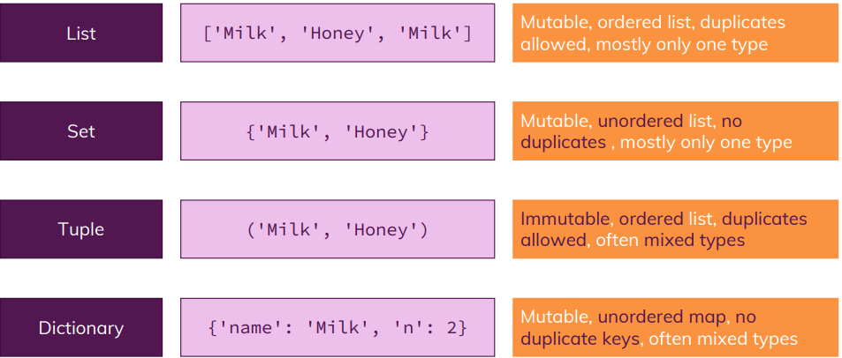

LISTS
- List is a data structure that holds an ordered collection of elements.
- List can have element of different data types
- Unlike String - Lists are mutable, which means we can change their content.
CREATING A LIST  fruits = ["apple", "banana", "orange", "grape"] |  |  | ACCESSING ELEMENTS  print(fruits[0]) # Output: "apple"  print(fruits[2]) # Output: "orange"
MODIFYING ELEMENTS  fruits[1] = "mango"  print(fruits) # Output: ["apple", "mango", "orange", "grape"] |  |  | ADDING ELEMENTS  fruits.append("kiwi")  print(fruits) # Output: ["apple", "mango", "orange", "grape", "kiwi"]
REMOVING ELEMENTS - This remove the first occurrence of the element in the list  fruits.remove("orange")  print(fruits) # Output: ["apple", "mango", "grape", "kiwi"]  REMOVE THE LAST ELEMENT FROM THE LIST  print(fruits.pop()) #grape  REMOVES THE SPECIFIC INDEX ELEMENT FROM THE LIST  fruits = ["apple", "banana", "orange", "grape"]  poped_element = fruits.pop(2)  print(poped_element) #orange  LIST OF LIST  fruits = [[1,"apple"], [2,"banana"], [3,"orange"], [4,"grape"]]  REMOVE ELEMENT : fruits.remove([3,"orange"])  though it will give an error  fruits.remove([“orange"]) ERROR  REMOVES THE SPECIFIC INDEX ELEMENT FROM THE LIST  fruits = ["apple", "banana", "orange", "grape"]  poped_element = fruits.pop(-1)  print(poped_element) # grape |  |  | CHECKING IF AN ELEMENT EXISTS  print("banana" in fruits) # Output: True
INDEX OF AN ELEMENT IN THE LIST
cars = ["Ford","Honda","Mercedes",'BMW']
cars.index("Honda")
- To find the element the search begins from beginning of the list, till the element is not found
- if we look for an index of an element not in the list – it gives an exception
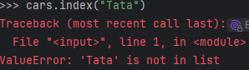
# Length of the list
print(len(fruits)) # Output: 4
ITERATING OVER A LIST
for fruit in fruits:
print(fruit)
LAST VALUE IN LIST
blocklist = [1,2,3]
blocklist[1] 3
INSERTION IN LIST
Inserts the element in at the specified Index
num_list = [1, 2, 3, 4, 5, 6, 7]
num_list.insert(3,9)
OUTPUT -[1, 2, 3, 9, 4, 5, 6, 7]
SLICING  - fruits=['apple', 'mango', 'orange']  - fruits[1:] ['mango', 'orange']  - fruits[1:2] ['mango']  - fruits[:2]) ['apple', 'mango'] |  | - fruits[:] ['apple', 'mango', 'orange']  - fruits[-2:] ['mango', 'orange']  Start counting from end and the print everything till end  - fruits[:-2] [‘apple’]-  Start counting from end and the print everything from beginning
nums = [1, 2, 3, 4, 5]
- print(nums[1:4]) # Output: [2, 3, 4]
- print(nums[1:]) # Output: [2, 3, 4, 5]
- print(nums[:3]) # Output: [1, 2, 3]
- print(nums[-2:]) # Output: [4, 5]
- print(nums[::2]) # Output: [1, 3, 5] Step size of 2
- print(nums[::-2]) # Output: [5, 3, 1] Negative Step Size will print the list backward
CONCATENATION
fruits=['apple', 'mango', 'orange'];
dryFruits =['almond','peanuts']
print(fruits+dryFruits) #['apple', 'mango', 'orange', 'almond', 'peanuts']
SORT  mylist = ['d','f','a','x','b']  mylist.sort() -- > ['a', 'b', 'd', 'f', 'x'] |  |  | REVERSE  mylist = ['a', 'b', 'd', 'f', 'x']  mylist.reverse()  ['x', 'f', 'd', 'b', 'a']
The sort() and reverse() does not return anything(return “None”) but sort / reverse the actual list
extend()
num_list =[1,2,3,4]  num_list.append([5,6,7])  print(num_list)  OUTPUT : [1, 2, 3, 4, [5, 6, 7]] | num_list =[1,2,3,4]  num_list.extend([5,6,7])  print(num_list)  OUTPUT : [1, 2, 3, 4, 5, 6, 7]
- The append() method adds the entire [5, 6, 7] list as a single element to the end of the num_list. So, the resulting list contains [1, 2, 3, 4, [5, 6, 7]].
- The extend() method adds each element of the [5, 6, 7] list individually to the end of the num_list. This results in the list being extended with the elements [5, 6, 7], resulting in [1, 2, 3, 4, 5, 6, 7].

LIST COMPREHENSION
- List comprehension is a concise way to create lists from an existing list. It allows us to generate a new list by applying an expression to each element of an existing iterable (such as a list, tuple, or string), along with optional filtering conditions. List comprehensions provide a more readable and compact alternative to using traditional loops.
SYNTAX | new_list = [expression for item in iterable if condition]  Example :  new_list = [number for number in range(1,10) if number%2 ==0]  print(new_list)  - expression: The expression that is applied to each item in the iterable to generate the new list. .  - item: The variable that represents each item in the iterable.  - iterable: The existing iterable from which the items are taken.  - condition (optional): A condition that filters the items. Only the items for which the condition evaluates to True are included in the new list.
EXAMPLES
SQUARING NUMBERS FROM 1 TO 5 | numbers = [1, 2, 3, 4, 5]  squared_numbers = [num ** 2 for num in numbers]  print(squared_numbers) # Output: [1, 4, 9, 16, 25]
FILTERING EVEN NUMBERS FROM A LIST | numbers = [1, 2, 3, 4, 5]  even_numbers = [num for num in numbers if num % 2 == 0]  print(even_numbers) # Output: [2, 4
EXTRACTING VOWELS FROM A STRING | text = "Hello, World!"  vowels = [char for char in text if char.lower() in 'aeiou']  print(vowels) # Output: ['e', 'o', 'o']
Use List Comprehension to create a list of the first letters of every word in the string below: | st = 'Create a list of the first letters of every word in this string'  words = [ letter for letter in st.split()]  firstLetterWord = [chars[0] for chars in words]  print(firstLetterWord)
Use a List Comprehension to create a list of all numbers between 1 and 50 that are divisible by 3. | numberDivisibleBy3= [num for num in range(1,51) if num %3 ==0 ]  print(numberDivisibleBy3)
PRINT THE WORDS WHICH HAS LESS THAN 3 LETTERS
def clean_text(text):
return text.replace(".","").lower()
my_text = "i am avishekh. i live in india. i am a software engineer."
sanitized = [clean_text(text) for text in my_text.split(" ") if len(clean_text(text)) < 3]
print(sanitized)
Friends attended as guest
friends = ["Alice", "Bob", "Charlie", "David"]
guests = ["Eve", "Frank", "Grace", "Alice", "bob"]

friends_lower = [friend.lower() for friend in friends]
present_friends = [guest.title() for guest in guests if guest.lower() in friends_lower]

print(present_friends)

DICTIONARIES
- Dictionary is a collection of key-value pairs that are unordered (cannot be sorted) and changeable.
- We cannot have duplicate keys in the dictionary. In case of duplicate key – When duplicate keys are present, the last assignment is the one that is retained.
person={
"name": "Alice",
"age": 30,
"city": "New York",
"name": "Bob"
}

print(person)# The output will show that the name is "Bob" because dictionary keys must be unique.
# When duplicate keys are present, the last assignment is the one that is retained.
OUTPUT = {'name': 'Bob', 'age': 30, 'city': 'New York'}

- Dictionary keeps the order in which it the elements has been added
CREATING DICTIONARY  Creating Empty Dictionary  - empty_dic= dict()  - empty_dic= {} | person = {  "name": "John",  "age": 30,  "city": "New York"  }  In dictionaries, keys can be of types like strings and integers, but keep in mind that they can also be any other hashable types, such as tuples.
ACCESSING VALUES  person["name"] or person.get(“name”)  print(person["age"]) or person.get(“age”) | Output: "John"  Output: 30
MODIFYING VALUES  person["age"] = 32  print(person) | Output: {'name': 'John', 'age': 32, 'city': 'New York'}
ADDING NEW KEY-VALUE PAIRS  person["occupation"] = "Engineer"  print(person) | Output: {'name': 'John', 'age': 32, 'city': 'New York', 'occupation': 'Engineer'}
REMOVING KEY-VALUE PAIRS  del person["city"]  print(person) | Output: {'name': 'John', 'age': 32, 'occupation': 'Engineer'}
CHECKING IF A KEY EXISTS  print("age" in person) | Output: True
LENGTH OF THE DICTIONARY  print(len(person)) # | Output: 3
ITERATING OVER KEY-VALUE PAIRS  for key, value in person.items():  print(key, value) | PRINT ALL KEYS/ VALUES / KEY AND VALUE AS LIST  print("values",person.values()) output dict_values(['Alex', 27, 'New York'])  print("keys",person.keys()) output : dict_keys(['name', 'age', 'city'])  Keys & values as a list
print(person.items()) # output - dict_items([('name', 'Alex'), ('age', 27), ('city', 'New York')])
for key, value in person.items():
print(key, value)
- The person.items() method returns a view object that contains the key-value pairs of the dictionary person.
- Each key-value pair is represented as a tuple
NOTE:  ITERATE OVER THE KEYS  When we iterate using below “for” – we are iterating over keys of dictionary |  | my_dict = {"key1": "value1", "key2": "value2", "key3": "value3"}  for key in my_dict:  print(key)
ITERATE OVER THE VALUES |  | for value in my_dict.values():  print(value)
ITERATE OVER BOTH KEYS AND VALUES |  | for key, value in my_dict.items():  print(key, value)  Note – my_dict.items() return the dictionary items as a list of tuples  print(my_dict.items())  # Outputs: dict_items([('key1', 'value1'), ('key2', 'value2'), ('key3', 'value3')])
BEST WAY TO STORE LIST OF SIMILAR TYPE |  | friends = (  {"name": "Alice", "age": 30},  {"name": "Bob", "age": 25},  {"name": "Charlie", "age": 35},  )  alice = f"Name: {friends[0]['name']}, Age: {friends[0]['age']}"  print(alice)

dict() function
- The `dict()` function is a built-in function used to create a dictionary object. It can be called with various arguments to create dictionaries in different ways.
CREATING AN EMPTY DICTIONARY  - Both statements create an empty dictionary with no key-value pairs. | empty_dict = dict()  # or  empty_dict = {}
CREATING A DICTIONARY FROM KEY-VALUE PAIRS: | student = dict(name="John", age=18, grade="A")  O/p {'name': 'John', 'age': 18, 'grade': 'A'}  - The `dict()` function is used to create a dictionary called `student` with three key-value pairs.  - Each keyword argument inside the `dict()` function represents a key-value pair.
CREATING A DICTIONARY FROM ITERABLE OBJECTS: | fruits = dict([('apple', 3), ('banana', 5), ('orange', 2)])  o/p : {'apple': 3, 'banana': 5, 'orange': 2}  - `dict()` function is called with a list of tuples as its argument.  - Each tuple contains a key-value pair. The `dict()` function then creates a dictionary named `fruits` based on these pairs.
CREATING A DICTIONARY USING zip() | keys = ['name', 'age', 'city']  values = ['Alice', 25, 'New York']  person = dict(zip(keys, values))  O/P {'name': 'Alice', 'age': 25, 'city': 'New York'}  - The `zip()` function is used to combine the `keys` and `values` lists into a single iterable, and then the `dict()` function is called to create a dictionary named `person` with the corresponding key-value pairs.

defaultdict() function
- defaultdict is a subclass of the built-in dict class from the collections module. It provides a default value for a nonexistent key, which avoids KeyError.
Example 1: Using int as default factory | Example 2: Using list as default factory
from collections import defaultdict  # Creates a defaultdict with int (default value 0)  count = defaultdict(int)  words = ['apple', 'banana', 'apple', 'orange', 'banana', 'apple']  for word in words:  count[word] += 1  print(count)  Output:  defaultdict(<class 'int'>, {'apple': 3, 'banana': 2, 'orange': 1}) | from collections import defaultdict  # Grouping values by keys  grouped = defaultdict(list)  pairs = [('a', 1), ('b', 2), ('a', 3), ('b', 4), ('c', 5)]  for key, value in pairs:  grouped[key].append(value)  print(grouped)  Output:  defaultdict(<class 'list'>, {'a': [1, 3], 'b': [2, 4], 'c': [5]})
Why use defaultdict?
- Avoids writing extra code to check if a key exists.
- Cleaner and more readable than using dict.setdefault() or if key in dict.

UNPACKING DICTIONARY
- Dictionary unpacking in Python allows us to unpack the key-value pairs of a dictionary into variables or use them directly as arguments in a function. It is performed using the ** operator.
UNPACKING INTO VARIABLES - Unpack a dictionary into individual variables.  my_dict = {"name": "Alice", "age": 25}  name, age = my_dict.values()  print(name) # Output: Alice  print(age) # Output: 25 | UNPACKING IN FUNCTION CALLS - Unpack dictionary unpacking to pass key-value pairs as arguments to a function.  def greet(name, age):  return f"Hello, {name}! You are {age} years old."  person = {"name": "Alice", "age": 25}  print(greet(**person)) # Output: Hello, Alice! You are 25 years old.
MERGING DICTIONARIES - Unpack multiple dictionaries to merge them.  dict1 = {"a": 1, "b": 2}  dict2 = {"b": 3, "c": 4}  merged = {**dict1, **dict2} # Dict2 values will override dict1 if keys overlap  print(merged) # Output: {'a': 1, 'b': 3, 'c': 4} | USING UNPACKING IN LOOPS - Unpacking within loops to work with keys and values directly.  my_dict = {"x": 10, "y": 20}  for key, value in my_dict.items():  print(f"{key} = {value}")  # Output:  # x = 10  # y = 20

ITERATING DICTIONARY

# Dictionary of a student with some sample data  student = {  "name": "Alice",  "age": 20,  }  # Loop through the keys of the student dictionary  for s in student:  print(s)  # Loop through the values of the student dictionary  for s in student.values():  print(s)  # Loop through the key-value pairs of the student dictionary  for name, age in student.items():  print(f"student key: {name}, student value: {age}") | name  age  ======  Alice  20  ======  student key: name, student value: Alice  student key: age, student value: 20

TUPLES
- A tuple is an immutable collection of ordered elements. Hence, we cannot add or remove element in the tuple
- It is like a list, but unlike lists, tuples cannot be modified once created. i.e. element cannot be added or removed from tuple
- Tuples are created using parentheses () or the tuple() constructor.
- The orders matter for tuple – (1,2) == (2,1) False
CREATING A TUPLE  Empty Tuple – empty= () or empty= tuple()  fruits = ("apple", "banana", "orange", "grape")  friend = “Alex”, this also will be treated as tuple  my_tuple = 1,2  print(type(my_tuple)) <class 'tuple'>  TUPLE INSIDE LIST  tuple_in_list = [("Alice", 30), ("Bob", 25), ("Charlie", 35)] | ACCESSING ELEMENTS  print(fruits[0]) # Output: "apple"  print(fruits[2]) # Output: "orange"
RETURNING MULTIPLE VALUES AS TUPLE
def return_tuple():
return 1, 2, 3
print(type(return_tuple())) <class 'tuple'>
a, b, c = return_tuple()
print(a, b, c) # Output: 1 2 3
CANNOT MODIFY OR ADD ELEMENTS IN TUPLE(IMMUTABLE)
fruits[1] = "mango" # Raises TypeError
my_tuple=(1,2)
my_tuple.append(3) # This will raise an AttributeError since tuples do not have an append method
NOTE : Once tuple is declared – we cannot add /modify any value in tuple
WORK AROUND TO ADD IN TUPLE  my_tuple = ("Rob", "Alice")  my_tuple = my_tuple + ("Bob",)  print(my_tuple) # Output: ('Rob', 'Alice', 'Bob') | tuple1 = (1, 2, 3, 4, 5)  tuple2 = ('a', 'b', 'c', 'd')  mixed_tuple = tuple1 + tuple2  Mixed Tuple: (1, 2, 3, 4, 5, 'a', 'b', 'c', 'd')
# Iterating over a tuple  for fruit in fruits:  print(fruit) | INDEX OF AN ELEMENT IN TUPLE  letters = ('a','b','c','d')  print(letters.index('c')) #output 2
TUPLE PACKING AND UNPACKING  name = "John"  age = 30  person = (name, age)  print(person) # Output: ("John", 30)  ## UNPACKING  name, age = person  print(name) # Output: "John"  print(age) # Output: 30 | NUMBER OF TIMES AN ELEMENT IN A TUPLE  letters = ('a','a','c','d')  print(letters.count('a')) #output 2
INDEXING IN TUPLE
- In a tuple individual elements can be accessed by using their index.
- We can use positive or negative indices. Positive indices count from the beginning of the tuple, while negative indices count from the end.
my_tuple = ("apple", "banana", "cherry", "date")
print(my_tuple[0]) # Output: apple
print(my_tuple[2]) # Output: cherry
print(my_tuple[-1]) # Output: date
SLICING:
- Slicing is done using the colon (:) operator. The slice notation is start:end:step, where start is the starting index, end is the ending index (exclusive), and step is the step size between elements.
my_tuple = ("apple", "banana", "cherry", "date")
print(my_tuple[1:3]) # Output: ('banana', 'cherry')
print(my_tuple[:2]) # Output: ('apple', 'banana')
print(my_tuple[1:]) # Output: ('banana', 'cherry', 'date')
print(my_tuple[::2]) # Output: ('apple', 'cherry')
LENGTH OF THE TUPLE
print(len(fruits)) # Output: 4
- There is a difference between a tuple with a single element and a tuple without the comma.
- my_tuple = ("apple",): This is a tuple with a single element. The trailing comma after "apple" distinguishes it from a regular string. The comma is necessary to indicate that it is a tuple with one element. Without the comma, it would be treated as a string.  - my_tuple = ("apple"): This is not a tuple but a string. Parentheses alone do not make it a tuple. In this case, "apple" is treated as a string literal. | my_tuple = ("apple",)  print(type(my_tuple)) # Output: <class 'tuple'>  my_tuple = ("apple")  print(type(my_tuple)) # Output: <class 'str'>

SETS
- Set is an unordered collection. i.e. if we add element to set – it will be added at random location within the set. Hence the element of set cannot be fetched using index.
- Set always has unique elements.
- Sets are created using the set() function or by enclosing a comma-separated sequence of elements within curly braces {}.
CREATING A SET | my_set = set() # Empty set  my_set = {1, 2, 3} # Set with elements 1, 2, and 3
CREATING SET USING ITERABLE | myset_list= set([1, 2, 3, 4, 5]) # Output: {1, 2, 3, 4, 5}  my_set_tuple = set((1, 2, 3, 4, 5)) # Output: {1, 2, 3, 4, 5}
ADDING ELEMENTS TO A SET: | my_set.add(4) # Adds element 4 to the set  my_set.update([5, 6, 7]) # Adds multiple elements to the set
REMOVING ELEMENTS FROM A SET: | my_set.remove(3) # Removes element 3 from the set  my_set.discard(4) # Removes element 4 if it exists, otherwise does nothing  my_set.pop() # Removes and returns an arbitrary element from the set  my_set.clear() # Removes all the element from the set
SET OPERATIONS: | set1 = {1, 2, 3}  set2 = {3, 4, 5}  set3 = {6, 7, 8}  RETURNS A SET CONTAINING ALL ELEMENTS FROM BOTH SETS  union_set = set1.union(set2) {1,2,3,4,5}  union_set = set1.union(set2,set3) {1,2,3,4,5,6,7,8}  # RETURNS A SET CONTAINING COMMON ELEMENTS FROM BOTH SETS  intersection_set = set1.intersection(set2) {3}  # RETURNS A SET CONTAINING ELEMENTS PRESENT IN SET1 BUT NOT IN SET2  difference_set = set1.difference(set2) {1,2}  # RETURNS A SET CONTAINING ELEMENTS PRESENT IN EITHER SET1 OR SET2, BUT NOT IN BOTH  symmetric_difference_set = set1.symmetric_difference(set2) {1,2,4,5}  SUBSET  s1 =set({1,2,3,4,5})  s2 =set({1,2})  s2.issubset(s1) True  s1.issuperset(s2) True
OTHER USEFUL METHODS: | len(my_set) # Returns the number of elements in the set  element in my_set # Checks if an element is present in the set  my_set.clear() # Removes all elements from the set .
EXISTENCE OF ELEMENT IN SET | my_set = {1, 2, 3, 4, 5}  print(1 in my_set) # Output: True  print(9 in my_set) # Output: False
SET FOR STRINGS | - The set() function can be used to create a set from an iterable object, such as a string.  - When we pass a string to the set() function, it treats the string as an iterable sequence of characters and creates a set containing all the unique characters from the string.  my_set = set('Parallel')  print(my_set) #output {'P', 'a', 'r', 'l', 'e'}  - Note that sets are unordered collections, so the order of the elements in the set may not match the original order of the characters in the string.  - Additionally, since sets only contain unique elements, any duplicate characters in the string will be removed in the resulting set.

SET AND LIST

The order in the set does not matter , but it matters for a list | List : [1,2]== [2,1] False  Set : {1,2} == {2,1} True  Set : {1,2} == {1,1,2,1} True
CREATING A SET OF UNIQUE ELEMENT FROM LIST OF REPEATED ELEMENTS | my_list = ['a', 'b', 'b','c','c', 'd']  unique_list = list(set(my_list))

SET AND DICTIONARY COMPREHENSION
- Both sets and dictionaries support comprehensions, which are concise ways to create these data structures from an iterable or based on certain conditions. Comprehensions allow you to create sets or dictionaries in a single line of code.

SET COMPREHENSION

- Set comprehensions are written using curly braces {}.  - SYNTAX  {expression for item in iterable if condition} | squares = {num**2 for num in range(1, 6)}  print(squares) # Output: {1, 4, 9, 16, 25}
FRIENDS ATTENDED AS GUEST
friends = ["Alice", "Bob", "Charlie", "David"]
guests = ["Eve", "Frank", "Grace", "Alice", "bob"]

friends_lower = {friend.lower() for friend in friends}
guests_lower = {guest.lower() for guest in guests}

present_friends = {
present_friend.title()
for present_friend in friends_lower.intersection(guests_lower)
}
print(present_friends)

DICTIONARY COMPREHENSION

- Dictionary comprehensions are written using curly braces {} with key-value pairs separated by a colon `:`.
SYNTAX: {key_expression: value_expression for item in iterable if condition}
EXAMPLE - 1
squares_dict = {num: num**2 for num in range(1, 6)}
print(squares_dict) # Output: {1: 1, 2: 4, 3: 9, 4: 16, 5: 25}
EXAMPLE – 2
employee =['John', 'Jane', 'Doe', 'Doy']
jobs = ['Manager', 'Supervisor', 'Clerk', 'Driver']
emp_dict = {employee[num] : jobs[num] for num in range(len(employee))}
print(emp_dict)
OUTPUT - {'John': 'Manager', 'Jane': 'Supervisor', 'Doe': 'Clerk', 'Doy': 'Driver'}
EXAMPLE 3
animalList = [('a','ant'), ('b', 'bear'), ('c', 'cat'), ('d', 'dog')]
animalList_dict = {key : value for key,value in animalList} {'a': 'ant', 'b': 'bear', 'c': 'cat', 'd': 'dog'}
animalList = [('a','ant'), ('b', 'bear'), ('c', 'cat'), ('d', 'dog')]
animalList_dict = {key : value for key,value in animalList}
print(animalList_dict.items()) # Output: [('a', 'ant'), ('b', 'bear'), ('c', 'cat'), ('d', 'dog')]
print(list(animalList_dict.items())) # Output: [('a', 'ant'), ('b', 'bear'), ('c', 'cat'), ('d', 'dog')]
stuctured_animals = [{"animalkey": key ,"animalvalue": value} for key, value in animalList]
print(stuctured_animals) # Output: [{'animalkey': 'a', 'animalvalue': 'ant'}, {'animalkey': 'b', 'animalvalue': 'bear'}, {'animalkey': 'c', 'animalvalue': 'cat'}, {'animalkey': 'd', 'animalvalue': 'dog'}]

ZIP FUNCTION
- The `zip()` function is a built-in function that takes multiple iterables as arguments and returns an iterator of tuples. Each tuple contains elements from the input iterables, paired together based on their positions.
SYNTAX - zip(*iterables)
- The `zip()` function can take any number of iterables as arguments. It returns an iterator that generates tuples containing elements from the corresponding positions of the input iterables. The length of the resulting iterator is determined by the shortest input iterable.

names = ["Alice", "Bob", "Charlie"]  ages = [25, 30, 35]  cities = ["New York", "London", "Paris"]  zipped = zip(names, ages, cities)  for item in zipped:  print(item)  OUTPUT  ('Alice', 25, 'New York')  ('Bob', 30, 'London')  ('Charlie', 35, 'Paris')  list(zipped):  [('Alice', 25, 'New York'), ('Bob', 30, 'London'), ('Charlie', 35, 'Paris')] | - In this example, we have three lists: `names`, `ages`, and `cities`. We use the `zip()` function to combine these lists into a single iterator of tuples.  - Each tuple contains corresponding elements from the input lists based on their positions. The resulting iterator is stored in the variable `zipped`.  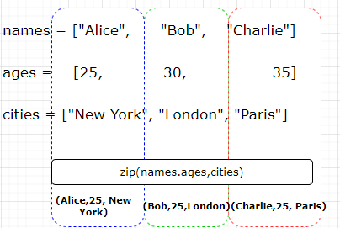
- Note: that the `zip()` function stops iterating as soon as the shortest input iterable is exhausted.  - In this example, if one of the lists (names)had fewer elements than the others, the resulting iterator would only contain tuples up to the length of the shortest list. | names = ["Alice", "Bob"]  ages = [25, 30, 35]  cities = ["New York", "London", "Paris"]  zipped = zip(names, ages, cities)  for item in zipped:  print(item)  OUTPUT :  ('Alice', 25, 'New York')  ('Bob', 30, 'London')
names = [  {"name": "Alice", "age": 25},  {"name": "Bob", "age": 35},  {"name": "Charlie", "age": 45},  ]  ages = [25, 30, 35]  cities = ["New York", "London", "Paris"]  zipped = zip(names, ages, cities)  for item in zipped:  print(item) | OUTPUT  ({'name': 'Alice', 'age': 25}, 25, 'New York')  ({'name': 'Bob', 'age': 35}, 30, 'London')  ({'name': 'Charlie', 'age': 45}, 35, 'Paris')
- The `zip()` function is commonly used when we need to process multiple iterables simultaneously, such as combining data from different sources or performing parallel iteration over multiple sequences.

ENUMERATE

- enumerate() function is a built-in function that allows us to loop over an iterable (e.g., list, tuple, string) while also keeping track of the index of each item.
- It returns an enumerate object, which can be converted to a list of tuples or used directly in a loop.
- 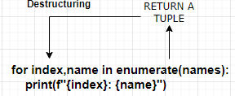
IMPORTANT
fruits = ['apple', 'banana', 'orange']
list(enumerate(fruits)) List of tuple [(0, 'apple'), (1, 'banana'), (2, 'orange')]
EXAMPLE  fruits = ['apple', 'banana', 'orange']  # Using enumerate in a loop  for index, fruit in enumerate(fruits):  print(index, fruit)  Output:  0 apple  1 banana  2 orange | - enumerate(fruits)` returns an enumerate object that yields tuples containing the index and value of each item in the `fruits` list.  - The `for` loop iterates over the enumerate object.  - In each iteration, the `index` variable receives the index of the current item, and the `fruit` variable receives the value of the current item.  - Note that the index starts from 0 by default, but we can specify a different starting index by passing a second argument to `enumerate()`. For example, `enumerate(fruits, start=1)` will start the index from 1 instead of 0.
# List: Mutable, ordered collection  my_list = ["apple", "banana", "cherry"]  for index, item in enumerate(my_list):  print(f"List item {index}: {item}") |  | List item 0: apple  List item 1: banana  List item 2: cherry
# Tuple: Immutable, ordered collection  my_tuple = ("red", "green", "blue")  for index, color in enumerate(my_tuple):  print(f"Tuple item {index}: {color}") |  | Tuple item 0: red  Tuple item 1: green  Tuple item 2: blue
# String: Immutable sequence of characters  my_string = "hello"  for index, char in enumerate(my_string):  print(f"String character {index}: {char}") |  | String character 0: h  String character 1: e  String character 2: l  String character 3: l  String character 4: o
# Dictionary: Key-value pairs  my_dict = {'name': 'Avishekh', 'role': 'Engineer', 'location': 'Noida'}  for index, (key, value) in enumerate(my_dict.items()):  print(f"Dictionary item {index}: {key} = {value}") |  | Dictionary item 0: name = Avishekh  Dictionary item 1: role = Engineer  Dictionary item 2: location = Noida
START THE GIVEN INDEX  employee = ["John", "Jane", "Doe", "Doy"]  jobs = ["Manager", "Supervisor", "Clerk", "Driver"]  for emp in enumerate(employee, start=1):  print(f"Employee {emp[0]}: {emp[1]}") |  | (1, 'John')  (2, 'Jane')  (3, 'Doe')  (4, 'Doy')
employee = ["John", "Jane", "Doe", "Doy"]  # Print a list of tuples with index and employee name  print(list(enumerate(employee)))  # Print a dictionary mapping index to employee name  print(dict(enumerate(jobs))) |  | [(0, 'John'), (1, 'Jane'), (2, 'Doe'), (3, 'Doy')]  {0: 'John', 1: 'Jane', 2: 'Doe', 3: 'Doy'}

QUEUE
- Queue are not fundamental data type in python
""" A Queue of Groceries to Put Away """

# create a new queue object
import queue
q = queue.Queue()
print(q.empty())

# put bags into the queue
q.put('bag1')
print(q.empty())
q.put('bag2')
q.put('bag3')

# get bags from the queue in FIFO order
print(q.get())
print(q.get())
print(q.get())
# q.get() # causes an error; use CTRL+C to

# create a new queue to hold two items
q2 = queue.Queue(maxsize=2)
print(q2.empty())

# put two bags into the two-item queue
q2.put('bag1')
print(q2.full())
q2.put('bag2')
print(q2.full())

# try to put an extra bag into the queue
q2.put_nowait('bag3') # causes an error

STACK

VARIABLE SCOPE
- The `global` keyword is used to indicate that a variable inside a function should be treated as a global variable, rather than a local variable.
- When we use the `global` keyword before a variable assignment inside a function, it tells Python that we want to modify the value of a global variable, instead of creating a new local variable with the same name.
global_var = 10  def my_function():  global global_var  global_var = 20  print(global_var)  my_function() # Output: 20  print(global_var) # Output: 20 | - The `global` keyword is used inside the `my_function` to indicate that `global_var` refers to the global variable, not a local variable.  - Thus, the assignment `global_var = 20` modifies the value of the global variable, and both the function and the outside code see the updated value.

DESTRUCTURING
- Documentation : https://blog.teclado.com/destructuring-in-python/

STANDARD DESTRUCTURING ASSIGNMENTS

Python, like many programming languages, allows us to assign more than one variable at a time on a single line. We just have to provide the same number of values on both sides of the assignment. For example:
x, y = 5, 11 Tuple Destructuring
Here we assign the value 5 to x, and 11 to y. The values are assigned entirely based on order, so if we switch the variable order, or the order of the values we intend to assign, we will end up with different results.
If we try to destructure a collection with more or fewer values than we provide variables, we end up with a ValueError.

DESTRUCTURING DICTIONARIES IN PYTHON

my_dict = {"name": "Bob", "age": 25}  x, y = my_dict | x = "name" and y = "age".  That's because by default when we use a dictionary as an unidimensional collection (such as a list or tuple), what we get back are the keys. It's the same if you call list(my_dict), you get back ["name", "age"].
If you wanted to destructure the dictionary values only  my_dict = {"name": "Bob", "age": 25}  x, y = my_dict.values() # "Bob", 25 | x = "Bob" and y = "25".

DESTRUCTURING IN FOR LOOPS

example_list = ["A", "B", "C"]
for counter, letter in enumerate(example_list):
print(counter, letter)
# 0 A
# 1 B
# 2 C
LIST OF TUPLE
people = [
("Bob", 42, "Mechanic"),
("James", 24, "Artist"),
("Harry", 32, "Lecturer")
]
for name, age, profession in people:
print(f"Name: {name}, Age: {age}, Profession: {profession}")
for person in people:
print(f"Name: {person[0]}, Age: {person[1]}, Profession: {person[2]}")

USING * TO COLLECT VALUES
In Python, we can use the * operator to collect leftover values when performing a destructuring assignment. For example, we might have a list of numbers, and we want to grab the first number, and then assign the remaining numbers to a second variable:
head, *tail = [1, 2, 3, 4, 5]  print(head) # 1  print(tail) # [2, 3, 4, 5] | *head, tail = [1, 2, 3, 4, 5]  print(head) # [1, 2, 3, 4]  print(tail) # 5
head, *middle, tail = [1, 2, 3, 4, 5]  print(head) # 1  print(middle) # [2, 3, 4]  print(tail) # 5 | first, second, third, *rest = [1, 2, 3, 4, 5]

UNDERSCORE VARIABLES
- The underscore (_) variable has several different uses depending on the context. Here are some common use cases:
- Ignoring values: The underscore can be used as a placeholder when we want to ignore a specific value returned by a function or assigned to a variable. It indicates that the value is not of interest and can be safely ignored. | _, y = (1, 2) # Ignoring the first value
- Temporary variable: In interactive Python interpreters or as a convention in code, the underscore can be used as a temporary variable to store the result of the last expression. It can be useful when you want to access the result later or perform further operations on it. For example: | result = 2 + 3  print(_) # Prints the result of the last expression (5)
- Localization: In some contexts, the underscore is used as a convention for localization and internationalization. It is used to mark strings that need to be translated into different languages. | message = _('Hello, world!')
- "Private" variables: Although not enforced by the language itself, a single leading underscore is often used as a convention to indicate that a variable or method is intended for internal use within a class or module. It suggests that the variable or method should not be accessed directly from outside the class or module.

- It's worth noting that the double leading underscores (e.g., `__variable`) have a different meaning in Python. They trigger name mangling, where the variable name is modified to avoid conflicts in subclasses. This is often used for "private" variables in the context of class inheritance. .

COMMENTS AND DOCSTRING
- Comments and docstrings are used to provide explanations, document code, and make it more readable. While both serve a similar purpose, they have different formats and use cases.
COMMENTS

Comments start with the `#` symbol and continue until the end of the line. | # This is a comment explaining the purpose of the following code  x = 10 # This is a comment explaining the value of x

DOCSTRINGS
- Docstrings, short for "documentation strings," are used to provide documentation for functions, classes, or modules. They are enclosed in triple quotes (`"""` or `'''`) and are typically placed immediately after the function, class, or module definition.

- Docstrings provide a standardized way to document code and convey information about the purpose, parameters, return values, and usage of functions, classes, or modules. They can be accessed using the `__doc__` attribute of an object.  - To generate well-documented code, it's good practice to include docstrings for all public functions, classes, and modules.  - Tools like Sphinx can automatically generate documentation based on docstrings. | def greet(name):  """  A function that takes a name as input and prints a greeting message.  Parameters:  name (str): The name of the person to greet.  Returns:  None  """  print(f"Hello, {name}!")  greet("Alice")

STATEMENTS

IF-ELSE

height = int(input("What's your Height? "))  if height > 120:  print("Can ride the Rollercoaster")  else:  print("Can't ride the Rollercoaster") | - Indentation of if / else block is important.  - “:” character after the if and else .
num = int(input("Enter a number: "))  if num % 2 == 0:  print("Even")  else:  print("Odd") | - Remainder Operator

bool()
- The `bool` type represents Boolean values, which can be either `True` or `False`. When used in an `if` statement, the `bool` type is automatically evaluated to determine the condition of the `if` statement.
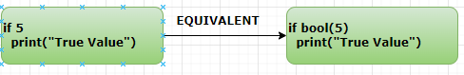
- When a value/ variable is passed to if condition, python evaluates the value by passing it bool()

- False  - None  - 0 (integer)  - 0.0 (float)  - "" (empty string)  - [] (empty list)  - {} (empty dictionary)  - () (empty tuple)  - set() (empty set) | - The following values are considered `False` when converted to `bool`, and all other values are considered `True`:  - Any other non-zero numbers, non-empty strings, and non-empty containers are considered `True` when converted to `bool`. Therefore, when using `bool` in an `if` statement, the condition is evaluated based on whether the expression evaluates to `True` or `False`.

NESTED IF-ELSE

height = int(input("What's your Height? "))
if height > 120:
print("Can ride the Rollercoaster")
age = int(input("Enter your age: "))
if age < 18:
print("Please pay $7")
else:
print("Please pay $12")
else:
print("Can't ride the Rollercoaster")

ELIF

height = int(input("What's your Height? "))

if height > 120:
print("Can ride the Rollercoaster")
age = int(input("Enter your age: "))
if age < 12:
print("Please pay $5")
elif age <= 18:
print("Please pay $7")
else:
print("Please pay $12")
else:
print("Can't ride the Rollercoaster")

is KEYWORD
"is" keywork is used for identity comparison, which checks if two objects refer to the same memory location.
- In this example, both x and y are assigned the value 5. Since integers are immutable objects in Python, the interpreter reuses the memory location for the integer value 5. Therefore, "x is y" evaluates to True, indicating that x and y refer to the same memory location.  - It's important to note that "is" compares the identity of the objects, not their values. If you want to compare the values of objects, we should use the "==" operator instead. | x = 5  y = 5  if x is y:  print("x and y refer to the same object")

Is VERSUS ==
In the context of lists in Python, the "==" operator and the "is" keyword are used for different types of comparisons:

- "==" operator: It is used for comparing the values of two lists element by element. It checks whether the elements in two lists are equal in both value and order  - In example - the "==" operator compares the values of each element in list1 and list2. Since the elements are the same in both lists, and the order is also the same, the condition is true | list1 = [1, 2, 3]  list2 = [1, 2, 3]  if list1 == list2:  print("list1 and list2 are equal")
- The "is" keyword checks if list1 and list2 are referencing the same list object in memory. Since list2 is assigned to the same list as list1, the condition is true. | list1 = [1, 2, 3]  list2 = list1  list3 = [1, 2, 3]  print(list1 is list2) True  print(list1 is list3) False

It's important to note that the "==" operator compares the values of the elements in the lists, while the "is" keyword compares the identity of the list objects in memory. In most cases, when comparing lists for equality, you would use the "==" operator. However, if you specifically want to check if two list objects are the same object in memory, you would use the "is" keyword.

in KEYWORD
- The "in" keyword is used to check if a specified value exists in a sequence, such as a list, tuple, string, or dictionary. It returns a boolean value indicating whether the value is present or not.
fruits = ['apple', 'banana', 'orange']  if 'banana' in fruits:  print("banana is present in the list") | message = "Hello, world!"  if 'world' in message:  print("The word 'world' is present in the message")

LOOPS

FOR LOOP
- for loop is used to iterate over a sequence or other iterable objects, such as lists, strings, or tuples.
ITERATING OVER A LIST | fruits = ["apple", "banana", "cherry"]  for fruit in fruits:  print(fruit)
ITERATING OVER A STRING | message = "Hello, World!"  for char in message:  print(char)
ITERATING OVER A RANGE OF NUMBERS: | for i in range(1, 6):  print(i)
SKIPPING ITERATIONS WITH CONTINUE: | numbers = [1, 2, 3, 4, 5]  for num in numbers:  if num == 3:  continue  print(num)
LIST COMPREHENSION | nums = [1,2,3,4,5,6,7,8,9,10]  [num for num in nums if num %2 ==0]  OUTPUT : [2, 4, 6, 8, 10]
TERMINATING THE LOOP WITH BREAK: | numbers = [1, 2, 3, 4, 5]  for num in numbers:  if num == 3:  break  print(num)
TUPLE UNPACKING | mylist = [(1,2),(3,4),(5,6)]  for value1, value2 in mylist:  print("value 1 ={} and value2= {}".format(value1, value2 ))  OUTPUT  value 1 =1 and value2= 2  value 1 =3 and value2= 4  value 1 =5 and value2= 6

WHILE LOOP

SIMPLE WHILE | count = 0  while count < 5:  print(count)  count += 1
WHILE WITH BREAK | while True:  num = int(input("Enter a number (0 to exit): "))  if num == 0:  break  print("You entered:", num)
WHILE WITH CONTINUE | count = 0  while count < 5:  count += 1  if count == 3:  continue  print(count)

ELSE IN LOOP
- The `else` keyword can be used in conjunction with a `for` loop to specify a block of code that should be executed after the loop completes, but only if the loop did not encounter a `break` statement.
numbers = [1, 2, 3, 4, 5]  for num in numbers:  if num > 2:  print("Number found!")  break  else:  print("Number not found!") # This will not execute  OUTPUT - Number found | numbers = [1, 2, 3, 4, 5]  for num in numbers:  if num == 6:  print("Number found!")  break  else:  print("Number not found!") # This will execute  OUTPUT - Number not found
- The `else` block in a `for` loop is optional and can be used to specify additional code to be executed after a loop finishes normally. It provides a way to differentiate between the loop completing normally and the loop being terminated early with a `break` statement.

EXAMPLES

Use for, .split(), and if to create a Statement that will print out words that start with 's': | st = 'Print only the words that start with s in this sentence'  for s in st.split() :  if(s.startswith("s")):  print(s)
Go through the string below and if the length of a word is even print "even!" | st = 'Print every word in this sentence that has an even number of letters'  for s in st.split():  if(len(s) %2 == 0):  print(“even”)

SOME USEFUL OPERATORS AND FUNCTIONS

RANGE
- The `range()` function is used to generate a sequence of numbers. It returns an iterable object that represents a sequence of numbers within a specified range.
SYNTAX  range(start, stop, step) | - `start` (optional): The starting value of the sequence. If not specified, the default value is 0.  - `stop`: The stopping value of the sequence (exclusive). The `range()` function will generate numbers up to, but not including, this value.  - `step` (optional): The increment between numbers in the sequence. If not specified, the default value is 1.
EXAMPLES
GENERATING A SEQUENCE FROM 0 TO 4 (EXCLUSIVE): | for i in range(5):  print(i)
GENERATING A SEQUENCE FROM 2 TO 8 (EXCLUSIVE) WITH A STEP OF 2 | for i in range(2, 9, 2):  print(i)
CREATING A LIST OF NUMBERS WITHIN A RANGE | my_list = list(range(1, 6))  print(my_list)

SORT
- The `sort()` function in Python has two optional parameters: `key` and `reverse`.
- It's important to note that the `sort()` function modifies the original list in place and does not return a new sorted list.
`key parameter:  - The `key` parameter allows us to specify a function that will be used to determine the sorting order.  - This function is applied to each element of the list before sorting.  - The `key` function should take an element as input and return a value that will be used for sorting.  - By default, the `key` parameter is `None`, which means the elements are sorted based on their natural order. | fruits = ["apple", "banana", "cherry", "date"]  fruits.sort(key=len)  print(fruits)  # Output: ['date', 'apple', 'cherry', 'banana']  - The `key` parameter is set to the `len` function, which returns the length of each element.  - The list is sorted based on the length of the elements.
reverse` parameter:  - The `reverse` parameter is a boolean value that determines whether the list should be sorted in descending order.  - By default, it is set to `False`, which means the list is sorted in ascending order. If you set `reverse` to `True`, the list will be sorted in descending order. | numbers = [5, 2, 9, 1, 7]  numbers.sort(reverse=True)  print(numbers)  # Output: [9, 7, 5, 2, 1]  In this example, the `reverse` parameter is set to `True`, so the `numbers` list is sorted in descending order, resulting in `[9, 7, 5, 2, 1]`.

FUNCTIONS

FUNCTION SYNTAX | def greet():  print("Hello, world!")  # Call the function  greet()
FUNCTION WITH PARAMETERS | def add_numbers(a, b):  return a + b  # Call the function and store the result in a variable  result = add_numbers(3, 5)  print(result) # Output: 8
FUNCTION WITH KEYWORD ARGUMENT | def print_name(first_name, last_name):  print(f"{first_name},{last_name}")  print_name(last_name='Doe', first_name='John')
INVALID |  | INVALID
Note : if the first argument has name then all subsequent argument should have name as well  def print_name(first_name, last_name):  print(f"{first_name},{last_name}")  print_name(last_name='Doe', 'John') |  | def print_name(first_name, last_name):  print(f"{first_name},{last_name}")  print_name('Doe', last_name= 'John')  But if the first argument don’t have name , subsequent arguments can have names

DEFAULT VALUE OF FUNCTION PARAMETERS

- Default values in function parameters are values that are automatically assigned to the parameters if no argument is provided for them when calling the function.  - This allows functions to be called with fewer arguments, as the default values will be used for any parameters that are not explicitly passed. | def greet(name, greeting="Hello"):  print(greeting + ", " + name + "!")  # Calling the function with only one argument  greet("Alice")  # Output: Hello, Alice!  # Calling the function with two arguments  greet("Bob", "Hi")  # Output: Hi, Bob!
INVALID | INVALID
Note : if the first parameter has a default value then then all subsequent parameter should have default value as well  def add(x=5,y):  return x + y  add(y=2) | def add(x,y=5):  return x + y  add(y=2)  TypeError: add() missing 1 required positional argument: 'x'
DEFAULT VALUE  - When the function my_function is defined, the default value for the parameter param_1 is set to the value of the variable a, which is 10 at that time. This default value is evaluated only once, at the time of function definition.  - Later, the value of the variable a is changed to 20. However, this change does not affect the default value of param_1, as it has already been assigned when the function was defined.  - When my_function() is called without passing any arguments, the default value of param_1 (which is 10) is used and printed. Hence, the result will be 10, regardless of the subsequent change in the value of a. | a = 10  def my_function(param_1=a):  print(param_1)  a = 20  my_function()  In the above example, the result will be 10.
NOTES
- We can't use a function before it is defined. If we try to do so, Python will raise a `NameError` stating that the function name is not defined.
- if we call a function with fewer arguments than the number of parameters in the function definition, Python throws a `TypeError` indicating that the function is missing some required positional arguments.

UNPACKING ARGUMENT

*args

args : argument  - The *args syntax is used when we want to pass a variable number of non-keyword arguments to a function.  - The args parameter is treated as a tuple that holds the additional arguments passed to the function. |  | def sum_numbers(*args):  total = 0  for num in args:  total += num  return total  result = sum_numbers(1, 2, 3, 4, 5)  print(result) # Output: 15
  def multiply(*args):
  print(args) (1, 2, 3)[Tuple]
  multiply(1,2,3)
DESTRUCTURING  num, *args = [1, 2, 3, 4, 5]  print(num) 1  print(args) [2, 3, 4, 5]  num, *middle, last = [1, 2, 3, 4, 5]  print(num) 1  print(middle) [2, 3, 4]  print(last) 5  *args, last = [1, 2, 3, 4, 5]  print(args) [1, 2, 3, 4]  print(last) 5 | DESTRUCTURING  def multiply(a,b):  return a*b  input = [3,4]  multiply(*input)  Passing the *input then get de-structured in function parameters

**kwargs

kwargs :Keyword argument  - The **kwargs syntax is used when we want to pass a variable number of keyword arguments to a function.  - The kwargs parameter is treated as a dictionary that holds the additional arguments passed to the function. |  | def print_person_info(**kwargs):  for key, value in kwargs.items():  print(key + ": " + value)  print_person_info(name="Alice", age="25", city="New York")  OR USING DESTRUCTURING
  def print_person_info(name, age, city):
  print(f"{name} is {age} years old and lives in {city}")
  person = {"name": "Alice", "age": "25", "city": "New York"}
  print_person_info(**person)
COMBINING BOTH  def printData(*args,**kwargs):  print(args)  print(kwargs)  Function Call : print(1,2,3,name='Max', age=25)  OUTPUT  (1, 2, 3) tuple  {'name': 'Max', 'age': 25} Dictionary | - We can mix positional arguments and keyword arguments in a function call, but the positional arguments must come before the keyword arguments.

HIGH ORDER FUNCTION
- A higher-order function is a function that takes one or more functions as arguments and/or returns a function as its result. It treats functions as first-class objects, allowing them to be manipulated and operated upon just like any other data type.
- Example – SEARCH MOVIES BY name or director
movies = [
{"name": "Star Wars", "director": "George Lucas"},
{"name": "The Godfather", "director": "Francis Ford Coppola"},
{"name": "The Matrix", "director": "Wachowski Brothers"},
]
def find_by_category(finder, val):
for movie in movies:
if finder(movie) == val:
return movie

find_by = input("Enter the category you want to search by (name or director): ")
value = input("Enter the value you are searching for: ")
print(find_by_category(lambda movie: movie[find_by], value))

LAMBDA FUNCTIONS, MAP AND FILTERS
- A lambda function is a different type of function which doesn't have a name, and is only used to return values.
- Lambda functions are exclusively used to operate on inputs and return outputs. They are almost never used to perform actions.
- Lambda expressions are anonymous functions that can be created on the fly without using the def keyword.
- They are typically used for simple functions that are not needed elsewhere.
- They are used in conjunction with other functions like “map()” and “filter()”
SYNTAX | lambda arguments: expression  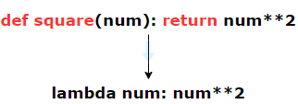
EXAMPLE | # Create a lambda function that adds two numbers  add_numbers = lambda x, y: x + y  # Call the lambda function  result = add_numbers(5, 3)  print(result) # Output: 8

FIRST CLASS FUNCTION
- A first-class function refers to the concept of treating functions as first-class citizens, which means that
  - FUNCTIONS CAN BE ASSIGNED TO VARIABLES,
  - PASSED AS ARGUMENTS TO OTHER FUNCTIONS,
  - RETURNED AS VALUES FROM OTHER FUNCTIONS.
Essentially, functions are treated as any other data type in the language.
https://teclado.com/30-days-of-python/python-30-day-16-lambda-expressions/
ASSIGNING FUNCTIONS TO VARIABLES:  def greet(name):  print("Hello, " + name + "!")  hello = greet  hello("Alice")  # Output: Hello, Alice! | PASSING FUNCTIONS AS ARGUMENTS TO OTHER FUNCTIONS  def apply_operation(operation, a, b):  return operation(a, b)  def add(a, b):  return a + b  result = apply_operation(add, 2, 3)  print(result)
RETURNING FUNCTIONS FROM OTHER FUNCTIONS  def greet():  def say_hello(name):  return "Hello, " + name + "!"  return say_hello  hello = greet()  result = hello("Alice")  print(result)  # Output: Hello, Alice! | STORING FUNCTIONS IN DATA STRUCTURES  def square(x):  return x * x  def cube(x):  return x * x * x  functions = [square, cube]  result = functions[0](2)  print(result)  # Output: 4
EXAMPLES
def divide(a, b):
if b == 0:
return "You can't divide by 0!"
else:
return a / b

operations = {
"a": lambda a, b: a + b,
"s": lambda a, b: a + b,
"m": lambda a, b: a * b,
"d": divide
}
selected_option = input("""Please select one of the following options:
a: add
s: subtract
m: multiply
d: divide
What would you like to do? """)
operation = operations.get(selected_option)
if operation:
a = int(input("Please enter a value for a: "))
b = int(input("Please enter a value for b: "))
print(operation(a, b))
else:
print("Invalid selection")
Problem - Use the sort method to put the following list in alphabetical order with regards to the students' names:  students = [  {"name": "Hannah", "grade_average": 83},  {"name": "Charlie", "grade_average": 91},  {"name": "Peter", "grade_average": 85},  {"name": "Rachel", "grade_average": 79},  {"name": "Lauren", "grade_average": 92}  ]  students.sort(key=lambda student: student["name"])  students.sort(key=lambda student: student["name"], reverse=True) Sort the student in reverse order of the name |  | OUTPUT  [  {'name': 'Charlie', 'grade_average': 91},  {'name': 'Hannah', 'grade_average': 83},  {'name': 'Lauren', 'grade_average': 92},  {'name': 'Peter', 'grade_average': 85},  {'name': 'Rachel', 'grade_average': 79}  ]

NESTED STATEMENT AND SCOPE
- The Python LEGB rule, also known as the "scope resolution rule," is used to determine the order in which Python searches for variables in different scopes.
- The acronym LEGB stands for Local, Enclosing, Global, and Built-in, representing the four different scopes in Python.
Local (L):
- This refers to the local scope, which is the innermost scope.
- It includes variables defined within a function(def or lambda).
- Local variables can only be accessed within the function in which they are defined.
def greet message= "This is global variable"  ():  message = "This is enclosed variable"  def hello():  message = "This is local variable"  print("Hello: " + message)  hello()  greet() | - Message is local to the hello() function , hence in the scope resolution it will look for the local variable. (as per LEGB Rule)  - OUTPUT : Hello: This is local variable
Enclosing (E)
  - This refers to the scope of an enclosing function.
  - It applies to nested functions, where an inner function can access variables from its containing outer function.
  - Example
message= "This is global variable"  def greet():  message = "This is enclosed variable"  def hello():  print("Hello: " + message)  hello()  greet() | - hello() is the nested function , hence in the scope resolution it will look for the variable enclosed within the enclosing outer function  - OUTPUT : Hello: This is enclosed variable
message= "This is global variable"  def greet():  def hello():  print("Hello: " + message)  hello()  greet() | - If there is no local variable it will resolve to the global variable (as per LEGB Rule)  - OUTPUT : Hello: This is global variable
Global (G)
- This refers to the global scope, which includes variables defined at the top level of a module or explicitly declared as global using the `global` keyword.
- Global variables can be accessed from anywhere within the module.
message= "This is global variable"  def greet():  global message  message = "This is enclosed variable"  greet()  print(message) | - This code illustrates how the `global` keyword can be used to modify a global variable within a function, affecting its value outside the function scope.  - OUTPUT: This is enclosed variable
Built-in (B)
- This is the outermost scope and includes Python's built-in functions and modules.
- These are pre-defined names and can be accessed from any module or function.

- The LEGB rule specifies the order in which Python searches for a variable. It starts with the local scope, then moves to the enclosing scope followed by the global scope and finally the built-in scope.
- If a variable is not found in any of these scopes, a `NameError` is raised.

INTERACTIVITY – USER INPUTS

- The input() function in Python is used to accept user input from the keyboard.  - The return type is “string”.  - Hence for any mathematical operation we need to do type conversion | def user_choice():  is_invalid_choice = True  while is_invalid_choice:  choice = input("Enter your choice (1-10): ")  if choice.isdigit() and 1 <= int(choice) <= 10:  is_invalid_choice = False  return int(choice)  else:  print("Invalid choice. Please enter a number between 1 and 10.")  print(user_choice())

OOPS IN PYTHON

CHECK THE TYPE OF OBJECT | - type(object)  - Example : type(‘hello’) <class 'str'>
CHECK THE ATTRIBUTES OF AN OBJECT | - dir(object)  - Example : dir(‘hello’)
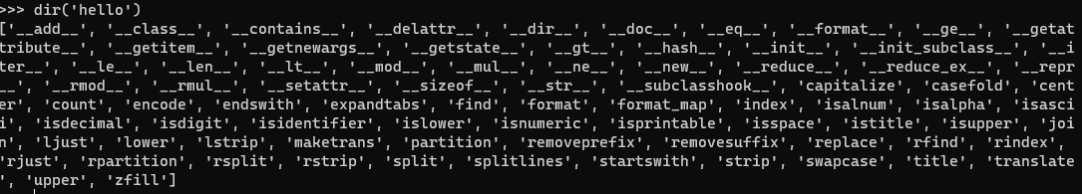

OBJECT ID
- In Python, the built-in id() function returns the identity of an object.
- This identity is unique and constant for the object during its lifetime.
SYNTAX | id(object)
WHAT IT RETURNS | - An integer that represents the memory address (or a unique identifier) of the object.  - Think of it as a way to check if two variables point to the same object in memory.
EXAMPLES | a = 10  b = 10  print(id(a)) # e.g., 140711234567888  print(id(b)) # same as id(a), because small integers are cached
EXAMPLES | c = [1, 2, 3]  d = [1, 2, 3]  print(id(c)) # different from id(d)  print(id(d))
USE CASE | - Check object identity: a is b is equivalent to id(a) == id(b)  - Debugging: Understand how Python handles memory and object references.  - Performance: Know when Python reuses objects (like small integers or strings).

CLASSES AND OBJECTS
- A class is a blueprint for creating objects. It defines the properties (attributes) and behaviors (methods) that objects of that class will have.
class Car():  def __init__(self, color, make):  self.color = color;  self.make = make;  def startEngine(self):  print("Time to start the {} which is {} in color".format(self.make,self.color))  honda = Car('blue', "city");  toyota = Car(make='Corolla',color="white")  honda.startEngine()  toyota.startEngine() | - __init__() is the constructor, that is automatically called when an object is created  - self, which refers to the instance of the class being created. Additional parameters can be included to accept values that will be used to initialize the object's attributes.  - The __init__() method does not explicitly return a value. Its purpose is to initialize the object class. It is used to initialize the attributes of the object.

CLASS OBJECT ATTRIBUTES
EXAMPLE
- Class object attributes are attributes that are defined at the class level and are shared by all instances of the class.  - These attributes are associated with the class itself, rather than with any specific instance of the class.  - Class object attributes are accessed using the class name, rather than an instance of the class | class Circle:  # Class object attribute  pi = 3.14159  def __init__(self, radius):  self.radius = radius  def calculate_area(self):  return Circle.pi * (self.radius ** 2)  # Accessing the class object attribute  print(Circle.pi) # Output: 3.14159  # Creating instances of the Circle class  circle1 = Circle(5)  circle2 = Circle(10)  # Accessing the instance attribute  print(circle1.radius) # Output: 5  print(circle2.radius) # Output: 10  # Accessing the class object attribute through an instance  print(circle1.pi) # Output: 3.14159  print(circle2.pi) # Output: 3.14159  # Calculating the area using the instance method  print(circle1.calculate_area()) # Output: 78.53975  print(circle2.calculate_area()) # Output: 314.159

__repr__ and __str__ METHODS
- `__repr__` and `__str__` methods are special methods that can be defined within a class to provide string representations of objects. These methods are automatically called by certain built-in functions and operators when working with objects of the class.

`__str__` method

- The `__str__` method is used to provide a string representation of an object that is meant to be readable and user-friendly.  - It should return a string that represents the object in a more human-readable format. This method is often used when printing or displaying objects.  - Its like toString() method in Java | class Point:  def __init__(self, x, y):  self.x = x  self.y = y  def __str__(self):  return f"({self.x}, {self.y})"  point = Point(2, 3)  print(point) (2,3)

`__repr__` method:

- The `__repr__` method is used to provide a string representation of an object that is unambiguous and can be used to recreate the object.  - It should return a string that represents the object in a way that, if evaluated, would create an identical object.  - This method is primarily used for debugging and development purposes. | class Point:  def __init__(self, x, y):  self.x = x  self.y = y  def __repr__(self):  return f"Point({self.x}, {self.y})"  point = Point(2, 3)  print(repr(point)) Point(2, 3)
- By defining both `__repr__` and `__str__` methods, we can control how objects are represented in different contexts, such as debugging or user output. If only one of these methods is defined, the other method may fall back to using the output of the defined method.

INSTANCE METHODS
- An instance method is a method that operates on an instance of a class.
- It takes the instance itself as its first argument, conventionally named self, and can access and modify the object's attributes.
class Car:  def __init__(self, brand, speed):  self.brand = brand  self.speed = speed  def accelerate(self, increment):  self.speed += increment  print(f"{self.brand} is now going at {self.speed} km/h") | my_car = Car("Tesla", 60)  my_car.accelerate(20) # Output: Tesla is now going at 80 km/h
INSTANCE METHODS CAN:
- Access and modify instance variables.
- Call other instance methods.
- Be overridden in subclasses.

CLASS AND STATIC METHODS

CLASS METHODS (@classmethod)

class Shape:  def __init__(self, color):  self.color = color  @classmethod  def create_shape(cls):  print(cls.__name__)  class Circle(Shape):  def __init__(self, color, radius):  super().__init__(color)  self.radius = radius  Shape.create_shape() Shape  Circle.create_shape() Circle | - Class methods are methods that are bound to the class and not the instance of the class.  - They are defined using the @classmethod decorator and take the class itself as the first parameter, conventionally named cls.  - Class method can be inherited  - Class methods can be used to manipulate class-level variables or perform operations related to the class.  - In this example, the change_pi class method is used to change the value of the class variable pi. The from_diameter class method is used as an alternative constructor to create a Circle object based on the diameter.  - USE CASE: Class methods are useful when we want to perform an operation on the entire class or manipulate class-level variables. For example, in a BankAccount class, a class method could be used to calculate the average balance of all accounts.
class Circle:
pi = 3.14
def __init__(self, radius):
self.radius = radius

@classmethod
def change_pi(cls, new_pi):
cls.pi = new_pi

@classmethod
def from_diameter(cls, diameter):
radius = diameter / 2
return cls(radius) CALLING THE CONSTRUCTOR
circle = Circle(5)
print(circle.pi)
Circle.change_pi(3.14159)
print(circle.pi)

circle2 = Circle.from_diameter(10)
print(circle2.radius)
SCENARIOS WHERE USING @CLASSMETHOD CAN BE BENEFICIAL
ALTERNATIVE CONSTRUCTORS | class Person:  def __init__(self, name, age):  self.name = name  self.age = age  @classmethod  def from_birth_year(cls, name, birth_year):  age = datetime.date.today().year - birth_year  return cls(name, age)  person1 = Person("Alice", 25)  person2 = Person.from_birth_year("Bob", 1990)
Accessing class-level variables or methods:  Class methods have access to class-level variables and other class methods. | class MathUtils:  PI = 3.14  @classmethod  def calculate_area(cls, radius):  return cls.PI * radius**2  area = MathUtils.calculate_area(5)
Factory method to create instance of class | class Car:  def __init__(self, make, model):  self.make = make  self.model = model  @classmethod  def create_sedan(cls, make, model):  return cls(make, model, "sedan")  sedan = Car.create_sedan("Toyota", "Camry")
Polymorphism and method overriding:  Class methods can be overridden in subclasses. | class Shape:  @classmethod  def get_type(cls):  return "Shape"  class Circle(Shape):  @classmethod  def get_type(cls):  return "Circle"  shape = Shape()  circle = Circle()  print(shape.get_type()) # Output: "Shape"  print(circle.get_type()) # Output: "Circle

STATIC METHODS (@staticmethod)

class MathUtils:  @staticmethod  def add(x, y):  return x + y  result = MathUtils.add(5, 3)  print(result)  Static methods are handy for utility functions or operations that do not rely on instance or class state. For example, in StringUtils class, a static method could be used to check if a given string is a palindrome. | STATIC METHODS  - Static methods are methods that do not operate on instance or class variables.  - They are defined using the @staticmethod decorator and do not require the self or cls parameters.  - Static methods are often used for utility functions or operations that do not rely on any specific instance or class state  - Static method can be inherited  - In this example, the add static method is defined in the MathUtils class. It takes two parameters and returns their sum. Since the method is static, it can be called directly on the class without creating an instance.
class Word:  def __init__(self):  self.words = set()  def add_text(self, text):  cleanedTxt = Word.clean_text(text)  return cleanedTxt  def clean_text(text: str):  return text.replace("!", "")  word = Word()  print(word.add_text("Hello World!")) | The @staticmethod decorator is not strictly required, but it is highly recommended when we are defining a method that:  - Does not use self or cls (i.e. it doesn't access instance or class variables).  - Logically related to the class but doesn't need to access or modify the class or instance state.  Without @staticmethod  - If we omit the decorator, Python treats the method as a regular instance method, which means it expects a self parameter:  class Word:  def clean_text(text): # No self, but no decorator either  return text.replace("!", "")  - Word.clean_text("Hello!") # This works, but it's not ideal  This works, but it's not clean or idiomatic.  It can also lead to confusion or errors if someone tries to call it via an instance:  word = Word()  word.clean_text("Hello!") # TypeError if not handled properly  With @staticmethod - Using the decorator makes your intent clear:  Now it’s obvious that this method doesn’t rely on instance or class data, and it can be safely called via the class or an instance.

INHERITANCE

class Car():  def __init__(self, color, make):  self.color = color;  self.make = make;  def startEngine(self):  print("Time to start the {} which is {} in color".format(self.make,self.color))  class EVCar(Car):  def __init__(self, color, make, batteryCapacity):  super().__init__(color,make)  self.batteryCapacity = batteryCapacity;  honda = Car('blue', "city");  toyota = Car(make='Corolla',color="white")  tesla= EVCar("grey","Model S", 75)  honda.startEngine()  toyota.startEngine()  tesla.startEngine() | EVCar class:  - The EVCar class is the subclass or derived class of Car.  - It has its own __init__() method that uses the super() function to call the __init__() method of the superclass (Car) and pass the color and make arguments.  - By inheriting from the Car class, the EVCar class automatically gains access to the __init__() and startEngine() methods defined in Car.
class Student:
def __init__(self, name, school):
self.name = name
self.school = school
self.marks = []
def average(self):
return sum(self.marks) / len(self.marks)
class WorkingStudent(Student):
def __init__(self, name, school, salary):
super().__init__(name, school)
self.salary = salary
def __repr__(self):
return f"Name: {self.name}, School: {self.school}, Salary: {self.salary}"
alex = WorkingStudent("Alex", "MIT", 15.50)
alex.marks.append(90)
alex.marks.append(80)
alex.marks.append(70)
alex.marks.append(60)
alex.marks.append(50)
print(f"Name: {alex.name}, School: {alex.school}, Salary: {alex.salary} and average {alex.average()}")
- Notice that the properties of parent class can be accessed using Subclass object
EXAMPLE 2
""" A Garage Full of Classy Vehicles """

# Base Vehicle class
class Vehicle:
def __init__(self, color, manufacturer):
self.color = color
self.manufacturer = manufacturer
self.gas = 4 # a full tank of gas

def drive(self):
if self.gas > 0:
self.gas -= 1
print(f'The {self.color} {self.manufacturer} goes VROOOM!!!')
else:
print(f'The {self.color} {self.manufacturer} sputters out of gas...')

# Car inherits the Vehicle class
class Car(Vehicle):
def radio(self): # turn on the radio
print("Rockin' Tunes!")

def window(self): # open the window
print('Ahhh... fresh air!')

# Motorcycle inherits the Vehicle class
class Motorcycle(Vehicle):
def helmet(self): # put on a helmet
print('Helmet on - nice and safe!')

# Demo Commands(with print() functions to show output when run as main script)
if __name__ == '__main__':

# create car & motorcycle objects
my_car = Car('red', 'Mercedes')
my_mc = Motorcycle('silver', 'Harley')

# take them out for a test drive
my_car.drive()
my_mc.drive()
my_mc.drive()
my_mc.drive()
my_mc.drive()
my_mc.drive() # out of gas
my_car.drive()

# play around with accessories
my_car.radio()
my_car.window()
my_mc.helmet()
# my_mc.window() # windows do not exist on motorcycles - throws and error

METHOD OVERRIDING

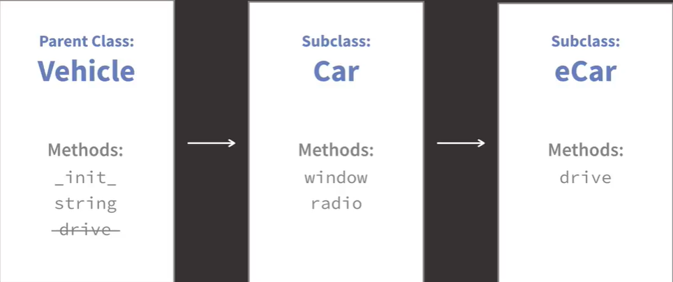

""" A Garage Full of Classy Vehicles """

# Base Vehicle class
class Vehicle:
def __init__(self, color, manufacturer):
self.color = color
self.manufacturer = manufacturer
self.gas = 4 # a full tank of gas

def drive(self):
if self.gas > 0:
self.gas -= 1
print(f'The {self.color} {self.manufacturer} goes VROOOM!!!')
else:
print(f'The {self.color} {self.manufacturer} sputters out of gas...')

# Car inherits the Vehicle class
class Car(Vehicle):
def radio(self): # turn on the radio
print("Rockin' Tunes!")

def window(self): # open the window
print('Ahhh... fresh air!')

# Motorcycle inherits the Vehicle class
class Motorcycle(Vehicle):
def helmet(self): # put on a helmet
print('Helmet on - nice and safe!')

# ECar inherits the Car class
class ECar(Car):
def drive(self): # an eco-friendly drive method
print(f'The {self.color} {self.manufacturer} goes ssshhh...')

# Demo Commands(with print() functions to show output when run as main script)
if __name__ == '__main__':

# create and use an electric car
my_ecar = ECar('white', 'Nissan')
my_ecar.window()
my_ecar.radio()
my_ecar.drive()

# access the lingering gas tank
print(my_ecar.gas)

PROPERTY DECORATOR

What is THE DECORATOR?
- A decorator is a design pattern that allows us to modify the behavior of a function or method without changing its actual code.
- Decorators are often used for logging, access control, memoization, and more.
- They are applied using the @decorator_name syntax just above the function definition.
- Used to define a method as a read-only property.
- It allows us to access a method like an attribute.
- Commonly used to implement getter, setter, and deleter methods for encapsulation
DEFINING A GETTER: The @property decorator is applied to a method to make it behave like an attribute.
class Circle:
def __init__(self, radius):
self._radius = radius # Private attribute by convention

@property
def radius(self):
"""Get the radius."""
return self._radius

circle = Circle(10)
print(circle.radius) # Access without parentheses, behaves like an attribute
2. ADDING A SETTER: The @<property_name>.setter decorator is used to define a setter for the property.
class Circle:
def __init__(self, radius):
self._radius = radius

@property
def radius(self):
"""Get the radius."""
return self._radius

@radius.setter
def radius(self, value):
"""Set the radius with validation."""
if value < 0:
raise ValueError("Radius cannot be negative!")
self._radius = value

circle = Circle(10)
circle.radius = 15 # Update radius
print(circle.radius) # 15
3. ADDING A DELETER: The @<property_name>.deleter decorator allows us to define behavior when the property is deleted.

class Circle:
def __init__(self, radius):
self._radius = radius

@property
def radius(self):
"""Get the radius."""
return self._radius

@radius.setter
def radius(self, value):
if value < 0:
raise ValueError("Radius cannot be negative!")
self._radius = value

@radius.deleter
def radius(self):
"""Delete the radius."""
print("Deleting radius...")
self._radius = None

circle = Circle(10)
del circle.radius # Triggers the deleter
print(circle.radius) # None
COMBINING GETTER, SETTER, AND DELETER  class Person:  def __init__(self, name):  self._name = name  @property  def name(self):  """Get the name."""  return self._name  @name.setter  def name(self, value):  """Set the name with validation."""  if not value:  raise ValueError("Name cannot be empty!")  self._name = value  @name.deleter  def name(self):  """Delete the name."""  print(f"Deleting name {self._name}...")  self._name = None | person = Person("Alice")  print(person.name) # "Alice"  person.name = "Bob" # Update name  print(person.name) # "Bob"  del person.name # Delete name  print(person.name) # None  - @property turns a method into a getter.  - Use @<property>.setter to define a setter.  - Use @<property>.deleter to define a deleter.  - Allows encapsulation + validation while keeping attribute-like syntax

POLYMORPHISM

class Animal:
def __init__(self, name):
self.name = name
def speak(self):
pass
class Dog(Animal):
def __init__(self, name):
super().__init__(name)
def speak(self):
print("{} speak WOFF!!".format(self.name))
class Cat(Animal):
def __init__(self, name):
super().__init__(name)
def speak(self):
print("{} speak Meow!!".format(self.name))
cat = Cat('Felix')
dog = Dog('Fred')
for pet in [cat, dog]:
pet.speak();

MULTIPLE INHERITANCE
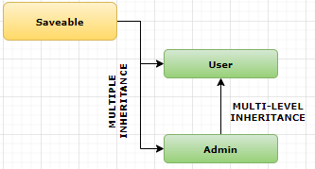
user.py
from save import Savable
class User(Savable):
def __init__(self, user_name, user_password):
self.user_name = user_name
self.user_password = user_password
admin.py
from user import User
from save import Savable
class Admin(User, Savable):
def __init__(self, user_name, user_password, access_level):
super().__init__(user_name, user_password)
self.access_level = access_level
def __repr__(self):
return f'<Admin {self.user_name}, access level {self.access_level}>'
def to_dict(self):
return {
'user_name': self.user_name,
'user_password': self.user_password,
'access_level': self.access_level
}
database.py
class Database:
content = {'users': []}
@classmethod
def insert(cls, user):
cls.content["users"].append(user)
@classmethod
def remove(cls, finder):
cls.content["users"] = [usr for usr in cls.content["users"] if not finder(usr)]
@classmethod
def find(cls, finder):
found_users = [usr for usr in cls.content["users"] if finder(usr)]
if found_users:
return found_users[0]
return None
Save.py
from database import Database
class Savable:
def save(self):
Database.insert(self.to_dict())

MORE EXAMPLES

class Grade:  def calculate_grade(self, average) -> str:  if average >= 90:  return "A+"  elif 80 <= average < 90:  return "A"  elif 70 <= average < 80:  return "B"  elif 60 <= average < 70:  return "C"  elif 50 <= average < 60:  return "D"  else:  return "F"  class Marks:  def calculate_average(self) -> float:  return sum(self.marks) / len(self.marks)  class Student(Grade, Marks):  def __init__(self, name, marks):  self.name = name  self.marks = marks  def print_profile(self):  avg = self.calculate_average()  return f"Name: {self.name}, Average Marks: {avg} , Grade :{self.calculate_grade(avg)}"  student = Student('Alex', marks=[90, 80, 70, 60, 50])  print(student.print_profile()) | """  Define your Salary class and Promotable class so that the Employee class objects may work like this:  rolf = Employee(15.0)  print(rolf.weekly_salary()) # --> prints out rolf's weekly salary (15.0 * 40 = 600.0)  rolf.promote(5.0) # rolf's hourly salary (rate) increases by 5.0 (15.0 + 5.0 = 20.0)  print(rolf.weekly_salary()) # --> prints 800.0 (20.0 * 40 = 800.0)  """  class Salary:  # define Salary class and associated methods here  def calculate(self, hours) -> float:  return hours * self.rate  class Promotable:  # define Promotable class and associated methods here  def promote(self, increased_rate) -> None:  self.rate = self.rate + increased_rate  # Do NOT change the code below:  class Employee(Salary, Promotable):  def __init__(self, rate: float):  # rate is hourly salary  self.rate = rate  def weekly_salary(self) -> float:  # 40 is number of hours worked/w  return self.calculate(40)  rolf = Employee(15.0)  print(rolf.weekly_salary()) # 600.0  rolf.promote(5.0)  print(rolf.weekly_salary()) # 800.0

ABSTRACT CLASSES
- ABCMeta in Python is a metaclass used to define Abstract Base Classes (ABCs). It is part of the abc module, which helps define classes that cannot be instantiated directly but serve as blueprints for other classes.
Why Use ABCMeta?
- Enforce Implementation: Ensure that derived classes implement specific methods.
- Define Abstract Methods: Specify methods that must be overridden in subclasses.
- Promote Interface Programming: Create classes focused on what they should do, not how they do it.
- To work with ABCMeta, we use the ABC class from the abc module as a base class.  KEY POINTS:  - ABCMeta is the metaclass behind the scenes for any class inheriting from ABC.  - @abstractmethod: Decorator to mark methods that must be implemented by subclasses.  - We cannot create an instance of a class with unimplemented abstract methods.  CHECKING IF A CLASS IS A SUBCLASS OF AN ABC  print(issubclass(Dog, Animal)) # Output: True  print(isinstance(dog, Animal)) # Output: True | from abc import ABC, abstractmethod  class Animal(ABC):  @abstractmethod  def sound(self):  """This method must be implemented in the subclass."""  pass  @abstractmethod  def move(self):  """This method must be implemented in the subclass."""  pass  # Attempting to instantiate an abstract class will raise an error  # animal = Animal() # TypeError: Can't instantiate abstract class  class Dog(Animal):  def sound(self):  return "Bark"  def move(self):  return "Run"  # Now you can instantiate Dog  dog = Dog()  print(dog.sound()) # Output: Bark  print(dog.move()) # Output: Run

ENCAPSULATION

PUBLIC MEMBERS

class Car:  def init(self):  self.model = "Sedan" # public attribute  c = Car()  print(c.model) # accessible everywhere | - A public member is any attribute or method whose name does not begin with an underscore.  - It is intended to be freely accessible from anywhere—inside the class, outside the class, in subclasses, or in other modules.

PROTECTED MEMBERS (_SINGLE_LEADING_UNDERSCORE)

class Vehicle:  def __init__(self):  self._speed = 60 # protected attribute  class Bike(Vehicle):  def show_speed(self):  print(self._speed)  b = Bike()  b.show_speed() # allowed  print(b._speed) # technically allowed but discouraged | - A protected member is an attribute that begins with a single leading underscore (e.g., _speed).  - Python does not prevent access, but it signals:  - This is an internal attribute. Do not access it from outside the class unless you know what you're doing.  - Accessible inside the class and subclasses; discouraged for external use.

PRIVATE MEMBERS (__DOUBLE_LEADING_UNDERSCORE)

class BankAccount:  def init(self):  self.balance = 1000 # private attribute  def getbalance(self):  return self.balance  acc = BankAccount()  print(acc.getbalance()) # correct access  print(acc.__balance) # AttributeError: cannot access directly  ✔️ Internal name (mangled)  acc.BankAccount_balance # Works, but violates encapsulation | - A private member begins with a double leading underscore.  - Python applies name-mangling, meaning the attribute name is rewritten internally as:  _ClassName__attribute  - This makes accidental access difficult and preserves encapsulation  - Accessible only within the class that defines it
- Encapsulation means bundling data (variables) and methods (functions) into a single unit (class) and restricting direct access to some data.
- Think of it as hiding the internal details of how data is stored and allowing controlled access.
class BankAccount:  def __init__(self):  self.__balance = 1000 # Private attribute  def get_balance(self):  return self.__balance  account = BankAccount()  print(account.get_balance()) # Output: 1000# The following line would raise an AttributeError  print(account.__balance) # Uncommenting this line will cause an error | - __balance is private (encapsulated).  - You cannot directly modify it → this protects the data.  - You can only change it through methods like deposit().

ENCAPSULATION USING GETTER AND SETTERS
- Unlike Java/C#, Python encourages using the @property decorator instead of explicit get_*/set_* method names.
class BankAccount:
def __init__(self, balance=0):
self.__balance = 0 # private storage
self.balance = balance # go through setter for validation

@property
def balance(self):
"""Getter: return the current balance."""
return self.__balance

@balance.setter
def balance(self, amount):
"""Setter: validate before setting."""
if not isinstance(amount, (int, float)):
raise TypeError("Balance must be a number.")
if amount < 0:
raise ValueError("Balance cannot be negative.")
self.__balance = float(amount)

@balance.deleter
def balance(self):
"""Optional: prevent deletion or define custom behavior."""
raise AttributeError("Balance cannot be deleted.")

READ ONLY PROPERTY | WRITE ONLY PROPERTY
class User:  def __init__(self, first, last):  self.__first = first  self.__last = last  @property  def full_name(self):  return f"{self.__first} {self.__last}"  user = User("John", "Doe")  print(user.full_name)  # AttributeError: can't set attribute  user.full_name = "Jane Smith" | class SecretBox:  def __init__(self):  self.__secret_hash = None  @property  def secret(self):  raise AttributeError("Secret is write-only.")  @secret.setter  def secret(self, value):  self.__secret_hash = hash(value)
COMPUTED + VALIDATED FIELDS
class Rectangle:
def __init__(self, width, height):
self.__w = width
self.__h = height
self.width = width
self.height = height

@property
def width(self):
return self.__w

@width.setter
def width(self, value):
if value <= 0:
raise ValueError("Width must be positive.")
self.__w = value
@property
def height(self):
return self.__h
@height.setter
def height(self, value):
if value <= 0:
raise ValueError("Height must be positive.")
self.__h = value

def area(self):
return self.__w * self.__h

# Example usage:
rect = Rectangle(4, 5)
print(f"Width: {rect.width}, Height: {rect.height}, Area: {rect.area()}")

ABSTRACTION
- Abstraction means showing only the essential features and hiding the background details.
from abc import ABC, abstractmethod  class Vehicle(ABC):  @abstractmethod  def start(self):  pass # abstract method (no detail)  class Car(Vehicle):  def start(self):  print("Car started using key/engine")  class Bike(Vehicle):  def start(self):  print("Bike started using self-start")  # Usage  v1 = Car()  v1.start()  v2 = Bike()  v2.start() | HOW THIS PROGRAM DEMOSTRATE ABSTACTION  - Abstraction means: Showing only the essential features of something and hiding unnecessary details.  - In OOP terms:  - You define what a method should do, but not how it should do it  - Different subclasses provide their own implementation for the same method.  - Vehicle is an Abstract Base Class (ABC)  - You cannot create an object of Vehicle.  - It provides a general idea of what all vehicles must be able to do (start),\ but not how they do it. This is abstraction: defining concepts without details.  - start() is an abstract method  - This method has no implementation.  - It only defines: Every vehicle must have a start method.”  WHAT TO DO IS DEFINED. HOW TO DO IT IS HIDDEN?  - Subclasses (Car, Bike) provide their own implementation. Each subclass gives a concrete version of start.  - The user of Vehicle doesn’t need to know this internal logic.  DIFFERENT VEHICLES START DIFFERENTLY, BUT YOU ONLY CARE THAT THEY CAN START.  Polymorphism demonstrates the abstraction  v1 = Car()  v1.start()  v2 = Bike()  v2.start()  These two objects both respond to .start() even though the implementations differ.

MAGIC/ DUNDER METHODS (DOUBLE UNDERSCORE)
- Magic methods, also known as dunder methods (short for "double underscore"), are special methods in Python surrounded by double underscores (__).
- These methods allow us to define or customize the behavior of Python objects. They are typically invoked implicitly, rather than being called directly.

CATEGORIES OF MAGIC METHODS

INITIALIZATION AND REPRESENTATION

__init__(self, ...) | Initializes an object. Called when creating an instance of a class
__new__(cls, ...) | Allocates memory for a new object. Used before __init__.
__del__(self) | Called when an object is about to be destroyed
__repr__(self) | Returns a formal, unambiguous string representation of the object.
`__str__(self) | Returns a user-friendly string representation

OPERATOR OVERLOADING

ARITHMETIC OPERATORS:
__add__(self, other): Defines behavior for +.
__sub__(self, other): Defines behavior for -.
__mul__(self, other): Defines behavior for *.
__truediv__(self, other): Defines behavior for /.
__floordiv__(self, other): Defines behavior for //.
__mod__(self, other): Defines behavior for %.
__pow__(self, other): Defines behavior for **.

COMPARISON OPERATORS:
__eq__(self, other): Defines behavior for ==.
__ne__(self, other): Defines behavior for !=.
__lt__(self, other): Defines behavior for <.
__le__(self, other): Defines behavior for <=.
__gt__(self, other): Defines behavior for >.
__ge__(self, other): Defines behavior for >=.

CONTAINER EMULATION
__len__(self): Defines behavior for len().
__getitem__(self, key): Defines behavior for indexing (obj[key]).
__setitem__(self, key, value): Defines behavior for assignment to indexed elements (obj[key] = value).
__delitem__(self, key): Defines behavior for del obj[key].
__iter__(self): Defines behavior for iteration (for loops).
__contains__(self, item): Defines behavior for in.

ATTRIBUTE ACCESS
__getattr__(self, name): Called when accessing a non-existent attribute.
__setattr__(self, name, value): Called when setting an attribute.
__delattr__(self, name): Called when deleting an attribute.
__dir__(self): Defines behavior for dir().

CALLABLE AND CONTEXT MANAGEMENT
__call__(self, ...): Makes an object callable like a function.
__enter__(self): Defines behavior for the start of a with block.
__exit__(self, exc_type, exc_value, traceback): Defines behavior at the end of a with block.

OTHERS
__hash__(self): Defines behavior for hash().
__bool__(self): Defines truth value testing (bool(obj)).
__copy__(self): Defines shallow copy behavior.
__deepcopy__(self, memo): Defines deep copy behavior.

Example: Operator Overloading

class Point:
def __init__(self, x, y):
self.x = x
self.y = y

def __add__(self, other):
return Point(self.x + other.x, self.y + other.y)

def __repr__(self):
return f"Point({self.x}, {self.y})"

p1 = Point(1, 2)
p2 = Point(3, 4)
p3 = p1 + p2 # Calls __add__
print(p3) # Output: Point(4, 6)

TYPE HINTING

MODULES AND PACKAGES

PIP INSTALL AND PyPi
- PiPy(Python Package Index) is a central repository for open source third party Python Package(like npm)
- PyPI is a platform where developers can publish and distribute their Python packages for others to easily install and use in their own projects.

INSTALLING PACKAGES FROM PIPY

TO INSTALL PACKAGES FROM PyPi | pip install requests

WRITING OWN PACKAGES AND MODULES
- Modules and packages are used to organize and structure code.
- A module is a single file containing Python code, while a package is a collection of modules organized in a directory hierarchy. Modules and packages allow for code reuse, modularity, and separation of concerns.

MODULES
- To create our own module, we need to create a new Python file with a `.py` extension.
CREATING MODULES
- Let's say we want to create a module called my_module.py.  - Create a file name my_module.py  - Inside this file, we can define functions, classes, or variables. | File Name : my_module.py  def greet(name):  print(f"Hello, {name}!")  class MyMath:  def square(self, num):  return num ** 2
USING MODULES
- Once we created the module, we can import it into another Python script and use its functions or classes.  - Here's an example of how to import and use the `greet` function from `my_module`: | import my_module  my_module.greet("Alice") # Output: Hello, Alice!

IMPORTING MODULES
- The import statement allows us to reuse code by bringing in external or built-in libraries, modules, or specific parts of them into the program

IMPORT INBUILT MODULE - EXAMPLE

""" The Right Tools for the Job """

# Demo Commands(with print() functions to show output when run as main script)

# import the entire random module
import random
print(random.randint(1,20))
# randint(1,20) # causes an error

# import just the randint function
from random import randint
print(randint(1,20))
print(random.random())

# import just the random function
from random import random
print(random())
# random.randint(1,20) # causes an error

# import the entire random module as "random"
import random as rand
print(rand.randint(1,20))
print(random())

IMPORTING CUSTOM MODULE

BASIC SYNTAX OF IMPORT  import module_name  - After importing, we access its contents using the module_name.function_name.  EXAMPLE:  import math  print(math.sqrt(16)) # Access sqrt function from the math module | IMPORTING SPECIFIC FUNCTIONS, CLASSES, OR VARIABLES  - Sometimes, we might not need the entire module but only specific parts.  - SYNTAX:  from module_name import specific_name  EXAMPLE:  from math import sqrt  print(sqrt(25)) # Directly access sqrt without prefixing with 'math.'  - We can also import multiple names:  from math import sqrt, pi  print(sqrt(36)) # Output: 6.0  print(pi) # Output: 3.141592653589793
IMPORTING WITH AN ALIAS  - If the module name is long, we can give it a shorter alias for convenience using the as keyword:  import module_name as alias  EXAMPLE:  import numpy as np  array = np.array([1, 2, 3])  print(array)  - Similarly, we can alias specific imports:  from math import sqrt as square_root  print(square_root(49)) # Output: 7.0 | IMPORTING ALL CONTENTS OF A MODULE  - We can use from module_name import * to import everything in a module directly into our namespace. This eliminates the need to prefix functions with the module name.  EXAMPLE:  from math import *  print(sqrt(64)) # Output: 8.0  print(pi) # Output: 3.141592653589793  Note: This approach is discouraged because:  - It can lead to namespace conflicts.  - It makes the code less readable.
USING CUSTOM MODULES  - We can create our own module by saving Python code in a .py file and then importing it into another file.  EXAMPLE:  my_module.py  def greet():  return "Hello, World!"  def add(a, b):  return a + b  main.py  from my_module import greet, add  print(greet()) # Output: Hello, World!  print(add(3, 4)) # Output: | IMPORTING MODULES DYNAMICALLY  - We can import a module dynamically using the importlib library:  import importlib  module_name = 'math'  math_module = importlib.import_module(module_name)  print(math_module.sqrt(16)) # Output: 4.0

MODULE SEARCH PATH

PACKAGES
- To create a package, we need to organize our modules in a directory structure.
- The directory should contain a special file called `__init__.py`, which can be an empty file or can contain initialization code.
EXAMPLE
Let's create a package called `my_package` with two modules: `module1.py` and `module2.py`.
DIRECTORY STRUCTURE | my_package/  __init__.py  module1.py  module2.py
MODULE 1(MODULE1.PY) | def func1():  print("This is function 1")  def func2():  print("This is function 2")
MODULE 2(MODULE2.PY) | def func3():  print("This is function 3")  def func4():  print("This is function 4")
USING PACKAGE | We can then import and use the functions from the package and its modules in your code:  import my_package.module1  import my_package.module2  my_package.module1.func1() # Output: This is function 1  my_package.module2.func3() # Output: This is function 3  OR - Alternatively, we can use the `from ... import` syntax to import specific functions directly  from my_package.module1 import func1  from my_package.module2 import func3  func1() # Output: This is function 1  func3() # Output: This is function 3

SUBPACKAGES

DIRECTORY STRUCTURE | my_package/  __init__.py  subpackage1/  __init__.py  module1.py  subpackage2/  __init__.py  module2.py | 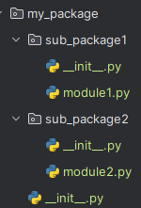
module1.py | def func1():  print("This is function 1 in subpackage1")  def func2():  print("This is function 2 in subpackage1")
module2.py | def func3():  print("This is function 3 in subpackage2")  def func4():  print("This is function 4 in subpackage2")
USING PACKAGE / SUBPACKAGES | from my_package.sub_package1 import module1  from my_package.sub_package2 import module2  module1.func1()  module1.func2()  module2.func3()  module2.func4()

__name__ and __main__

ERROR HANDLING
- Error handling allows us to gracefully handle and manage exceptions or errors that may occur during the execution of the code.

MECHANISMS FOR ERROR HANDLING

Try-Except:  - The `try-except` block is used to catch and handle specific exceptions.  - We enclose the code that may raise an exception in the `try` block, and then specify the exception type(s) we want to handle in the `except` block. | try:  # Code that may raise an exception  result = 10 / 0  except ZeroDivisionError:  # Code to handle the ZeroDivisionError  print("Error: Division by zero occurred")
Try-Except-Else:  - The `try-except-else` block allows us to specify code that should be executed if no exception occurs. | try:  # Code that may raise an exception  result = 10 / 2  except ZeroDivisionError:  # Code to handle the ZeroDivisionError  print("Error: Division by zero occurred")  else:  # Code to execute if no exception occurs  print("Result:", result)
Try-Finally:  - The `try-finally` block ensures that a specified block of code is always executed, regardless of whether an exception occurs or not.  - This is useful for performing cleanup operations. | try:  # Code that may raise an exception  file = open("my_file.txt", "r")  # Code to read from the file  finally:  # Code to always execute, like closing the file  file.close()

RAISING ERRORS/EXCEPTION
- We can use the `raise` statement to manually raise exceptions in the code. This is useful when we want to explicitly handle specific situations or create custom exceptions
EXAMPLE -1  age = -1  if age < 0:  raise ValueError("Age cannot be negative") | EXAMPLE -2  def raise_error(num):  if num ==0:  raise Exception()  print(num)  raise_error(0)

CUSTOM EXCEPTION

STEPS TO CREATE CUSTOM EXCEPTIONS

Step 1: Define a class for custom exception:  - Create a new class that inherits from the base `Exception` class or any of its subclasses.  - This class will serve as custom exception. | class CustomException(Exception):  pass
CUSTOMIZE THE EXCEPTION  - We can add additional attributes, methods, or customize the behavior of the custom exception by adding them to the class. | class CustomException(Exception):  def __init__(self, message):  self.message = message  super().__init__(self.message)  - In this example, we add an `__init__()` method to the custom exception class to initialize the exception with a custom error message.  - The `super().__init__(self.message)` line ensures that the base class `Exception` is also initialized with the custom error message.
RAISE THE CUSTOM EXCEPTION  - When we encounter a situation that warrants raising the custom exception, use the `raise` statement followed by an instance of custom exception class | raise CustomException("This is a custom exception")
Handle the custom exception  - Surround the code that may raise the custom exception with a `try-except` block to catch and handle the exception | try:  # Code that may raise the custom exception  except CustomException as e:  # Handle the custom exception

EXAMPLES

class InvalidInputException(Exception):  def __init__(self, value):  self.value = value  super().__init__(f"Invalid input: {value} is not a valid value")  def process_input(value):  if value < 0 or value > 100:  raise InvalidInputException(value)  else:  print(f"Processing input: {value}")  try:  input_value = 150  process_input(input_value)  except InvalidInputException as e:  print(e.value) | - In this example, we define a custom exception class `InvalidInputException` that inherits from the base `Exception` class. The `__init__()` method is overridden to initialize the exception with the `value` attribute and a custom error message.  - The `process_input()` function takes a `value` as a parameter and checks if it is a valid input (between 0 and 100). If it is not valid, the function raises an `InvalidInputException` with the value as the argument. Otherwise, it processes the input.  - In the `try-except` block, we call the `process_input()` function with an input value of 150. Since 150 is not a valid value, an `InvalidInputException` is raised. The exception is caught in the `except` block, and the value passed to the exception is printed.
class UncountableError(ValueError):
def __init__(self,n):
super().__init__(f"Invalid value for {n}, WRONG_VALUE. {n} must be greater than 0.")
def count_from_zero_to_n(n):
if n < 1:
raise UncountableError(n)
for x in range(0, n + 1):
print(x)
count_from_zero_to_n(-1)
class HttpException(Exception):  status_code = None  message = None  def __init__(self):  super().__init__(f"status code:{self.status_code} , message:{self.message}")  class NotFoundException(HttpException):  status_code = 404  message = "Not Found"  class ServerError(HttpException):  status_code = 500  message = "Internal Server Error"  def raise_server_error():  raise ServerError()  raise_server_error() |  | OUTPUT  ServerError: status code:500 , message:Internal Server Error

EXCEPTION HANDLING USING DECORATORS

Centralizing the Exception handling using decorators | def handle_exception(fn):  def wrapper():  try:  fn()  except TypeError:  print("Type Error")  except ZeroDivisionError:  print("Division Error")  except Exception:  print("Some Exception occured")  return wrapper  @handle_exception  def cause_error():  return 1 / 0  cause_error()

GENERATORS
- Generators are the functions which remembers the state it’s in between the execution
- They allow us to yield items one at a time, as opposed to computing all the values upfront, which is useful for handling large data sets or streams of data.
- Generators are functions that use the yield keyword instead of return, when called, they return a generator object without executing the function immediately.

CREATING GENERATORS

def countdown_generator(x):  count = x  while count > 0:  yield count  count -= 1  generator = countdown_generator(5) This does not execute the function  # Iterate over the generator object  print(next(generator))  print(next(generator))  # using the generator object in a for loop  print("Using For Loop")  for num in generator:  print(num) | OUTPUT  5  4  Using For Loop======== THE GENERATOR WILL BE PAUSED TILL next is called. i.e The generator function resumes from where it left off on subsequent calls to next().  3  2  1
- When a generator function is called, it doesn’t execute the code in the function body.Instead, it creates a generator object, which can be iterated over.
- When next() is called on the generator, the function runs until it hits a yield statement, pauses, and returns the yielded value.

USING GENERATOR EXPRESSIONS:
Like list comprehensions but with parentheses instead of square brackets.

gen = (x * x for x in range(5))
print(next(gen)) # Output: 0
print(next(gen)) # Output: 1

KEY METHODS

next(generator) | Fetches the next value from the generator.
for loop | Automatically iterates through all values in the generator.
send(value) | Sends a value into the generator. The generator resumes and uses the value of send().
close() | Stops the generator.

CHAINING GENERATORS

def numbers():  for i in range(1, 10):  yield i  def square(numbers):  for num in numbers:  yield num ** 2  def filter_odd(squares):  for sq in squares:  if sq % 2 == 1:  yield sq  # Create a pipeline  result = filter_odd(square(numbers()))  print(list(result)) # Output: [1, 9, 25, 49, 81] | - When we pass a generator object as an argument to the list() function, it consumes the generator and creates a list containing all the values generated by the generator.  - The list() function iterates over the generator object, calling next() on it until the generator is exhausted.

EXAMPLES

INFINITE GENERATOR | OUTPUT
def infinite_numbers():  num = 0  while True:  yield num  num += 1  gen = infinite_numbers()  print("First for loop to invoke generators")  for i in range(5):  print(next(gen)) # Outputs: 0, 1, 2, 3, 4  print("Second for loop to invoke generators")  for i in range(5):  print(next(gen)) # Outputs: 5,6,7,8,9 | First for loop to invoke generators  0  1  2  3  4  Second for loop to invoke generators  5  6  7  8  9
GENERATORS IN LOOP
def count_up_to(n):  count = 1  while count <= n:  yield count  count += 1  # Create a generator  gen = count_up_to(5)  # Iterate over the generator with a for loop  for number in gen:  print(number) # Outputs: 1, 2, 3, 4,5 | - Generators work seamlessly with loops, especially for loops, because they are inherently iterable.  - When we use a for loop with a generator, the loop repeatedly calls the generator’s __next__() method until the generator is exhausted, at which point it raises a StopIteration exception and the loop stops.  WHAT HAPPENS BEHIND THE SCENES?  - The generator function is called, creating a generator object.  - Each iteration of the for loop calls the generator’s __next__() method.  - When a yield statement is hit, the value is returned to the loop.  - Once there are no more yield statements, the generator raises StopIteration.  - The for loop catches the StopIteration and ends gracefully.

REAL TIME USAGE OF GENERATORS
- Generators are highly useful in real-world scenarios where we need to handle large datasets, infinite sequences, or asynchronous data streams efficiently.
PROCESSING LARGE FILES:  - When dealing with large files, loading the entire file into memory might not be feasible.  - Generators can be used to process the file line by line without exhausting memory. | Example: Reading a Large File  def read_large_file(file_path):  with open(file_path, 'r') as file:  for line in file:  yield line.strip()  # Use the generator  for line in read_large_file("large_file.txt"):  print(line)
GENERATING INFINITE SEQUENCES  - Generators can produce infinite sequences, useful for tasks like simulations, testing, or mathematical computations. | Example: Fibonacci Sequence  def fibonacci():  a, b = 0, 1  while True:  yield a  a, b = b, a + b  # Use the generator to get Fibonacci numbers  for num in fibonacci():  if num > 100: # Stop condition  break  print(num)
DATA STREAMING  - In applications like video streaming, data analysis, or real-time logging, data is often streamed in chunks. Generators can yield chunks of data on demand. | Example: Streaming Log Lines  import time  def stream_logs(file_path):  with open(file_path, 'r') as file:  while True:  line = file.readline()  if not line:  time.sleep(0.1) # Wait for new logs  continue  yield line.strip()  # Use the generator to process log entries  for log in stream_logs("server.log"):  print(log)
DATABASE QUERY PAGINATION  - Fetching large datasets from a database can be memory-intensive.  - Generators allow us to fetch results in smaller chunks. | Example: Fetching Rows in Batches  def fetch_rows_in_batches(cursor, batch_size):  while True:  rows = cursor.fetchmany(batch_size)  if not rows:  break  yield rows  # Use the generator to process rows  for batch in fetch_rows_in_batches(db_cursor, 100):  process(batch)

GENERATOR COMPREHENSION

GENERATORS CLASSES AND ITERATORS

ITERABLES

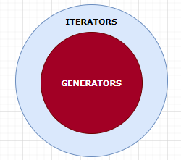 | ALL GENERATORS ARE ITERATORS, THE REVERSE IS NOT TRUE.

FILTER FUNCTION

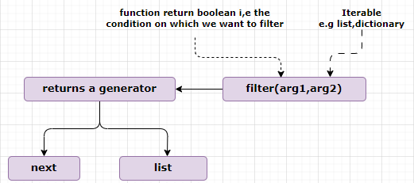
- The filter() function takes 2 argument and return a generator.
friends = ['Rolf', 'Jose', 'Randy', 'Anna', 'Mary']  start_with_A = filter(lambda name: name.startswith('A'),friends)  print(next(start_with_A))  print(next(start_with_A)) | - Since – the filter() is a generator – the element can be extracted using “next()”  - If no element left – the generator will throw StopIteration Exception
- SINCE FILTER IS A GENERATOR, WE CAN WRITE OUR OWN FILTER FUNCTION USING GENERATOR
def custom_filter(fn, iterable):
for i in iterable:
if fn(i):
yield i

start_with_A = custom_filter(lambda name: name.startswith('A'), friends)
print(next(start_with_A))
NOTE
friends = ['Rolf', 'Jose', 'Randy', 'Anna', 'Mary']  start_with_A = filter(lambda name: name.startswith('A'), friends)  for friend in start_with_A:  print(friend) Anna  print(list(start_with_A)) ['Anna'] | - The “list()” and for loop is can iterate over the generator as it can call the “next()” in the background

EXAMPLE

friends = ['Rolf', 'Jose', 'Randy', 'Anna', 'Mary']  def start_with_a(friend):  return friend.startswith('R')  start_with_A = list(filter(start_with_a,friends))  print(start_with_A) | # LAMBDA EQUIVALENT  friends = ['Rolf', 'Jose', 'Randy', 'Anna', 'Mary']  start_with_A = list(filter(lambda name: name.startwith('A'),friends))  print(start_with_A)
PRINT EVEN NUMBERS USING FILTER  def isEven(num):  if num % 2 == 0:  return num  for num in filter(isEven, nums):  print(num) | # LAMBDA EQUIVALENT  for num in filter(lambda num : num%2 ==0, nums):  print(num)
FILTERS IN DICTIONARY
persons = [{
"name": "Alice",
"age": 30,
"city": "New York"

},
{
"name": "Bob",
"age": 25,
"city": "Los Angeles"
},
{
"name": "Charlie",
"age": 35,
"city": "Chicago"
}]

get_person_greater_than_25= lambda person: person["age"] > 25
filtered_persons = list(filter(get_person_greater_than_25, persons))
print(filtered_persons)
# Output: [{'name': 'Alice', 'age': 30, 'city': 'New York'}, {'name': 'Charlie', 'age': 35, 'city': 'Chicago

MAP
- The map() function applies a given function to each item of an iterable and returns a new iterator with the results.
- Map will manipulate the existing list(final length of list will remain same)
EXAMPLE | def square(num):  return num **2  for sq in map(square,range(1,5)):  print(sq)
USING LAMBDA EXPRESSION | # Convert a list of numbers to their squares using map()  numbers = [1, 2, 3, 4, 5]  squares = list(map(lambda x: x ** 2, numbers))  print(squares) # Output: [1, 4, 9, 16, 25]
REVERSE | names =["Andy","Dick","reef"]  nameFirstLetter =list(map(lambda name:name[::-1],names))  print(nameFirstLetter)

MULTIPLE ITERABLES IN MAP
- map() can take multiple iterables. When you pass more than one iterable, Python calls the function with one item from each iterable per step, stopping at the shortest iterable.
map(func, iterable1, iterable2, ..., iterableN)
- Iteration stops when the shortest iterable is exhausted.
- In Python 3, map returns an iterator (lazy); wrap with list() if we need the results immediately.
ELEMENTWISE ADDITION OF TWO LISTS FROM OPERATOR IMPORT ADD  a = [1, 2, 3]  b = [10, 20, 30]  result = list(map(add, a, b))  print(result) # [11, 22, 33] | WITH DIFFERENT LENGTHS → STOPS AT SHORTEST  a = [1, 2, 3, 4]  b = [10, 20]  result = list(map(lambda x, y: x + y, a, b))  print(result) # [11, 22] (stops after index 1)
CONVERT STRING TO NUM  - Int is a in-built functions  list_of_string_numbers = ["1", "2", "3", "4", "5"]  num_list= map(int, list_of_string_numbers)  print(list(num_list)) # Output: [1, 2, 3, 4, 5] | POWER WITH TWO ITERABLES (BASE & EXPONENT)  bases = [2, 3, 4]  exps = [5, 2, 3]  result = list(map(pow, bases, exps))  print(result) # [32, 9, 64]
list_of_fruit = ["apple", "banana", "cherry"]
upper_fruit = map(str.upper, list_of_fruit)
print(list(upper_fruit)) # Output: ['APPLE', 'BANANA', 'CHERRY']

map() IN DICTIONARY

persons = [{
"name": "Alice",
"age": 30,
"city": "New York"

},
{
"name": "Bob",
"age": 25,
"city": "Los Angeles"
},
{
"name": "Charlie",
"age": 35,
"city": "Chicago"
}]
get_name = lambda person: person["name"]
list_of_names = list(map(get_name, persons))
print(list_of_names) # Output: ['Alice', 'Bob', 'Charlie']

any()
- The any() function is built-in Python functions that allow us to perform logical operations on iterable objects.
- The any() function takes an iterable (such as a list, tuple, or set) as an argument and returns True if at least one element in the iterable evaluates to True, and False otherwise.
# Example using any()  my_list = [False, False, True, False]  result = any(my_list)  print(result) # Output: True | #Checking if any number in a list is divisible by 2  numbers = [3, 5, 7, 8, 9]  result = any(num % 2 == 0 for num in numbers)  print(result) # Output: True
friends = [  {  'name': 'Rolf',  'location': 'Washington, D.C.'  },  {  'name': 'Anna',  'location': 'San Francisco'  },  {  'name': 'Jose',  'location': 'Washington, D.C.'  },  {  'name': 'Pierre',  'location': 'Paris'  }  ]  your_location = input('Where are you right now? ')  friend_list_near_me = [friend for friend in friends if friend['location'] == your_location]  if any(friend_list_near_me):  print('You have friends near you')  else:  print('You have no friends near you') |  | - The friend_list_near_me will return a list of dictionaries based on the location entered by user.  - “any” function will check for “truthy” value of the list  - If list is empty Falsy  - If list is non-empty Truthy

all()
- The all() functions are built-in Python functions that allow us to perform logical operations on iterable objects.
- The all() function, on the other hand, returns True if all elements in the iterable evaluate to True, and False otherwise
# Example using all()  my_list = [True, True, True, True]  result = all(my_list)  print(result) # Output: True | #Checking if all strings in a list have a length greater than 3  strings = ["apple", "cats", "dogs", "elephant"]  result = all(len(s) > 3 for s in strings)  print(result) # Output: True
Similarly “all” also check for truthy and falsy values
print(all([1, 2, 3, 4, 5])) # True
print(all([0, 1, 2, 3, 4, 5])) # False(as “0” is consider to be falsy value )

COLLECTIONS MODULE
- The `collections` module in Python provides additional data structures and utilities that are not available in the built-in data types.
- It includes several specialized container datatypes, such as `namedtuple`, `deque`, `Counter`, `defaultdict`, and `OrderedDict`, which offer enhanced functionality compared to the standard data types.

COMMONLY USED CLASSES IN THE `COLLECTIONS` MODULE

Counter
- It is a dict subclass that counts the occurrences of elements in a collection.
- It provides a convenient way to count elements and can be useful for tasks such as frequency analysis.
EXAMPLE 1 | from collections import Counter,  # Counter example  c = Counter(['a', 'b', 'a', 'c', 'b', 'a'])  print(c) # Output: Counter({'a': 3, 'b': 2, 'c': 1})
EXAMPLE- 2 | sentence = "This is a very very very very long sentence"  count = Counter(sentence.split())  print(count)  Counter({'very': 4, 'This': 1, 'is': 1, 'a': 1, 'long': 1, 'sentence': 1})
EXAMPLE- 3 | letters = "aaaaabbbbbccccccdddddd"  count = Counter(letters)  print(count)  Counter({'c': 6, 'd': 6, 'a': 5, 'b': 5})

COUNTER METHODS

most_common()  - The most_common() method is a convenient way to find the most common elements in a list | from collections import Counter  num_list = [1,1,1,1,2,2,2,2, 'a', 'a', 'b', 'b', 'b', 'c', 'c', 'c', 'c', 'c']  count= Counter(num_list)  print(count.most_common())  OUTPUT - [('c', 5), (1, 4), (2, 4), ('b', 3), ('a', 2)]
- The parameter to most_common(2) will output the top 2 most common | print(count.most_common(2))  OUTPUT - [('c', 5), (1, 4)

from collections import Counter
# Creating a Counter object
c = Counter([1, 2, 2, 3, 3, 3, 4, 4, 4, 4])
# Total of all counts
print(sum(c.values())) # Output: 10
# Reset all counts
c.clear()
print(c) # Output: Counter()
# List unique elements
print(list(c)) # Output: []
# Convert to a set : print(set(c)) # Output: {1, 2, 3, 4}
# Convert to a regular dictionary
print(dict(c)) # Output: {}
# Convert to a list of (elem, cnt) pairs
print(c.items()) # Output: dict_items([])
# Convert from a list of (elem, cnt) pairs
list_of_pairs = [('a', 2), ('b', 3), ('c', 1)]
c = Counter(dict(list_of_pairs))
print(c) # Output: Counter({'b': 3, 'a': 2, 'c': 1})
# N least common elements
n = 2
print(c.most_common()[:-n-1:-1]) # Output: [('c', 1), ('a', 2)]
# Remove zero and negative counts
c += Counter()
print(c) # Output: Counter({'b': 3, 'a': 2, 'c': 1})

namedtuple
- It is a factory function that creates tuple subclasses with named fields.
- It allows us to access tuple elements by name, making the code more readable and self-explanatory.
EXAMPLE | from collections import namedtuple  # namedtuple example  Point = namedtuple('Point', ['x', 'y'])  p = Point(2, 3)  print(p.x, p.y) # Output: 2 3

deque
- It is a double-ended queue that allows efficient appending and popping of elements from both ends.
- It provides fast operations for inserting and removing elements from the beginning or end of the queue.
EXAMPLE | from collections import deque  # deque example  d = deque([1, 2, 3])  d.append(4)  d.appendleft(0)  print(d) # Output: deque([0, 1, 2, 3, 4])

defaultdict
- It is a dict subclass that provides a default value for missing keys.
- It eliminates the need for checking if a key exists before accessing its value, making the code cleaner and more concise.
EXAMPLE | from collections import defaultdict,  # defaultdict example  d = defaultdict(int)  d['apple'] += 1  d['banana'] += 2  print(d) # Output: defaultdict(<class 'int'>, {'apple': 1, 'banana': 2})

OrderedDict
- It is a dict subclass that remembers the order of key-value pairs.
- It maintains the order in which the elements were added, making it useful in scenarios where the order of insertion matters.
EXAMPLE | from collections import OrderedDict  # OrderedDict example  od = OrderedDict()  od['a'] = 1  od['b'] = 2  od['c'] = 3  print(od) # Output: OrderedDict([('a', 1), ('b', 2), ('c', 3)])

OSMODULE
- The os module in Python provides a way to interact with the operating system.
- It offers functions for performing various tasks related to files, directories, processes, environment variables
- os.name:
  - Returns the name of the operating system.
- os.getcwd():
  - Returns the current working directory.
- os.chdir(path):
  - Changes the current working directory to the specified path.
- os.listdir(path):
  - Returns a list of files and directories in the specified path.
  - If no path specified, it will list the files in current directory
- os.mkdir(path):
  - Creates a new directory with the specified path.
- os.remove(path):
  - Deletes the file at the specified path.
- os.rmdir(path):
  - Removes the empty directory at the specified path.
- os.path.join(path, *paths):
  - Joins one or more paths to create a single path.
- os.path.exists(path):
  - Returns True if the file or directory at the specified path exists.
- os.path.isfile(path):
  - Returns True if the specified path points to a file.
- os.path.isdir(path):
  - Returns True if the specified path points to a directory.
- os.environ:
  - A dictionary containing the environment variables.
- os.getenv(var_name):
  - Returns the value of the environment variable with the specified var_name.
- os.system(command):
  - Executes the specified command in the system shell.

DATETIME

MATH AND RANDOM

TIMEIT

REGULAR EXPRESSION

UNZIP AND ZIP MODULE

WEB SCRAPING
- Web scraping is the process of extracting data from websites by using automated methods or tools. It involves
  - Fetching web pages,
  - Parsing the HTML or XML content
  - Extracting the desired information.
Web scraping allows us to gather data from multiple web pages and websites, which can then be used for various purposes, such as data analysis, research, or building applications.

WEB SCRAPING PROCESS

INSTALL FOLLOWING PACKAGE
Step 1: Fetching web pages:
- Web scraping starts with sending HTTP requests to the target website's server to retrieve the HTML content of the desired web page.
- This can be done using programming libraries like requests or urllib in Python.
pip install requests
Step 2: Parsing HTML:
- Once the HTML content is obtained, it needs to be parsed to extract the relevant data.
- This is typically done using parsing libraries like BeautifulSoup or lxml in Python.
- These libraries provide convenient methods to navigate and search through the HTML structure.
pip install lxml
pip install bs4
Step 3: Extracting data:
- After parsing the HTML, we can use the libraries' methods to extract the desired data from specific HTML elements or attributes.
- This can include text, links, images, tables, or any other relevant information present on the web page.
Step 4: Data processing and storage:
- Once the data is extracted, we can process and manipulate it as per your requirements.
- This may involve cleaning the data, performing calculations, or transforming it into a suitable format.
We can store the scraped data in a file or a database for further analysis or use in our applications.

GRABBING IMAGES
- Let’s so web scraping of https://example.com/
GRABBING TITLE  The selected code performs a simple web scraping task using the `requests` and `BeautifulSoup` libraries  IMPORT LIBRARIES  - `requests`: Used to send HTTP requests.  - `bs4` (BeautifulSoup): Used to parse HTML and XML documents.  SEND HTTP GET REQUEST  - Sends a GET request to `http://example.com/` and stores the response in the `result` variable.  PARSE HTML CONTENT  - Parses the HTML content of the response using BeautifulSoup with the `lxml` parser.  EXTRACT AND PRINT TITLE  - Selects the `<title>` element from the parsed HTML.  - Extracts the text content of the first `<title>` element and prints it. | import requests, bs4  result = requests.get('http://example.com/')  soup = bs4.BeautifulSoup(result.text, 'lxml')  print(soup.select('title')[0].getText())  - This code will output the title of the webpage located at `http://example.com/`.  - “select” function excepts “selector” , similar to JQuery selector
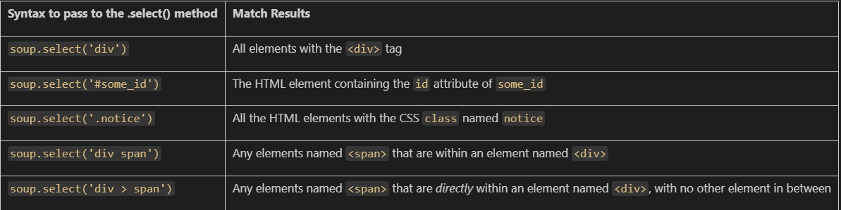

import requests, bs4  basePath = "https://www.aarpmedicareplans.com" ;  result = requests.get(basePath)  image =soup.select('img.loadOnlyDesktop')[0]  imgSrc = image['data-src']  downloaded_image_link = requests.get(basePath + imgSrc)  downloaded_image = open('downloaded_image.jpg', 'wb')  downloaded_image.write(downloaded_image_link.content)  downloaded_image.close() | EXTRACTING IMAGE AND DOWNLOAD  - ”wb” Creates a new file called 'downloaded_image.jpg' in write binary mode ('wb') using open()

FILES

I/O FILES

OPENING A FILE | - To open a file, we can use the `open()` function.  - It takes the file path and a mode as arguments. The mode can be `'r'` for reading, `'w'` for writing, `'a'` for appending, or `'x'` for creating a new file.  file = open("example.txt", "r")
READING FROM A FILE | - To read the contents of a file, we can use the `read()` or `readline()` methods of the file object.  - The `read()` method reads the entire file, while the `readline()` method reads one line at a time  file = open("example.txt", "r")  # Reading the entire file  content = file.read()  print(content)  # Reading one line at a time  line = file.readline()  print(line)  file.close()
READLINES | - The `readlines()` method is another way to read a file.  - It reads all the lines of a file and returns them as a list of strings. Each string represents a line from the file, including the newline character (`'\n'`) at the end of each line.  with open("example.txt", "r") as file:  lines = file.readlines()  for line in lines:  print(line)  In this example, the `readlines()` method is used to read all the lines from the file "example.txt". The lines are stored in the `lines` variable as a list of strings. The `for` loop is then used to iterate over each line and print it.  Note: that each line retrieved from `readlines()` includes the newline character (`'\n'`) at the end. If we want to remove the newline character, we can use the `strip()` method on each line:  with open("example.txt", "r") as file:  lines = file.readlines()  for line in lines:  line = line.strip()  print(line)
WRITING TO A FILE | - To write to a file, we can use the `write()` method of the file object.  - It writes the given content to the file. If the file doesn't exist, it creates a new file. If the file already exists, it overwrites the existing content  file = open("example.txt", "w")  file.write("Hello, World!")  file.write("End Of File !")  file.close() NOTE – Python will write a file once it is closed – other wise it will be kept in buffer
APPENDING TO A FILE | - To append content to an existing file, you can open the file in append mode (`'a'`) and then use the `write()` method to write the content  file = open("example.txt", "a")  file.write("This is additional content.")  file.close()
CLOSING A FILE | - After performing I/O operations on a file, it's important to close the file to release system resources.  - We can use the `close()` method of the file object to close the file  file = open("example.txt", "r")  content = file.read()  print(content)  file.close()

WITH STATEMENT

- We can use the `with` statement when working with files, as it automatically takes care of closing the file.  - In this example, the file is automatically closed when the `with` block is exited, even if an exception occurs. | with open("example.txt", "r") as file:  content = file.read()  print(content)

CURSORS IN FILE READING
- When reading a file in Python, we can use cursors to control the position within the file.
- The cursor, also known as the file pointer, keeps track of the current position in the file from which the next read operation will start.

CURSOR-RELATED METHODS FOR FILE READING

seek(offset[, whence])`: Sets the cursor's position in the file.  - `offset`: The number of bytes to move. Positive offsets move forward, and negative offsets move backward.  - `whence` (optional): Specifies the reference position for the offset. Default is 0 (beginning of the file).  - `0`: Beginning of the file  - `1`: Current position  - `2`: End of the file | tell()`: Returns the current position of the cursor in the file.
EXAMPLE
- In this example, the `seek()` method is used to move the cursor to different positions within the file.  - The `tell()` method is used to retrieve the current position of the cursor.  - The `readline()` method is used to read the first line,  - `read()` method is used to read the entire file or a specific number of characters.  - Finally, the cursor is moved to the end of the file, and the `read()` method is used again to read the last 5 characters. | with open("example.txt", "r") as file:  # Read the first line  line1 = file.readline()  print(line1)  # Get the current position of the cursor  position = file.tell()  print("Current position:", position)  # Move the cursor to the beginning of the file  file.seek(0)  # Read the entire file starting from the beginning  content = file.read()  print(content)  # Move the cursor to the end of the file  file.seek(0, 2)  # Read the last 5 characters  last_chars = file.read(5)  print("Last 5 characters:", last_chars)

MODES

WORKING WITH SPREADSHEETS(CSV)

READING CSVs
- There are multiple ways to read / write in a CSV file . In the below example – we will be using built it CSV module in python
import csv

# Step 1 - Open the file
data = open('C:\\Users\\asinha37\\AviRepo\\Python\\python-exercises\\python-exercies\\resources\\example.csv',
encoding='utf-8')
example.csv
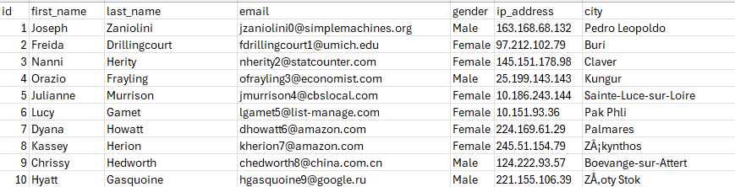
# Step 2 - Call csv.reader on data
data_csv = csv.reader(data)

NOTE: if csv is separated by different delimiter(other than “,”) and we want to read the file as CSV we need to specify
# Step 3 - Reformat it to python object i.e list of list
data_lines = list(data_csv)

for data_line in data_lines[:5]:
print(data_line)

data.close()
OUTPUT
['id', 'first_name', 'last_name', 'email', 'gender', 'ip_address', 'city']
['1', 'Joseph', 'Zaniolini', 'jzaniolini0@simplemachines.org', 'Male', '163.168.68.132', 'Pedro Leopoldo']
['2', 'Freida', 'Drillingcourt', 'fdrillingcourt1@umich.edu', 'Female', '97.212.102.79', 'Buri']
['3', 'Nanni', 'Herity', 'nherity2@statcounter.com', 'Female', '145.151.178.98', 'Claver']
['4', 'Orazio', 'Frayling', 'ofrayling3@economist.com', 'Male', '25.199.143.143', 'Kungur']
- Note : The data_csv will be the list of list
PRINT TO 10 EMAILS FROM CSV  - Started the iteration from 2nd item as the 1st item is column heading | for data_line in data_lines[1:11]:  print(data_line[3])
PRINT LIST OF FULL NAME TO CSV | for data_line in data_lines[1:]:  print("{first_name},{last_name}".format(first_name=data_line[1], last_name=data_line[2]))

DELIMITERS
In Python's csv module, the delimiter parameter is used to specify the character that separates fields (columns) in each row of the CSV file.
csv.reader(file, delimiter=',')
- delimiter: A one-character string used to separate fields.
- Default is , (comma), which is standard for CSV (Comma-Separated Values).
- We can change it to any character depending on the file format:
  - \t → for TSV (Tab-Separated Values)
  - ; → common in European CSVs
  - | → sometimes used in log files
  - : or other custom delimiters
Comma-separated (default): | csv.reader(file) # same as delimiter=','
Tab-separated | csv.reader(file, delimiter='\t')
Pipe-separated | csv.reader(file, delimiter='|')
EXAMPLE: READING A TAB-SEPARATED FILE (TSV)
Let's say you have a file called data.tsv with the following content:
data.tsv | Code | O/p
Name Age City  Alice 30 New York  Bob 25 Los Angeles  Charlie 35 Chicago | import csv  with open('data.tsv', newline='') as file:  reader = csv.reader(file, delimiter='\t')  for row in reader:  print(row) | ['Name', 'Age', 'City']  ['Alice', '30', 'New York']  ['Bob', '25', 'Los Angeles']  ['Charlie', '35', 'Chicago']

WRITING CSVs

WRITING TO FILE for ANOTHER FILE (example.csv)
list_of_full_name=[];
for data_line in data_lines[1:]:
list_of_full_name.append(data_line[1]+" "+ data_line[2])
# Writing to file in csv format
file_to_output = open('C:\\Users\\asinha37\\AviRepo\\Python\\python-exercises\\python-exercies\\resources\\full_name.csv', mode="w", newline= '')
csv_writer = csv.writer(file_to_output, delimiter=',')
csv_writer.writerow(['Full Name'])
for full_name in list_of_full_name:
csv_writer.writerow([full_name])
file_to_output.close()
- The `csv_writer.writerow()` function is used to write a single row to a CSV file using the `csv` module.  - It takes a list or tuple as an argument, where each element represents a column value in the row. | import csv  # Open the CSV file in write mode  with open('example.csv', 'w', newline='') as file:  csv_writer = csv.writer(file)  # Write a single row to the CSV file  csv_writer.writerow(['a', 'b', 'c'])  - In the above example, the `csv_writer.writerow(['a', 'b', 'c'])` statement writes a single row with three columns ('a', 'b', 'c') to the CSV file.
- `csv_writer.writerows()` function is used to write multiple rows to a CSV file.  - It takes an iterable of rows, where each row is represented as a list or tuple. | import csv  # Open the CSV file in write mode  with open('examp le.csv', 'w', newline='') as file:  csv_writer = csv.writer(file)  # Write multiple rows to the CSV file  csv_writer.writerows([['a', 'b', 'c'], ['x', 'y', 'z']])  - In the above example, the csv_writer.writerows([[‘a,’b’,’c’],[‘x’,’y’,’z’]]) statement writes two rows to the CSV file. The first row contains ('a', 'b', 'c') and the second row contains ('x', 'y', 'z').
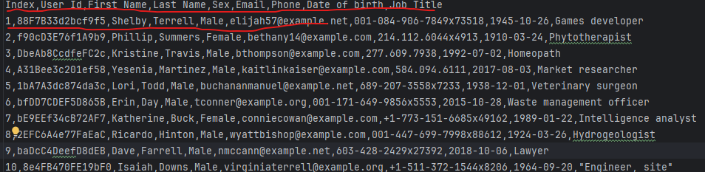
CSV TO DICTIONARY  {  'Date of birth': '1945-10-26',  'Email': 'elijah57@example.net',  'First Name': 'Shelby',  'Index': '1',  'Job Title': 'Games developer',  'Last Name': 'Terrell',  'Phone': '001-084-906-7849x73518',  'Sex': 'Male',  'User Id': '88F7B33d2bcf9f5'  } | with open("resources/people.csv") as file:  csv_dict_reader = csv.DictReader(file)  people_list = list(csv_dict_reader)  for people in people_list:  if people['First Name'] == 'Shelby':  pprint(people)

TIP

JOINING LIST – The Join method can be used to join the elements of the list using a given separator
list_of_names = ["John", "Jane", "Jim", "Jack", "Jill"]
seperator = " & "
joined_string = seperator.join(list_of_names)
print(joined_string)
OUTPUT : John & Jane & Jim & Jack & Jill

WORKING WITH JSON

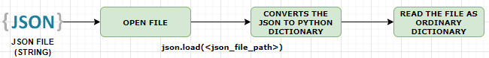
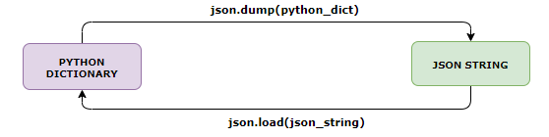
READ JSON FILE  import json  json_file = open("friends.json", "r")  json_data = json.load(json_file)  json_file.close()  print(type(json_data))  print("Json Data :\n", json_data)  # Extracting data from json  print("[friends][0][\"name\"]:", json_data["friends"][0]["name"])  #Looping  friend_list = json_data["friends"]  for friend in friend_list:  print(f"Friend is {friend['name']} and age is {friend['age']}") | - The json.load() function is a method in the Python json module that is used to parse JSON data from a file-like object and convert it into a Python object(Dictionary)
WRITE TO JSON FILE
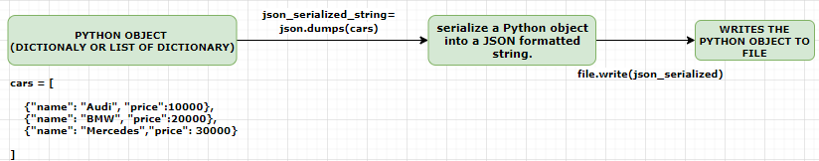
# cars dictionary  cars = [  {"name": "Audi", "price": 10000},  {"name": "BMW", "price": 20000},  {"name": "Mercedes", "price": 30000}  ]  file = open("cars.json", "w")  file.write(json.dumps(cars))  file.close() | - To write the Python object to file , we need to serialize it  - The json.dumps() function is a method in the Python json module that is used to serialize a Python object into a JSON formatted string.  - It takes a Python object as input and returns a string representation of that object in JSON format.
CONVERT JSON STRING TO JSON

json_str = '[{"name": "Audi", "price": 10000}, {"name": "BMW", "price": 20000}, {"name": "Mercedes", "price": 30000}]'
json_cars = json.loads(json_str)
print(type(json_cars))
print(type(json_cars[0]))
print("Car Name:",json_cars[0]["name"])
- The json.loads() function is a method in the Python json module that is used to parse a JSON formatted string and convert it into a Python object. It takes a JSON string as input and returns a corresponding Python object.

Json.dumbs() versus json.dump()

json.dumps()
- Stands for: dump string  - Purpose: Converts a Python object into a JSON-formatted string.  - Use case: When you want to store or transmit JSON data as a string (e.g., sending over a network, saving to a database). | import json  data = {"name": "Alice", "age": 25}  json_string = json.dumps(data)  print(json_string) # Output: {"name": "Alice", "age": 25}
json.dump()
- Stands for: dump to file  - Purpose: Writes a Python object as JSON directly to a file-like object.  - Use case: When you want to save JSON data to a file. | import json  data = {"name": "Alice", "age": 25}  with open("data.json", "w") as f:  json.dump(data, f)
CSV TO JSON
with open('resources/people.csv', "r") as file:
csv_reader = csv.DictReader(file)
csv_data = list(csv_reader)
with open('resources/people.json', "w") as json_file:
# people_data = json.loads(json_data)
json.dump(csv_data,json_file,indent=2)

WORKING WITH PDFs
- We will be using PyPDF2 free open source library to extract and read files
INSTALL PyPDF2 Library | pip install PyPDF2
- Below code demonstrates how to read and extract text from a PDF file using the `PyPDF2` library.
import PyPDF2
with open('C:\\Users\\asinha37\\AviRepo\\Python\\python-exercises\\python-exercies\\resources\\Working_Business_Proposal.pdf', 'rb') as file:
reader = PyPDF2.PdfReader(file)
num_of_pages = len(reader.pages)
print("Number of Pages=",num_of_pages)
page = reader.pages[0] # reading the first page
print(page.extract_text()) # extracting text from the first page
- Opens a PDF file in binary read mode (`'rb'`). This is done using a `with` statement to ensure the file is properly closed after its contents are read.
- Within the `with` block, a `PdfReader` object is created by passing the opened file to `PyPDF2.PdfReader`. This object allows access to the PDF's content.
- The number of pages in the PDF is determined by checking the length of the `pages` attribute of the `PdfReader` object.
- The code then reads the first page of the PDF by accessing the first element of the `pages` list. The text content of this page is extracted using the `extract_text()` method.

WRITING TO PDFs
- To write to PDF files using the PyPDF2 library in Python, qw can perform operations such as merging, splitting, or adding content to existing PDFs(we cannot write in middle of the page in the using PyPDF2).
ADDING PAGE TO PDF
import PyPDF2
with open('C:\\Users\\asinha37\\AviRepo\\Python\\python-exercises\\python-exercies\\resources\\Working_Business_Proposal.pdf', 'rb') as file:
reader = PyPDF2.PdfReader(file)
page = reader.pages[0] # reading the first page
print(page.extract_text())
with open('C:\\Users\\asinha37\\AviRepo\\Python\\python-exercises\\python-exercies\\resources\\Working_Business_Proposal_Page1.pdf', 'ab') as pdf_file:
writer = PyPDF2.PdfWriter()
writer.add_page(page)
writer.write(pdf_file)

EXAMPLE
Create a console-based book store system that allows users to:
  - ENTER AND RETRIEVE BOOK DETAILS.
  - MARK BOOKS AS READ (MEANING THEY’VE FINISHED READING THEM).
  - DELETE EXISTING BOOKS.
Note – Save the Data in CSV file
csv_database.py | prompts.py
import csv  BOOKS_FILE = "books.csv"  def add_book(name, author):  with open(BOOKS_FILE, "a") as bookdb:  bookdb.write(f"{name},{author},0\n")  def list_books():  with open(BOOKS_FILE, "r") as bookdb:  lines = [book.strip().split(",") for book in bookdb.readlines()]  for line in lines:  print(f"name: {line[0]}, author: {line[1]}, read: {line[2]}")  def read_book(name):  with open(BOOKS_FILE, "r") as bookdb:  lines = [book.strip().split(",") for book in bookdb.readlines()]  for line in lines:  if line[0] == name:  line[2] = "1"  _save_all_books(lines)  def delete_book(name):  with open(BOOKS_FILE, "r") as bookdb:  lines = [book.strip().split(",") for book in bookdb.readlines()]  lines = [line for line in lines if line[0] != name]  _save_all_books(lines)  def _save_all_books(lines):  with open(BOOKS_FILE, "w") as bookdb:  for line in lines:  bookdb.write(f"{line[0]},{line[1]},{line[2]}\n") | #import utils.database as database  import utils.csv_database as database  def prompt_add_book():  name = input('Enter the name of the book:')  author = input('Enter the author of the book:')  database.add_book(name, author)  def prompt_list_books():  database.list_books()  def prompt_read_book():  name = input('Enter the name of the book you just finished reading:')  database.read_book(name)  def prompt_delete_book():  name = input('Enter the name of the book you want to delete:')  database.delete_book(name)
app.py
import prompts.prompts as prompts
USER_CHOICE = """
Enter:
- 'a' to add a book
- 'l' to list all books
- 'r' to mark a book as read
- 'd' to delete a book
- 'q' to quit
Your choice:"""
operations = {
'a': prompts.prompt_add_book,
'l': prompts.prompt_list_books,
'r': prompts.prompt_read_book,
'd': prompts.prompt_delete_book
}
def menu():
user_input = input(USER_CHOICE)
while user_input != 'q':
if user_input and user_input in operations.keys():
operations[user_input]()
else:
print('Invalid input. Please try again.')
user_input = input(USER_CHOICE)
menu()

OS MODULE

DATABASE OPERATION – SQLITE
- SQLite is a lightweight, serverless, and self-contained relational database management system (RDBMS).
- It is embedded within many applications and used as a local database storage solution.
- We can interact with SQLite using SQL (Structured Query Language) statements.
- For Python comes with SQLite already installed
LIMITATIONS OF SQLITE:
- Concurrent access: SQLite is not suitable for high-concurrency environments where multiple users need simultaneous write access to the database. It is designed for single-user or low-concurrency scenarios.
- Scalability: SQLite is not designed for handling large amounts of data. As it is a file-based database, performance may degrade when dealing with very large datasets.
- Client-Server architecture: Unlike traditional relational databases, SQLite does not have a client-server architecture. It is embedded within the application, which means it lacks features like remote access and centralized management.
ADVANTAGES OF SQLITE:
- Simplicity and Lightweight: SQLite is a self-contained, serverless database that requires minimal setup and administration. It is easy to deploy and operate, making it suitable for small-scale applications or situations where simplicity is preferred.
- Zero-Configuration: SQLite does not require any complex configuration or administration. The database is stored in a single file, making it portable and easy to distribute.
- ACID-compliant: SQLite ensures data integrity by supporting ACID (Atomicity, Consistency, Isolation, Durability) properties. It guarantees that database transactions are reliably executed and provide consistency.
- Cross-platform Compatibility: SQLite is available on various platforms, including Windows, macOS, Linux, and mobile operating systems like Android and iOS. This allows for easy development and deployment across different environments.
- Wide Language Support: SQLite has bindings for many programming languages, including Python, Java, C/C++, and more. This makes it accessible and usable in a wide range of applications.

SQLITE TERMINOLOGIES

CURSORS
- In SQLite, a cursor is an object that allows us to traverse and manipulate the records returned by a SELECT statement.
- Cursors provide a way to iterate over the result set and perform various operations on the data.

import sqlite3  # Connect to the SQLite database  conn = sqlite3.connect('example.db')  # Create a cursor object  cursor = conn.cursor()  # Execute a SELECT statement  cursor.execute('SELECT * FROM employees')  # Fetch all rows from the result set  rows = cursor.fetchall()  # Iterate over the rows and print the data  for row in rows:  print(row)  # Close the cursor and the database connection  cursor.close()  conn.close() | - In this example, we first import the `sqlite3` module and establish a connection to the SQLite database using the `connect()` function. We then create a cursor object using the `cursor()` method of the connection.  - Next, we execute a SELECT statement using the `execute()` method of the cursor. The result set is fetched using the `fetchall()` method, which returns all the rows.  - We then iterate over the rows using a loop and print the data. Each row is represented as a tuple.  - Finally, we close the cursor and the database connection using the `close()` method.  - Cursors in SQLite provide additional methods like `fetchone()` to retrieve one row at a time, `fetchmany(n)` to fetch a specific number of rows, and methods like `execute()` to perform other SQL operations like INSERT, UPDATE, and DELETE.

CONTEXT MANAGER
- A context manager in Python is an object that defines the methods `__enter__()` and `__exit__()` to enable the management of resources and the execution of specific actions before and after a block of code.
- By utilizing context managers, we can write cleaner and more readable code that handles resource management and cleanup tasks automatically, reducing the chances of resource leaks and improving code efficiency.
- It allows for the automatic acquisition and release of resources. For example,
  - Opening and closing files
  - Acquiring and releasing locks
  - Establishing and closing database connections.
CONTEXT MANAGER FLOW
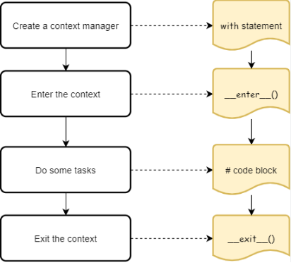

class MyContextManager:  def __init__(self): 1. CREATES CONTEXT MANAGER  print('Initializing context')  def __enter__(self): 2. ENTER THE CONTEXT  print("Entering the context")  return “my value”  def __exit__(self, exc_type, exc_value, traceback): 4. EXIT THE CONTEXT  print("Exiting the context")  # Using the context manager with the 'with' statement  with MyContextManager() as value:  print("Inside the context") 3. DO SOME TASK  print(value) 3. PRINT “my value” | OUTPUT  Initializing context 1  Entering the context 2  Inside the context 3  my value  Exiting the context 4

DUNDER METHODS IN CONTEXT MANAGER
- The `__enter__()` method is called when entering the context, and it sets up the necessary resources or performs any required setup actions. It returns an object that represents the context or resource.
- The `__exit__()` method is called when exiting the context, and it performs any cleanup actions or resource release tasks. It takes parameters that represent the exception type, value, and traceback, allowing for exception handling within the context.
- The most common way to work with a context manager is by using the `with` statement. The `with` statement automatically calls the `__enter__()` method to set up the context and ensures that the `__exit__()` method is always called, even if an exception occurs within the `with` block.

EXAMPLE

IN BUILT CONTEXT MANAGER

- We can use the `with` statement when working with files, as it automatically takes care of closing the file.  - In this example, the file is automatically closed when the `with` block is exited, even if an exception occurs. | with open("example.txt", "r") as file:  content = file.read()  print(content)

CUSTOM CONTEXT MANAGER
In the below example we can observe the advantage of using context manager
OLD CODE
database.py
import sqlite3
DB_FILE = "data.db"
TABLE_NAME = "books"

def create_book_table():
connection = sqlite3.connect(DB_FILE)
cursor = connection.cursor()
cursor.execute(f"CREATE TABLE IF NOT EXISTS {TABLE_NAME} (name text primary key, author text, read integer)")
connection.commit()
connection.close()
UPDATING CODE USING CONTEXT MANAGER
CONTEXT MANAGER
import sqlite3
class DatabaseConnection:
def __init__(self, db_host):
self.db_host = db_host
self.connection = None
def __enter__(self):
connection = sqlite3.connect(self.db_host)
self.connection = connection
return connection
def __exit__(self, exc_type, exc_value, traceback):
self.connection.commit()
self.connection.close()
USING THE CONTEXT MANAGER IN CODE
from utils.database_connection import DatabaseConnection
TABLE_NAME = "books"
DB_FILE = "data.db"
def create_book_table():
with DatabaseConnection(DB_FILE) as connection:
cursor = connection.cursor()
cursor.execute(f"CREATE TABLE IF NOT EXISTS {TABLE_NAME} (name text primary key, author text, read integer)")
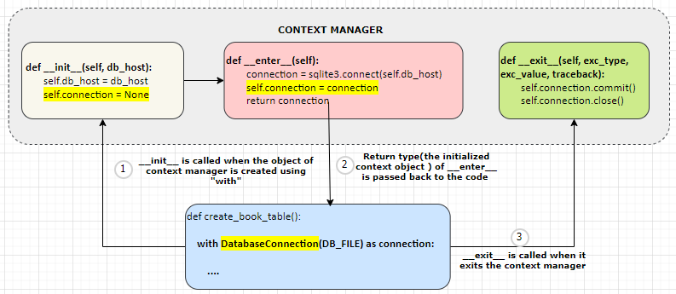

ERRORS IN CONTEXT MANAGER
- When an exception occurs within a context manager, the __exit__() method is responsible for handling the exception and performing any necessary cleanup actions. The context manager can choose to handle the exception, suppress it, or re-raise it after performing cleanup.
def __exit__(self, exc_type, exc_value, traceback):
pass
exc_type | The exc_type argument represents the exception type | When no exception is raised the values are “None” for all these parameters
exc_value | exc_value represents the exception value
traceback | traceback provides information about the traceback.
But – when the exception occurs – above parameter get values bases on type of exception occurred!
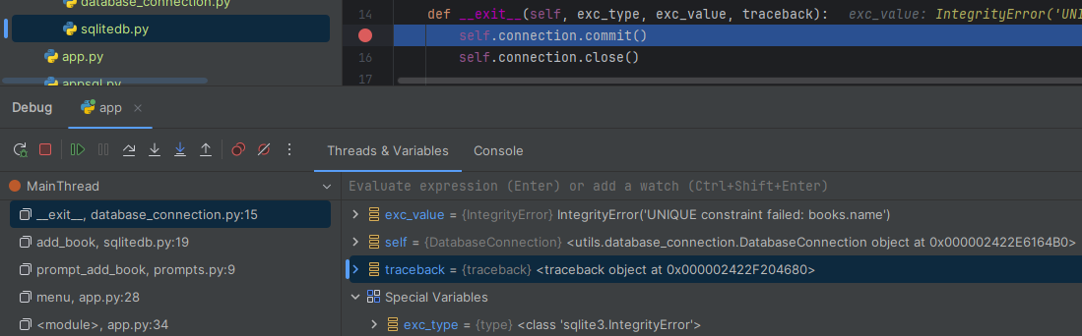

EXAMPLE- HANDLING EXCEPTION IN CONTEXT MANAGER
- In the below example – We are closing the database connection with committing to database whenever exception occurs in the context manager
OLD CODE | EXCEPTION HANDLING
def __exit__(self, exc_type, exc_value, traceback):  self.connection.commit()  self.connection.close() | def __exit__(self, exc_type, exc_value, traceback):  if exc_type or exc_value or traceback:  self.connection.close()  self.connection.commit()  self.connection.close()

TYPING
- The typing module in Python provides support for type hints, allowing developers to indicate the types of variables, function arguments, and return values.
- It improves code readability, enables better IDE support (e.g., autocompletion and type checking), and helps catch bugs during development.
BASIC TYPE HINTS: We can use built-in types like int, str, float, bool, etc. | def add(a: int, b: int) -> int:  return a + b
TYPING FOR COLLECTIONS: Use List, Tuple, Set, Dict, etc., to indicate the types of elements within a collection. | from typing import List, Tuple  def even_nums(data: List[int]) -> List[int]:  return [num for num in data if num % 2 == 0]  def min_max(data: List[int]) -> Tuple[int, int]:  return min(data), max(data)  print(even_nums([1, 2, 3, 4, 5]))  print(min_max([1, 2, 3, 4, 5]))
UNION: Allows a value to be one of several types.For example- below example returns either int or string | from typing import Union  def process(value: Union[int, str]) -> str:  return str(value)
Optional: A shorthand for Union[T, None] (used for nullable values). | from typing import Optional  def greet(name: Optional[str] = None) -> str:  if name:  return f"Hello, {name}!"  return "Hello!"  print(greet("Alice"))  print(greet())
ANY: Indicates that any type is allowed. | from typing import Any  def print_message(mesage:Any)->None:  print(mesage)  print(1)  print('hello')
Callable: Represents a callable (like functions) with specific argument and return types.

def calculate(fn: Callable[[int, int], int], a: int, b: int) -> int:
return fn(a, b)
print(calculate(lambda a, b: a + b, 10, 5))
print(calculate(lambda a, b: a - b, 10, 5))
print(calculate(lambda a, b: a * b, 10, 5))
print(calculate(lambda a, b: a / b, 10, 5))
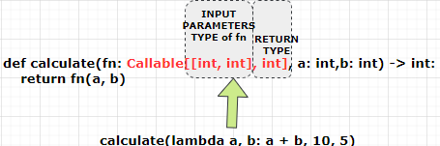
TYPE ALIAS: Create a custom type alias for readability.  - In this example, we use List[Dict[str, Union[int, str]]] as the type hint for the slist variable.  - It indicates that data is a list of dictionaries where the keys are strings and the values can be string or integers. | from typing import List, Dict  StudentList = List[Dict[str, Union[int,str]]]  def print_student_name(slist: StudentList) -> None:  for student in slist:  print(f"Name: {student['name']} Age: {student['age']}")  print_student_name([  {'name': 'Alice', 'age': 20},  {'name': 'Bob', 'age': 22},  {'name': 'Charlie', 'age': 21}  ])
Generic Types: Use Generic to create reusable, type-safe components. | from typing import TypeVar, Generic, List  T = TypeVar('T') # Declare a type variable  class Stack(Generic[T]):  def __init__(self):  self.items: List[T] = []  def push(self, item: T) -> None:  self.items.append(item)  def pop(self) -> T:  return self.items.pop()
Literal (Python 3.8+): Specify exact values a variable can take. | from typing import Literal  def move(direction: Literal["left", "right", "up", "down"]) -> str:  return f"Moving {direction}"
Self (Python 3.11+): Refers to the instance of the class in type hints for method chaining. | class Builder:  def set_name(self, name: str) -> Self:  self.name = name  return self
NewType: Create distinct types from existing ones. | from typing import NewType  UserId = NewType('UserId', int)  def get_user(user_id: UserId) -> str:  return f"User {user_id}"

STATIC TYPE CHECKING
- mypy is a static type checker for Python. It helps catch type errors in the code before runtime by allowing us to annotate the Python code with type hints. mypy analyze type hints for correctness without executing the code
INSTALLATION | pip install mypy
RUNNING mypy for a file | mypy <file_name>  Example - mypy example.py

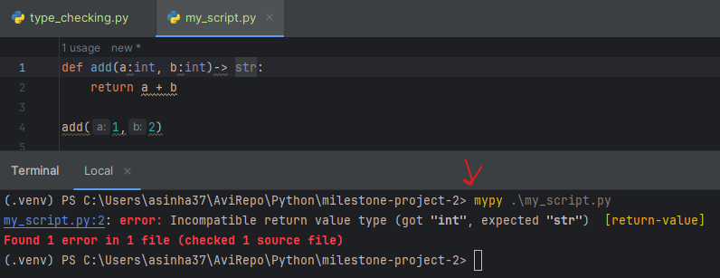

LOGGING
- Logging in Python is a built-in module that allows us to record and display log messages from the application.
- It helps in tracking the flow of the program, debugging issues, and monitoring its behavior.
- The logging module provides a flexible and configurable logging system with different log levels and output destinations.
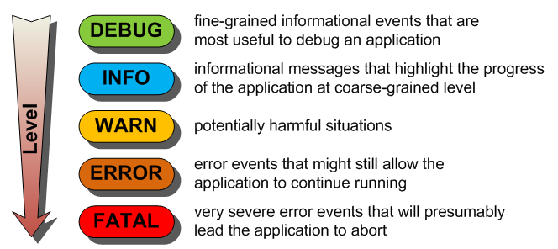
VISIBILITY OF LOGS IN DIFFERENT LOG LEVELS
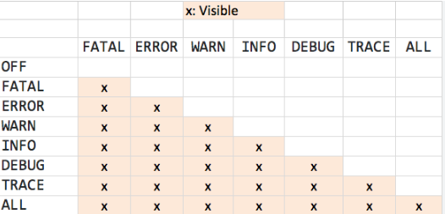

SIMPLE LOGGER

import logging Step 1

# Configure the logging system Step 2
logging.basicConfig(level=logging.DEBUG,
format='%(asctime)s - %(levelname)-8s [%(filename)s:%(lineno)d]- %(message)s',
filename='app.log',
datefmt='%Y-%m-%d %H:%M:%S')
)

# Create a logger object
logger = logging.getLogger(__name__)

# Log messages at different levels
logger.debug('This is a debug message')
logger.info('This is an info message')
logger.warning('This is a warning message')
logger.error('This is an error message')
logger.critical('This is a critical message')
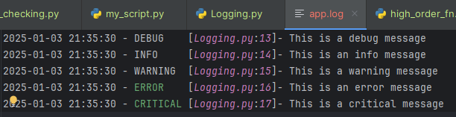

STEPS TO CONFIGURE LOGGING
- Step 1: Import `logging` module.
- Step 2: Configure the logging system using basicConfig()
- basicConfig() is a function provided by the `logging` module in Python. It is used to configure the logging system by specifying various settings such as the log level, output format, and destination.
- The `basicConfig()` function should be called once at the beginning of your program before any log messages are generated. It helps in setting up the logging system according to your requirements.

SYNTAX | logging.basicConfig(**kwargs)  The `**kwargs` represents a set of keyword arguments that can be used to configure the logging system

level | - Specifies the log level to be displayed. The available log levels are `DEBUG`, `INFO`, `WARNING`, `ERROR`, and `CRITICAL`.  - Messages with a log level equal to or higher than the specified level will be displayed. For example, if we set `level=logging.DEBUG`, all log messages will be displayed
filename | - Specifies the name of the file where the log messages will be written.  - If this argument is provided, the log messages will be written to the specified file instead of being displayed in the console.
filemode | - Specifies the mode in which the log file will be opened.  - The available modes are `a` (append) and `w` (overwrite). By default, the log file is opened in append mode.
format | - Specifies the format of the log messages. This argument allows us to customize the appearance of log messages by specifying placeholders that will be replaced with the actual log information.  - Some commonly used placeholders are below (“s”- represents the string conversion)  %(asctime)s` (timestamp), `%(levelname)s` (log level), and `%(message)s.
datefmt | - Specifies the format of the timestamp in the log messages.  - This argument is used in conjunction with the `%(asctime)s` placeholder in the `format` argument. By default, the timestamp format is `%Y-%m-%d %H:%M:%S`.
stream | - Specifies the output stream where the log messages will be written. By default, the log messages are displayed in the console (`sys.stderr`).
filename , lineno | lineno and filename are placeholders that can be used in the log message format to include the line number and the name of the file where the logging statement is executed.  Ex - logging.basicConfig(level=logging.DEBUG, format='%(asctime)s - %(levelname)-8s [%(filename)s:%(lineno)d]- %(message)s', filename='app.log')
- Step 3 – CREATE A LOGGER OBJECT
- Create a logger object using `getLogger(__name__)
- The `__name__` variable represents the name of the current module, which helps in identifying the source of log messages.
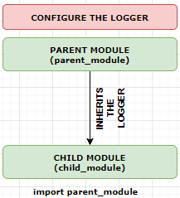
parent_module.py
import logging
# Configure logging in the parent module
logging.basicConfig(level=logging.CRITICAL, format='%(asctime)s - %(name)s - %(levelname)s - %(message)s')
# Get the logger for the parent module
logger = logging.getLogger(__name__)
# Log a message in the parent module
logger.debug('This is a debug message in the parent module')
logger.info('This is an info message in the parent module')
logger.warning('This is a warning message in the parent module')
logger.error('This is an error message in the parent module')
logger.critical('This is a critical message in the parent module')
child_module.py
import logging
import parent_module
# Inherit the logger from the parent module
logger = logging.getLogger(__name__)
# Customize the logger in the child module
logger.setLevel(logging.INFO)
logger.name = 'child_module'
# Log a message in the child module
logger.debug('This is a debug message in the child module')
logger.info('This is an info message in the child module')
logger.warning('This is a warning message in the child module')
logger.error('This is an error message in the child module')
logger.critical('This is a critical message in the child module')
OUTPUT
2025-01-04 12:59:42,561 - parent_module - CRITICAL - This is a critical message in the parent module
2025-01-04 12:59:42,561 - child_module - INFO - This is an info message in the child module
2025-01-04 12:59:42,561 - child_module - WARNING - This is a warning message in the child module
2025-01-04 12:59:42,561 - child_module - ERROR - This is an error message in the child module
2025-01-04 12:59:42,562 - child_module - CRITICAL - This is a critical message in the child module
- Step 4: Finally, we log messages at different levels using the logger object. The log messages will be displayed in the console according to the configured log level and format.

DECORATORS

ASSIGNING FUNCTION TO VARIABLE
- Functions can be assigned to variables, just like any other object. Assigning a function to a variable allows us to refer to the function using that variable name and call the function through the variable.
- In this example, the `greet` function is defined, which prints "Hello, world!". The `my_function` variable is then assigned the value of the `greet` function. When `my_function()` is called, it behaves the same as calling `greet()`, printing "Hello, world!". | def greet():  print("Hello, world!")  my_function = greet  my_function()
- We can also pass the function assigned to a variable as an argument to another function or return it from a function:  - In this example, the `wrapper` function takes a function as an argument and executes it. The `my_function` variable, which holds the `greet` function, is passed as an argument to `wrapper`. When `wrapper(my_function)` is called, it first prints "Before function execution", then calls `my_function()` (which is equivalent to calling `greet()`), and finally prints "After function execution". | def greet():  print("Hello, world!")  def wrapper(func):  print("Before function execution")  func()  print("After function execution")  my_function = greet  wrapper(my_function)
- Assigning functions to variables can be useful in scenarios like
  - Where we want to pass functions as arguments
  - Return functions from other functions
  - Dynamically choose which function to call based on certain conditions.
  - It provides flexibility and allows for more advanced programming techniques like higher-order functions and callbacks.

SCENARIOS

PASSING FUNCTIONS AS ARGUMENTS  def apply_operation(func, num):  return func(num)  def square(x):  return x ** 2  def cube(x):  return x ** 3  result = apply_operation(square, 5) # Passes the square function as an argument  print(result) # Output: 25  result = apply_operation(cube, 3) # Passes the cube function as an argument  print(result) # Output: 27 | RETURNING FUNCTIONS FROM OTHER FUNCTIONS  def get_operation(operation):  if operation == "add":  def add(a, b):  return a + b  return add  elif operation == "subtract":  def subtract(a, b):  return a - b  return subtract  operation_func = get_operation("add")  result = operation_func(3, 4) # Calls the returned add function  print(result) # Output: 7  operation_func = get_operation("subtract")  result = operation_func(8, 5) # Calls the returned subtract function  print(result) # Output: 3
DYNAMICALLY CHOOSING WHICH FUNCTION TO CALL
def fast_function():
print("Fast function called")

def slow_function():
print("Slow function called")

mode = "fast"
if mode == "fast":
function_to_call = fast_function
else:
function_to_call = slow_function

function_to_call() # Calls the chosen function based on the mode

DECORATORS
- A decorator is a design pattern in Python that allows us to modify or enhance the behavior of functions or classes without directly changing their source code.
- Decorators are functions that wrap around other functions or classes to provide additional functionality. They are denoted by the `@decorator` syntax, where `decorator` is a function that takes a function or class as input and returns a modified version of it.
- When a function or class is decorated, it is essentially passed as an argument to the decorator function, and the decorator function returns a new function or class that incorporates the modifications or enhancements.

PURPOSE OF DECORATORS
- ADDING FUNCTIONALITY:
  - To add new behavior or modify the existing behavior of functions or classes.
  - For example, we can use decorators to add logging, authentication, caching, or error handling to functions.
- MODIFYING BEHAVIOR:
  - To change the behavior of functions or classes by wrapping them with additional code.
  - This can be useful for tasks like input validation, parameter manipulation, or altering the return value.
- CODE ORGANIZATION:
  - Decorators can help organize and separate concerns in your code.
  - By separating cross-cutting concerns into decorators, we can keep the core functions or classes clean and focused on their primary responsibilities.
- REUSABILITY:
  - Decorators promote code reusability by allowing us to apply the same modifications or enhancements to multiple functions or classes. You can define a decorator function once and use it on multiple functions or classes throughout the codebase.

EXAMPLES

- In this example, we define a decorator function called uppercase_decorator.  - It takes a function as input (func) and defines an inner function called wrapper. The wrapper function wraps the execution of the original function (func) and modifies its result by converting it to uppercase. Finally, the wrapper function is returned.  - The @uppercase_decorator syntax is used to apply the uppercase_decorator to the say_hello function. This means that the say_hello function is wrapped with the functionality provided by the uppercase_decorator.  - When say_hello() is called, it executes the code inside the wrapper function. The wrapper function first calls the original say_hello function, which returns the string "Hello, world!". Then, it converts the original result to uppercase and returns the modified result, which is then printed. | def uppercase_decorator(func):  def wrapper():  original_result = func()  modified_result = original_result.upper()  return modified_result  return wrapper  @uppercase_decorator  def say_hello():  return "Hello, world!"  print(say_hello()) # Output: "HELLO, WORLD!"
- In this example, the `log_decorator` function is a decorator that wraps around the `add` function. When the `add` function is called, the decorator function adds logging statements before and after the function call. The output of the program shows the log messages, indicating the function call and completion.  - Decorators are a powerful feature in Python that provide flexibility, code organization, and modularity. They enable you to enhance and modify the behavior of functions and classes without directly modifying their source code, leading to cleaner and more maintainable code. | def log_decorator(func):  def wrapper(*args, **kwargs):  print(f"Calling function: {func.__name__}")  result = func(*args, **kwargs)  print(f"Function {func.__name__} completed")  return result  return wrapper  @log_decorator  def add(a, b):  return a + b  result = add(3, 4) # Output: Calling function: add, Function add completed  print(result) # Output: 7
CLASS DECORATORS  - When decorators applied to a class, a decorator can modify the class definition or add additional functionality to the class. | def add_perimeter(cls):  def calculate_perimeter(self):  return 2 * 3.14 * self.radius  cls.calculate_perimeter = calculate_perimeter  return cls  @add_perimeter  class Circle:  def __init__(self, radius):  self.radius = radius  def calculate_area(self):  return 3.14 * self.radius ** 2  circle = Circle(5)  print(circle.calculate_area())  print(circle.calculate_perimeter())

THREAD AND PROCESS

POOLING
- Definition: A program continuously checks for a specific condition or event (e.g., button press).
- Analogy: Waiting for a pizza delivery by repeatedly checking the front door.
- Process:
  - Constantly checking the condition (e.g., if the pizza person has arrived).
  - Uses a loop that runs over and over again.
  - Inefficient and exhausting (both for humans and computers).
""" Polling for Pizza Because I'm Hungry! """  import time  hungry = True # I need a pizza!  while hungry:  print('Opening the front door')  front_door = open('front_door.txt', 'r', encoding='utf-8')  if 'Delivery Person' in front_door:  print('The pizza is here!!!!!!!!!!')  hungry = False  else:  print('Not yet...')  print('Closing the front door.\n')  front_door.close()  time.sleep(1) # rest for 1 second | - Example Scenario: A Python script simulates checking for a pizza delivery.  - Steps in the Script:  - A hungry variable is set to True.  - A while loop runs as long as hungry is True.  - The program opens a file (front_door.txt) to simulate checking the door.  - If "delivery person" is found in the file, it prints a message and exits the loop.  - Otherwise, it prints “Not yet…” and repeats.  PROBLEMS WITH POLLING  - Resource Intensive: Consumes a lot of CPU cycles.  - Inefficient: Especially in high-level applications (e.g., GUI apps in Python or Java).  - Not Scalable: Prevents multitasking or slows down other processes.  IMPROVING POLLING WITH DELAYS  - Solution: Add a delay using time.sleep(1) to pause for 1 second between checks.  - Benefits:  - Reduces CPU usage.  - Makes the loop less aggressive.  - Uses interrupts to sleep efficiently without wasting CPU cycles.
front_door.txt
Welcome Mat
Door Bell
Delivery Person

EVENT DRIVEN PROGRAMMING
- Definition: The program waits passively for events to occur and responds only when necessary.
- Analogy: Waiting for the pizza delivery while relaxing, and only getting up when the doorbell rings or a timer goes off.
- Benefits:
  - More efficient than polling.
  - Conserves energy and CPU cycles.
  - Allows multitasking and responsiveness.
""" A Brief Study in Handling Life Events """

import asyncio
import time

def alarm(): # handler for when the alarm goes off
print('Wake Up!')
print('Calling the Pizza Company.\n')
loop.call_later(1, alarm) # schedule another alarm

def doorbell(): # handler for when the doorbell rings
print('Ding Dong!')
time.sleep(3)
print('Opening the door... "Thanks for bringing the pizza!"\n')
loop.stop()

def phonecall(): # handler for when the phone rings
print('Ring Ring!')
print('Answering the phone... "Hello! Who is this?"\n')

loop = asyncio.get_event_loop()
loop.call_later(1, alarm) # schedule initial alarm event
loop.call_later(4, doorbell) # schedule doorbell event
loop.call_later(5, phonecall) # schedule phone call event

print('Starting the event loop...\n')
loop.run_forever() # run until stop() is called

print('The event loop stopped; closing it down.')
loop.close()

COMMAND LINE ARGUMENT

ARGPARSE
- The argparse module is used to parse command-line arguments.
- It allows us to write user-friendly command-line interfaces and automatically generates help and usage messages.
- Imagine we create a Python script that prints a message. We want to choose what message to print without changing the code every time.  - argparse helps us do that by letting you pass values when running the script. | # greet.py  import argparse  # Create parser  parser = argparse.ArgumentParser(description="Say hello to someone.")  # Add argument  parser.add_argument("name", help="Name of the person")  # Parse arguments  args = parser.parse_args()  # Use the argument  print(f"Hello, {args.name}!")
COMMAND: python greet.py Alice
Output:Hello, Alice!

# greet_optional.py  import argparse  parser = argparse.ArgumentParser()  parser.add_argument("--name", default="world", help="Name to greet")  args = parser.parse_args()  print(f"Hello, {args.name}!") | - The --name argument is a named (optional) argument because it starts with --.  - The presence of default="world" means that if the user does not provide --name when running the script, the value "world" will be used automatically.  - If it were a required argument, you would need to specify required=True.  TO RUN  python greet_optional.py  ➡️ Hello, world!  or  python greet_optional.py --name Alice  ➡️ Hello, Alice!
python .\ greet.py --help
- When the code is executed with –help – it will show up the “help” text in the command line
usage: greet.py [-h] [--name NAME]

Say Hello to someone

options:
-h, --help show this help message and exit
--name NAME name of the person

TYPES OF COMMAND-LINE ARGUMENTS

1. POSITIONAL ARGUMENTS (REQUIRED)  These must be passed in the exact order.  # example1.py  import argparse  parser = argparse.ArgumentParser(description="Add two numbers")  parser.add_argument("x", type=int, help="First number")  parser.add_argument("y", type=int, help="Second number")  args = parser.parse_args()  print("Sum:", args.x + args.y) |  | python example1.py 5 10  Output: Sum: 15
2. OPTIONAL ARGUMENTS (NOT REQUIRED, HAVE DEFAULTS)  # example2.py  import argparse  parser = argparse.ArgumentParser()  parser.add_argument("--greeting", help="Greeting word", default="Hello")  parser.add_argument("--name", help="Name to greet", default="World")  args = parser.parse_args()  print(f"{args.greeting}, {args.name}!") |  | python example2.py  ➡️ Hello, World!  python example2.py --name Alice --greeting Hi  ➡️ Hi, Alice!
3. BOOLEAN FLAGS (JUST TOGGLE THEM ON/OFF)  # example3.py  import argparse  parser = argparse.ArgumentParser()  parser.add_argument("--shout", action="store_true", help="Shout the greeting")  args = parser.parse_args()  message = "Hello, there!"  if args.shout:  message = message.upper()  print(message) | python example3.py  ➡️ Hello, there!  python example3.py --shout  ➡️ HELLO, THERE!  - action="store_true" means:  - If -- shout is included on the command line, the value will be True.  - If -- shout is not included, the value will be False.
4. CHOICES (LIMIT INPUT TO FIXED VALUES)  # example4.py  import argparse  parser = argparse.ArgumentParser()  parser.add_argument("--language", choices=["English", "Hindi", "Spanish"], help="Select a language")  args = parser.parse_args()  print(f"You chose: {args.language}") | python example4.py --language Hindi  ➡️ You chose: Hindi  python example4.py --language French  ❌ Error: Invalid choice
5. MULTIPLE VALUES (LISTS)  # example5.py  import argparse  parser = argparse.ArgumentParser()  parser.add_argument("--nums", nargs="+", type=int, help="List of numbers")  args = parser.parse_args()  print("You entered:", args.nums)  print("Total:", sum(args.nums)) | python example5.py --nums 1 2 3 4  ➡️ You entered: [1, 2, 3, 4]  ➡️ Total: 10  - nargs="+": This means the argument expects one or more values.

EXAMPLES

import argparse  # Create parser  parser = argparse.ArgumentParser(description="Add two numbers")  # Add arguments  parser.add_argument("a", type=int, help="First number")  parser.add_argument("b", type=int, help="Second number")  # Parse arguments  args = parser.parse_args()  # Use arguments  print(f"Sum: {args.a + args.b}") | How to Run This Script  If saved as add.py, you can run it from the terminal like:  python add.py 5 7  Output:Sum: 12

The add_argument() function in Python's argparse module is used to define what command-line arguments your script accepts.
Syntax:parser.add_argument(name or flags, **options)

Common Parameters Explained:
Parameter | Description
name or flags | The name of the argument. Positional (e.g., "filename") or optional (e.g., "--verbose").
type | The expected data type (e.g., int, str, float).
help | A description of the argument (used in --help).
default | A default value if the argument is not provided.
required | If True, the argument must be provided (used with optional args).
action | Special behavior like store_true, store_false, etc.
choices | A list of valid values.
nargs | Number of arguments expected (e.g., ?, *, +, or a number).
Example:
import argparse

parser = argparse.ArgumentParser()

# Positional argument
parser.add_argument("filename", type=str, help="Name of the file to process")

# Optional argument
parser.add_argument("--verbose", action="store_true", help="Enable verbose output")

args = parser.parse_args()
Running the script: python script.py data.txt --verbose
📌 Output of args:
args.filename # 'data.txt'
args.verbose # True

nargs Options:
Value | Meaning
'?' | Zero or one value. If not provided, uses default if set.
'*' | Zero or more values. Returns a list (can be empty).
'+' | One or more values. Like '*', but requires at least one.
int | A specific number of values (e.g., nargs=3 expects exactly 3 values).
Examples:
- parser.add_argument('--foo', nargs='?', default='bar') - Accepts 0 or 1 value. If none is given, defaults to 'bar'.
- parser.add_argument('--items', nargs='*') - Accepts any number of values (including none):
  - --items a b c → ['a', 'b', 'c']
  - --items → []
- parser.add_argument('--nums', nargs=3, type=int) - Requires exactly 3 integers:
  - --nums 1 2 3 → [1, 2, 3]

UNIT TEST

LINTING - PYLINT
- Pylint is a Python static code analysis tool that checks code for errors, potential bugs, coding style, and other issues.
- It provides feedback on code quality, helps identify and fix potential issues, and enforces coding standards.
- It can be used as a command-line tool or integrated into various development environments, such as IDEs or text editors.
- Pylint analyzes Python code based on a set of predefined rules and generates reports with suggestions and warnings.

PEP8
- PEP 8 is a set of guidelines for writing Python code in a consistent and readable manner.
- PEP stands for Python Enhancement Proposal, and PEP 8 specifically focuses on the style and formatting of Python code.
- PEP 8 provides recommendations on various aspects of code style, including naming conventions, indentation, line length, comments, imports, and more. Following these guidelines helps improve code readability, maintainability, and collaboration among developers.
Some key recommendations from PEP 8 include:
- Using lowercase with underscores for variable and function names (e.g., my_variable, my_function).
- Using CamelCase for class names (e.g., MyClass).
- Indenting with four spaces per level.
- Limiting lines to a maximum of 79 characters.
- Using spaces around operators and after commas.
- Writing docstrings to document code and provide usage information.
- Importing modules on separate lines and avoiding wildcard imports (from module import *).

- There are various tools available that can automatically check code against PEP 8 guidelines, such as pylint and flake8. These tools can be integrated into development environments or run as command-line tools to provide feedback on code style violations.

SETTING UP PYLINT

INSTALL PYLINT | pip install pylint
Python File (lint_test.py)  a= 1  b = 2  print(a)  print(B) | pylint myexample.py -r y
GENERATED REPORT
************* Module lint_test
lint_test.py:4:0: C0304: Final newline missing (missing-final-newline)
lint_test.py:1:0: C0114: Missing module docstring (missing-module-docstring)
lint_test.py:1:0: C0103: Constant name "a" doesn't conform to UPPER_CASE naming style (invalid-name)
lint_test.py:2:0: C0103: Constant name "b" doesn't conform to UPPER_CASE naming style (invalid-name)
lint_test.py:4:6: E0602: Undefined variable 'B' (undefined-variable)

Report
======
4 statements analysed.

Statistics by type
------------------

+---------+-------+-----------+-----------+------------+---------+
|type |number |old number |difference |%documented |%badname |
+=========+=======+===========+===========+============+=========+
|module |1 |1 |= |0.00 |0.00 |
+---------+-------+-----------+-----------+------------+---------+
|class |0 |NC |NC |0 |0 |
+---------+-------+-----------+-----------+------------+---------+
|method |0 |NC |NC |0 |0 |
+---------+-------+-----------+-----------+------------+---------+
|function |0 |NC |NC |0 |0 |
+---------+-------+-----------+-----------+------------+---------+

6 lines have been analyzed

Raw metrics
-----------

+----------+-------+------+---------+-----------+
|type |number |% |previous |difference |
+==========+=======+======+=========+===========+
|code |5 |83.33 |NC |NC |
+----------+-------+------+---------+-----------+
|docstring |0 |0.00 |NC |NC |
+----------+-------+------+---------+-----------+
|comment |0 |0.00 |NC |NC |
+----------+-------+------+---------+-----------+
|empty |1 |16.67 |NC |NC |
+----------+-------+------+---------+-----------+

Duplication
-----------

+-------------------------+------+---------+-----------+
| |now |previous |difference |
+=========================+======+=========+===========+
|nb duplicated lines |0 |0 |0 |
+-------------------------+------+---------+-----------+
|percent duplicated lines |0.000 |0.000 |= |
+-------------------------+------+---------+-----------+

Messages by category
--------------------

+-----------+-------+---------+-----------+
|type |number |previous |difference |
+===========+=======+=========+===========+
|convention |4 |4 |4 |
+-----------+-------+---------+-----------+
|refactor |0 |0 |0 |
+-----------+-------+---------+-----------+
|warning |0 |0 |0 |
+-----------+-------+---------+-----------+
|error |1 |1 |1 |
+-----------+-------+---------+-----------+

% errors / warnings by module
-----------------------------

+----------+-------+--------+---------+-----------+
|module |error |warning |refactor |convention |
+==========+=======+========+=========+===========+
|lint_test |100.00 |0.00 |0.00 |100.00 |
+----------+-------+--------+---------+-----------+

Messages
--------

+-------------------------+------------+
|message id |occurrences |
+=========================+============+
|invalid-name |2 |
+-------------------------+------------+
|undefined-variable |1 |
+-------------------------+------------+
|missing-module-docstring |1 |
+-------------------------+------------+
|missing-final-newline |1 |
+-------------------------+------------+

------------------------------------------------------------------
Your code has been rated at 0.00/10 (previous run: 0.00/10, +0.00)

TESTING LIBRARY
- Unittest is a built-in Python module that provides a framework for writing and running unit tests. Unit testing is a software testing method where individual components, such as functions, classes, or methods, are tested to ensure they work correctly in isolation.
- The unittest module provides a set of classes and methods that help us define test cases and test suites. Test cases are created by subclassing the `unittest.TestCase` class and defining test methods within it. Each test method should test a specific aspect of the code being tested.
- The unittest module provides various assertion methods, such as `assertEqual`, `assertTrue`, `assertFalse`, etc., to check the expected behavior of the code under test. These assertions help determine if the actual output matches the expected output.
- Test suites can be created to group related test cases together. The `unittest.TestSuite` class allows us to combine multiple test cases or test suites into a single suite.
- To run unit tests, we can use the `unittest.main()` function or run the tests using test runners provided by various testing frameworks and development environments.

CHEATSHEETS

ITERATION UTILITIES

# Looping through each name in NAMES
for name in NAMES:
print(name)
# result > 'John', 'Paul', 'George', 'Ringo'

# Looping through each name and age using zip
for name, age in zip(NAMES, AGES):
print(f"{name} {age}")
# result > 'John 20', 'Paul 21', 'George 22', 'Ringo 23'

# Looping through NAMES in reverse order
for name in reversed(NAMES):
print(name)
# result > 'Ringo', 'George', 'Paul', 'John'

# Using range to print numbers 0 through 4
for i in range(5):
print(i)
# result > 0, 1, 2, 3, 4

# Using enumerate to get index and name from NAMES
for i, name in enumerate(NAMES):
print(f"{i} {name}")
# result > '0 John', '1 Paul', '2 George', '3 Ringo'

SIMPLE WEB APP USING FLASK

from flask import Flask, jsonify, request  import csv  app = Flask(__name__)  @app.route("/")  def index():  return "Hello World"  with open('resources/people.csv', "r") as file:  csv_reader = csv.DictReader(file)  csv_data = list(csv_reader)  @app.route("/profiles")  def profiles():  req_param = request.args.get("sex")  list_by_gender= []  if not req_param:  return jsonify(  {  "message": "Not Found"  }  )  gender = req_param.lower().strip()  for people in csv_data:  if gender == people["Sex"].lower():  list_by_gender.append(people)  return jsonify(list_by_gender)  app.run(debug=True) | In Python, jsonify is a function provided by Flask, a popular web framework, and it's used to convert Python data structures (like dictionaries or lists) into a JSON response object suitable for HTTP responses.  Purpose:  - Converts Python objects to JSON  - Sets the correct Content-Type header (application/json)  - Returns a Flask Response object

PYTHON THIRD PARTY LIBRARIES

PENDULUM
- The Pendulum library in Python is a powerful and user-friendly replacement for the built-in datetime module.
- It inherits the date time module
- It simplifies date and time manipulation, especially when dealing with time zones, durations, and formatting.
INSTALLATION | pip install pendulum
DOCUMENTATION | https://pendulum.eustace.io/docs/

USAGE

CREATING DATETIME

CREATING DATETIME | from datetime import datetime  import pendulum  datetime_pendulum = pendulum.datetime(2025,7,6)  print(datetime_pendulum)
PENDULUM inherits the datetime class | print(f"Is Instance of datetime={isinstance(datetime_pendulum, datetime)}")  OUTPUT  Is Instance of datetime=True
DEFAULT TIME ZONE is UTC | print(datetime_pendulum.timezone.name) UTC
CREATING DATATIME WITH DIFFERENT TIMEZONE | from datetime import datetime  import pendulum  datetime_pendulum = pendulum.datetime(2025,7,6,tz="America/New_York")  print(datetime_pendulum) 2025-07-06 00:00:00-04:00  print(datetime_pendulum.timezone.name) America/New_York
CONVERT ONE TIME ZONE TO ANOTHER | datetime_new_york = pendulum.datetime(2025,7,6,tz="America/New_York")  datetime_europe_paris = datetime_new_york.in_timezone("Europe/Paris")  print(datetime_europe_paris , datetime_europe_paris.timezone.name)  OUTPUT - 2025-07-06 06:00:00+02:00 Europe/Paris
DATETIME USING now() | datetime_now = pendulum.now()  print(datetime_now)  OUTPUT: 2025-07-06 20:18:05.926502+05:30
LOCAL  - Converts a datetime to the local time zone | datetime_here = pendulum.local(2025,7,6)  print(f"Datetime={datetime_here} with Timezone={datetime_here.timezone}")  OUTPUT:  Datetime=2025-07-06 00:00:00+05:30 with Timezone=Asia/Calcutta
UTILITY FUNCTION | today = pendulum.today()  tomorrow = pendulum.tomorrow()  yesterday = pendulum.yesterday()  print(today,tomorrow,yesterday)  OUTPUT  2025-07-06 00:00:00+05:30 2025-07-07 00:00:00+05:30 2025-07-05 00:00:00+05:30
CREATE DATETIME FROM SYSTEM TIMESTAMP | t = time.time()  pendulum_datetime = pendulum.from_timestamp(t)  print(pendulum_datetime)  OUTPUT: 2025-07-06 15:02:01.412177+00:00

DATETIME FORMAT

datetime_pendulum = pendulum.datetime(2025,7,6,20, 38,10)
print(datetime_pendulum) 2025-07-06 20:38:10+00:00
print(datetime_pendulum.to_time_string()) 20:38:10
print(datetime_pendulum.to_date_string()) 2025-07-06
print(datetime_pendulum.to_datetime_string()) 2025-07-06 20:38:10
print(datetime_pendulum.to_formatted_date_string()) Jul 06, 2025
print(datetime_pendulum.to_day_datetime_string()) Sun, Jul 6, 2025 8:38 PM

CUSTOM FORMATING

print(datetime_pendulum.format('DD-MM-YYYY HH:MM A')) 06-07-2025 20:07 PM
print(datetime_pendulum.format("dddd DD MMMM YYYY")) Sunday 06 July 2025

LOCALIZATION

print(datetime_pendulum.format("dddd DD MMMM YYYY",locale="de")) Sonntag 06 Juli 2025
print(datetime_pendulum.format("dddd DD MMMM YYYY",locale="fr")) dimanche 06 juillet 2025

DATE CALCULATION AND COMPARISION
import pendulum
# create some base datetimes
dt1 = pendulum.datetime(2020, 7, 28, 23, 0, 0)
dt2 = pendulum.datetime(2020, 12, 22)
print("--- Original Dates ---")
print(dt1.to_date_string())
print(dt2.to_date_string())
print("------\n")

ADD AND SUBTRACT

ADD HOURS | new_date_hours = dt1.add(hours=1)  print(new_date_hours.to_date_string()) 2020-07-29
ADD MINUTES | new_date_min = dt1.add(minutes=60)  print(new_date_min.to_date_string()) 2020-07-29
ADD YEAR & MONTH | add_year_month= dt1.add(years=2, months=3)  print(add_year_month) 2022-10-28
SUBSTRACT MONTH & HOURS | sub_mon_hours = dt1.subtract(months=48, hours=72)  print(sub_mon_hours.to_date_string()) 2016-07-25
ADD NEGATIVES | add_negative= dt1.add(years=-1, months=-4)  print(add_negative.to_date_string()) 2019-03-28
DATE COMPARISION

dt1 = pendulum.datetime(2020, 7, 28, 23, 0, 0)
dt2 = pendulum.datetime(2020, 12, 22)
print("--- Original Dates ---")
print(dt1.to_date_string()) 2020-07-28
print(dt2.to_date_string()) 2020-12-22
print(dt1>dt2) False
dt3 = pendulum.datetime(2020, 12, 22)
print(dt2 == dt3) True

CREATE A PERIOD USING DIFFERENCE

dt1 = pendulum.datetime(2020, 7, 28, 23, 0, 0)
dt2 = pendulum.datetime(2020, 12, 22)
print(period.in_hours()) 3505
print(period.in_months()) 4
print(period.in_days())147
period_humans = dt2.diff_for_humans(dt1)  print(period_humans)  OUTPUT: 4 months after | - Returns a human-readable difference between two datetime objects.
now = pendulum.now()
# A past time
past = now.subtract(days=3, hours=5)

# Human-readable difference
print(past.diff_for_humans()) # Output: "3 days ago"

REQUESTS
- The requests library in Python is a HTTP library used to send HTTP/1.1 requests, making it easy to interact with web services and APIs.
INSTALL requests package | pip install requests

FEATURES

AUTOMATIC CONTENT DECODING | response = requests.get("https://api.github.com")  data = response.json() # Automatically decodes JSON  We don’t need to manually convert the response into readable text or JSON.
CONNECTION POOLING | Reuses the same internet connection for multiple requests to the same server
COOKIE HANDLING | session = requests.Session()  session.get("https://example.com/login")  session.get("https://example.com/dashboard") # Cookies are reused  - What it does: Automatically stores and sends cookies between requests.  - Why it matters: Useful for staying logged in or maintaining sessions.
TIMEOUT AND RETRY SUPPORT | BASIC TIMEOUT EXAMPLE  import requests  try:  response = requests.get("https://example.com", timeout=5)  print(response.status_code)  except requests.exceptions.Timeout:  print("The request timed out")  except requests.exceptions.RequestException as e:  print(f"An error occurred: {e}")  For retries, you can use requests.adapters with urllib3 for more control.  - What it does: Lets you set a time limit for how long to wait for a response, and retry if it fails.  - Why it matters: Prevents your program from hanging forever if a website is slow or down.
SSL VERIFICATION | - What it does: Checks if the website has a valid security certificate (HTTPS).  - Why it matters: Protects your data and ensures you're talking to the real website.  - Example: requests.get("https://secure-site.com", verify=True)  We can disable it with verify=False, but that’s not recommended unless we trust the source.

ISSUING REQUEST USING REQUESTS LIBRARY

MAKING REQUEST | res = requests.get("http://httpbin.org/xml")  print(res.status_code)  print(res.text)
REQUEST USING QUERY STRINGS | query_strings = {  "key1": "value1",  "key2": "value2"  }  res = requests.get("http://httpbin.org/get", params=query_strings)  print(res.status_code)  print(res.url)  print(res.text)  URL : http://httpbin.org/get?key1=value1&key2=value2
REQUEST WITH CUSTOM HEADER | custom_header = {  "custom_header1": "custom_header1_value",  "custom_header2": "custom_header3_value",  }  res = requests.get("http://httpbin.org/get", headers=custom_header)  print(res.status_code)  print(res.url)  print(res.text)  OUTPUT  200  http://httpbin.org/get  {  "args": {},  "headers": {  "Accept": "*/*",  "Accept-Encoding": "gzip, deflate",  "Custom-Header1": "custom_header1_value",  "Custom-Header2": "custom_header3_value",  "Host": "httpbin.org",  "User-Agent": "python-requests/2.32.3",  "X-Amzn-Trace-Id": "Root=1-686a2968-6803030570e313976f28ae71"  },  "origin": "223.233.76.12, 136.226.231.95",  "url": "http://httpbin.org/get"  }
POST REQUEST | request_body = {  "key1": "value1",  "key2": "value2"  }  res = requests.post("http://httpbin.org/post",data=request_body)  print(res.text)

PYFILESYSTEM
The pyfilesystem2 package (imported as fs) is a Python library that provides a unified interface to many types of filesystems, such as:
- Local filesystems
- In-memory filesystems
- FTP, SFTP
- ZIP, TAR archives
- Cloud storage (like S3, Dropbox, etc.)
INSTALL PYFILESTEM | pip install fs
Docs | https://pyfilesystem.readthedocs.io/en/latest/

WORKING WITH FILES

LOCAL FILSYSTEM
from fs.osfs import OSFS  with OSFS(".") as my_local:  if(not my_local.exists("testdir")):  my_local.makedir("testdir")  with my_local.open("testdir/example.txt", mode="w") as local_file:  local_file.write("This is PyfileSystem")  with my_local.open("testdir/example.txt", mode="r") as local_file:  content = local_file.read()  print(content)  - Step 1: Creates a directory(testdir) if does not exist  - Step 2: Create a file(example.txt) in the directory and write some text  - Step 3: Read the content of the file | 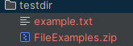
ZIP FILE FILSYSTEM
with ZipFS("testdir/FileExamples.zip") as fs_zip:
if(fs_zip.exists("FileExamples/File1.txt")):
with fs_zip.open("FileExamples/File1.txt") as zip_file:
content = zip_file.read()
print(content)

BASIC EXAMPLE: WORKING WITH LOCAL FILESYSTEM  from fs.osfs import OSFS  # “.” Means Open the current directory  with OSFS('.') as myfs:  # Create a new file and write to it  myfs.writetext('hello.txt', 'Hello, PyFilesystem!')  # Read the file  content = myfs.readtext('hello.txt')  print(content)  # List directory contents  print(myfs.listdir('.')) | EXAMPLE: IN-MEMORY FILESYSTEM  from fs.memoryfs import MemoryFS  mem_fs = MemoryFS()  mem_fs.writetext('test.txt', 'This is in memory!')  print(mem_fs.readtext('test.txt'))
EXAMPLE: WORKING WITH ZIP FILES
from fs.zipfs import ZipFS
with ZipFS('example.zip', write=True) as zip_fs:
zip_fs.writetext('file.txt', 'Inside the ZIP!')

WORKING WITH DIRECTORIES

DIRECTORY TREE | with OSFS(".") as current_path:  current_path.tree()
LIST DIRECTORY IN A GIVEN FOLDER (listdir) | with OSFS(".") as current_path:  directory_listing = current_path.listdir("FileExamples")  print(directory_listing)
ITERATOR FOR DIRECTORY(scandir) | with OSFS(".") as current_path:  directory_listing = list(current_path.scandir("FileExamples"))  print(directory_listing)  OUTPUT  [<dir 'Dir1'>, <dir 'Dir2'>, <file 'File1.txt'>, <file 'File2.txt'>, <file 'File3.txt'>]
LIST THE FILE FOR A GIVEN EXTENSION | with OSFS(".") as current_path:  directory_listing = list(current_path.filterdir("FileExamples",files=["*.txt"]))  print(directory_listing)  OUTPUT  <dir 'Dir1'>, <dir 'Dir2'>, <file 'File1.txt'>, <file 'File2.txt'>, <file 'File3.txt'>]
COPY CONTENT FROM ONE FOLDER TO ANOTHER | with OSFS(".") as fs:  fs.copydir("FileExamples","CopyFileExamples", create=True )
REMOVE AN EMPTY DIRECTORY | with OSFS(".") as fs:  if(fs.exists("CopyFileExamples")):  fs.remove("CopyFileExamples")
REMOVE A DIRECTORY RECURSIVELY | with OSFS(".") as fs:  if(fs.exists("CopyFileExamples")):  fs.removetree("CopyFileExamples")

It abstracts away the differences between these systems, so you can write code that works across all of them with the same API.
Goal - Write a file, read it back, and list directory contents — using the same code structure — across:
- Local filesystem
- In-memory filesystem
- ZIP archive
COMMON LOGIC (ABSTRACTED)
def demo_filesystem(fs):
fs.writetext('example.txt', 'Hello from PyFilesystem!')
print("File content:", fs.readtext('example.txt'))
print("Directory listing:", fs.listdir('/'))
- We can use the same demo_filesystem() function with any backend — local disk, memory, ZIP, S3, FTP, etc. — without changing the logic.
Local Filesystem  from fs.osfs import OSFS  with OSFS('.') as local_fs:  demo_filesystem(local_fs) | In-Memory Filesystem  from fs.memoryfs import MemoryFS  with MemoryFS() as mem_fs:  demo_filesystem(mem_fs)
ZIP Archive Filesystem
from fs.zipfs import ZipFS
with ZipFS('archive.zip', write=True) as zip_fs:
demo_filesystem(zip_fs)

WALKING A FILESYSTEM
What Is Walking a File Tree?
It means recursively visiting every file and directory starting from a root directory. This includes:
- The root directory itself
- All its subdirectories
- All files within those directories
Why Walk a File Tree?
You might do this to:
- Search for a specific file or pattern (e.g., *.log, report_*.csv)
- Batch process files (e.g., convert images, rename files, compress logs)
- Analyze file metadata (e.g., size, creation date)
- Clean up old or temporary files
- Build a file index or manifest
PRINT THE RELATIVE PATH OF ALL DIRECTORIES (in the current directory) | with OSFS(".") as fs:  for path in fs.walk.dirs():  print(path)
PRINT THE RELATIVE PATH ALL FILES IN DIRECTORIES AND SUBDIRECTORIES (in the current directory) | with OSFS(".") as fs:  for path in fs.walk.files():  print(path)
FILTERING BASED ON FILETYPE | with OSFS(".") as fs:  for path in fs.walk.files(filter=["*.txt"]):  print(path)

DETAILS

GET MORE DETAIL INFO OF FILES AND DIRECTORIES
fs.walk.info(namespaces=["details"])
- fs.walk is a walker object that allows recursive traversal of the filesystem.
- info(...) yields a tuple of:
  - path: the relative path to the file or directory
  - info: a ResourceInfo object containing metadata
- namespaces=["details"] requests extra metadata, like file size, modification time, etc.
CODE
with OSFS(".") as fs:
for path,info in fs.walk.info(namespaces=["details"]):
print(f"Path ={path} , {info.size}, {info.is_dir}, {info.modified}")
with OSFS("FileExamples") as fs:
for step in fs.walk(): RETURN A GENERATORS
print(f"Path={step.path}")
print(f"----Directories={step.dirs}")
print(f"----------Files={step.files}")
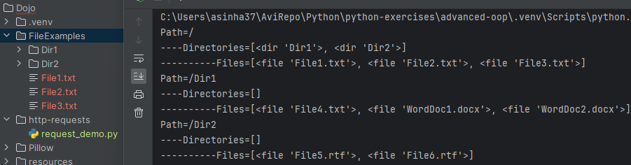
- What This Code Does: This script walks through the directory tree rooted at "FileExamples" and prints out the structure of each directory it visits.
- for step in fs.walk():
- fs.walk() returns a generator that yields Step objects.
- Each Step represents a directory in the tree and contains:
  - step.path: the relative path to the current directory
  - step.dirs: a list of subdirectory names in that directory
  - step.files: a list of file names in that directory

FOR ZIP FILES

with ZipFS("testdir/FileExamples.zip") as fs:
for step in fs.walk():
print(f"Path={step.path}")
print(f"----Directories={step.dirs}")
print(f"----------Files={step.files}")

PILLOW
- The Pillow library is a powerful and user-friendly Python imaging library, used for opening, manipulating, and saving many different image file formats.
- It’s a fork of the original PIL (Python Imaging Library) and is actively maintained.
- INSTALLATION: pip install Pillow
OPENING THE FILE | from PIL import Image  img = Image.open("example.jpg")
GET IMAGE ATTRIBUTES | print(pic.filename)  print(pic.format)  print(pic.size)  print(pic.width)  print(pic.height) | OUTPUT  ImagesArchive/Data.jpeg  JPEG  (5760, 3840)  5760  3840
SHOW THE IMAGE | pic.show() | Open image in default image editor
SAVE & CONVERT IMAGE FORMAT | output_file = "ImagesArchive/Data.png"  pic.save(output_file,"png")

IMAGE MANIPULATION

RESIZE AND CROP IMAGE | resized = img.resize((200, 200))  cropped = img.crop((10, 10, 100, 100)) # (left, upper, right, lower)  EXAMPLE:
ROTATION AND RESIZE

HANDLING RESPONSE USING REQUESTS LIBRARY

res = requests.get("http://httpbin.org/json")  print(res.json())  print(res.headers)  print(res.headers["content-type"]) | - res.json() : Prints the JSON response  - res.header: Prints all response headers & value as dictionary  - res.header[‘content-type’]: Prints the value of content-type response header

raise_for_status()
- The raise_for_status() method in the requests library is used to automatically raise an error if the HTTP request returned an unsuccessful status code (like 4xx or 5xx).
HOW IT WORKS
import requests  response = requests.get("https://example.com/data")  # This will raise an HTTPError if the request failed  response.raise_for_status()  If the response is successful (e.g., 200 OK), nothing happens.  If the response is an error (e.g., 404 or 500), it raises a requests.exceptions.HTTPError. | Example with Error Handling  try:  response = requests.get("https://example.com/bad-url")  response.raise_for_status()  except requests.exceptions.HTTPError as err:  print(f"HTTP error occurred: {err}")  except Exception as err:  print(f"Other error occurred: {err}")  else:  print("Success!")

AUTHENTICATION

BASIC AUTHENTICATION
When we access a protected web resource (like a private API), the server may require us to prove our identity using a username and password. One simple way to do this is called Basic Authentication.
- Credentials are sent with the request.
- They are encoded in Base64 (not encrypted).
- The server checks them and either allows or denies access.
- Security:Not very secure unless used over HTTPS, because credentials are easily decoded.
import requests
from requests.auth import HTTPBasicAuth

response = requests.get(
"https://httpbin.org/basic-auth/user/pass",
auth=HTTPBasicAuth("user", "pass")
)

print(response.status_code)
print(response.json())
- We can also use a shortcut: response = requests.get("https://httpbin.org/basic-auth/user/pass", auth=("user", "pass"))
- HTTPBasicAuth: A helper class that makes it easy to send your username and password using Basic Authentication.
response = requests.get(
"https://httpbin.org/basic-auth/user/pass",
auth=HTTPBasicAuth("user", "pass")
)
- requests.get(...): Sends a GET request to the URL.
- URL: https://httpbin.org/basic-auth/user/pass is a test endpoint that expects:
  - Username: "user"
  - Password: "pass"
- auth=HTTPBasicAuth(...): Adds an Authorization header to your request that looks like:
Authorization: Basic dXNlcjpwYXNz
(That’s user:pass encoded in Base64.)

print(response.status_code)
- Prints the HTTP status code:
  - 200 = Success
  - 401 = Unauthorized (wrong credentials)

print(response.json())
- Converts the JSON response from the server into a Python dictionary.
- If successful, the response will be:
{
"authenticated": true,
"user": "user"
}

DIGEST AUTHENTICATION
- Digest Authentication is a more secure way for a client (like your Python script) to prove its identity to a server compared to Basic Authentication.
- When we use Basic Authentication, your username and password are simply encoded in Base64 and sent with every request. This is not very secure unless you're using HTTPS.
- Digest Authentication, on the other hand:
- Uses a challenge-response mechanism.
- Sends a hashed version of your credentials instead of the raw password.

HOW DIGEST AUTHENTICATION WORKS (SIMPLIFIED)
- Client sends a request to the server.
- Server responds with a challenge (a random string called a nonce).
- Client hashes the username, password, and nonce together.
- Client sends the hashed result back to the server.
- Server checks the hash. If it matches, access is granted.
This way, the password is never sent directly, and the hash is different each time.
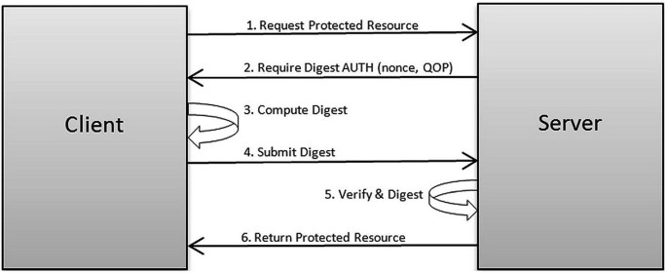
USING DIGEST AUTHENTICATION IN PYTHON WITH REQUESTS
import requests  from requests.auth import HTTPDigestAuth  response = requests.get(  "https://httpbin.org/digest-auth/auth/user/pass", auth=HTTPDigestAuth("user", "pass"))  print(response.status_code)  print(response.json()) | - HTTPDigestAuth handles all the hashing and challenge-response steps for you.  - If the credentials are correct, you’ll get:  {  "authenticated": true,  "user": "user"  }

ADVANCED FEATURES

TIMEOUT

try:
res = requests.get("https://httpbin.org/delay/2.5", timeout=1.0)
print(res.status_code)
except Exception as e:
print("Timeout Exception",e)

OUTPUT
Timeout Exception HTTPSConnectionPool(host='httpbin.org', port=443): Read timed out. (read timeout=1.0)

SESSION OBJECT
In Python's requests library, a Session object is used to persist certain parameters across multiple requests. It allows us to maintain things like:
- Cookies across requests
- Headers that are reused
- Connection pooling for performance
- Authentication credentials

IMAGE EDITING

3. Rotating and Flipping
rotated = img.rotate(90)
flipped = img.transpose(Image.FLIP_LEFT_RIGHT)
4. Converting Image Modes
gray = img.convert("L") # Convert to grayscale
5. Saving Images
img.save("new_image.png")
6. Drawing on Images
from PIL import ImageDraw

draw = ImageDraw.Draw(img)
draw.text((10, 10), "Hello, Pillow!", fill="white")
7. Working with Pixels
pixels = img.load()
print(pixels[0, 0]) # Get RGB value of top-left pixel
pixels[0, 0] = (255, 0, 0) # Change it to red

Would you like a specific example, like adding a watermark, creating a thumbnail, or applying filters?

